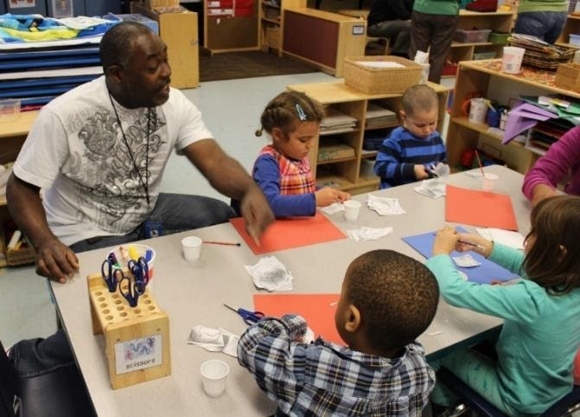

This Photo by Unknown Author is licensed under CC BY-SA-NC
I Can Be Safe!

At school, being safe is important!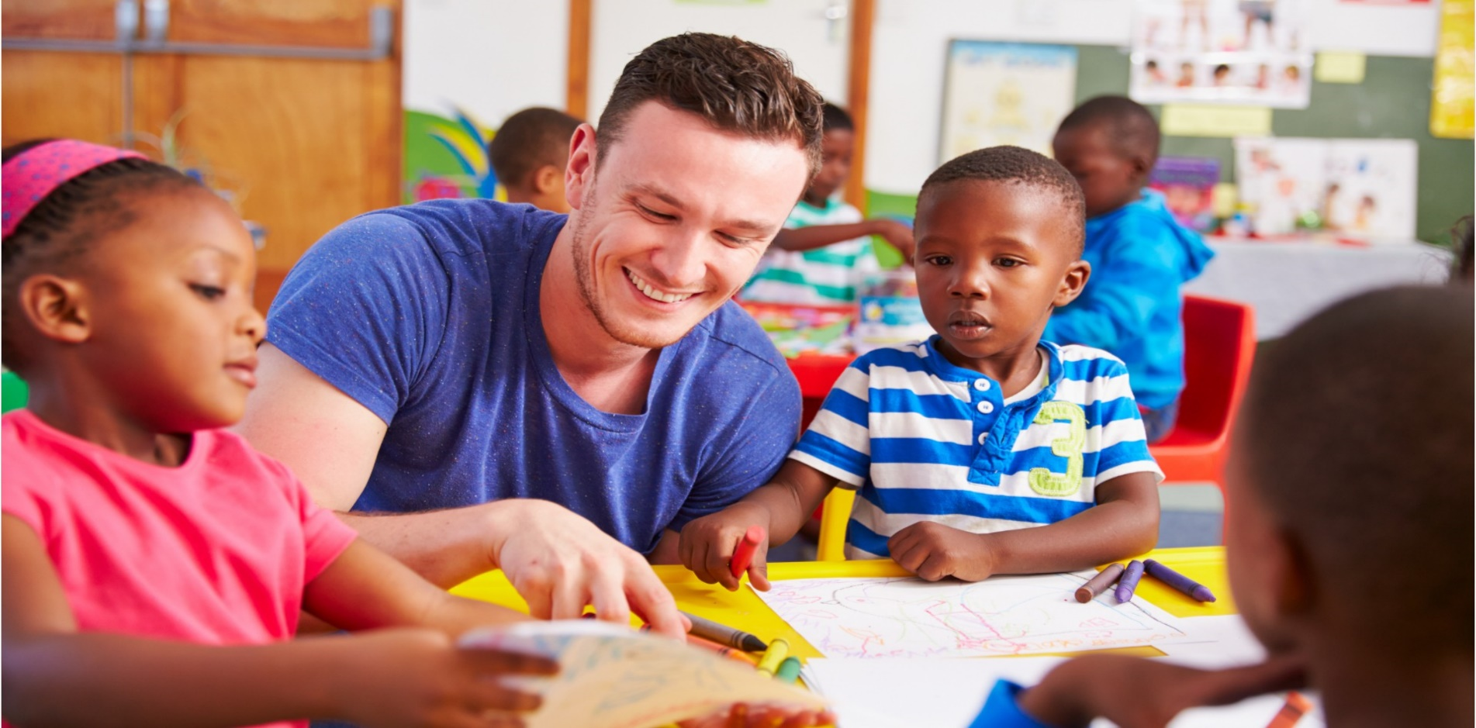

This Photo by Unknown Author is licensed under CC BY
When I am in school, I use walking feet.
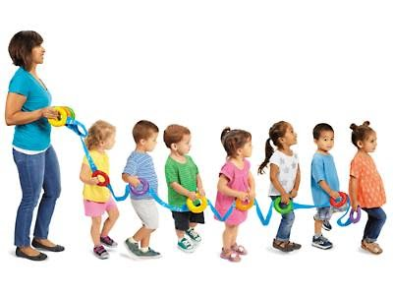

This Photo by Unknown Author is licensed under CC BY-NC-ND
I listen to my teachers.
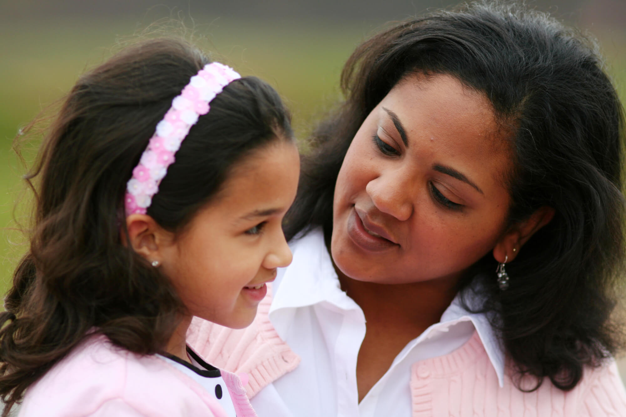

This Photo by Unknown Author is licensed under CC BY
I use gentle hands with my friends.
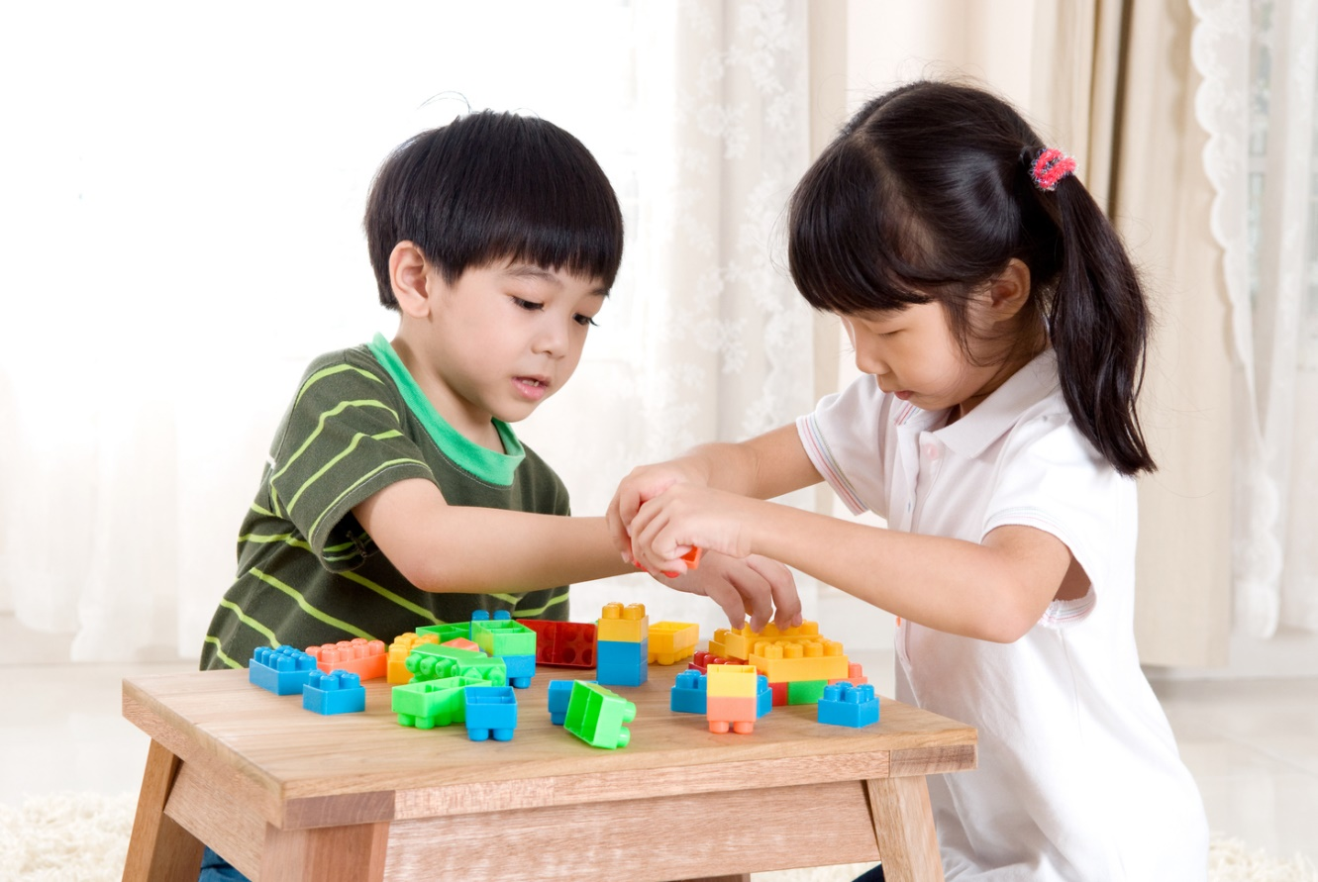

This Photo by Unknown Author is licensed under CC BY-ND
I follow directions on the playground.
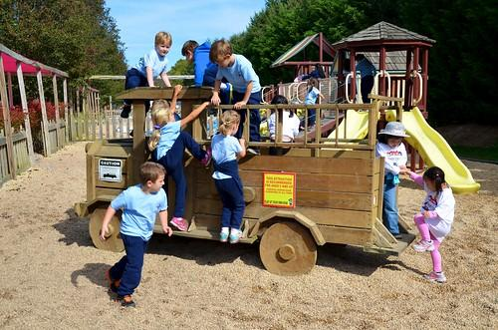

This Photo by Unknown Author is licensed under CC BY-SA-NC

When I am at home, keep my feet on the floor.
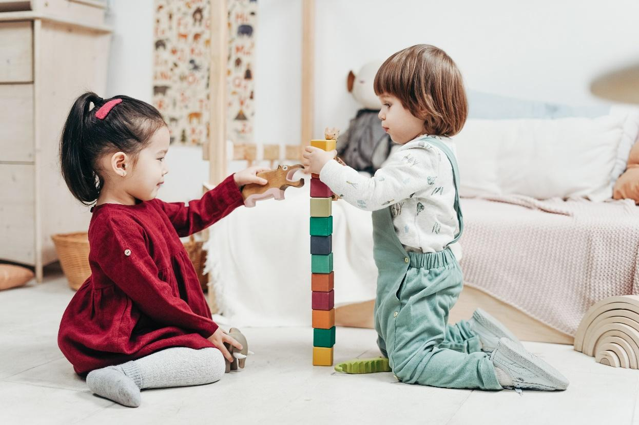
I listen to my grownups.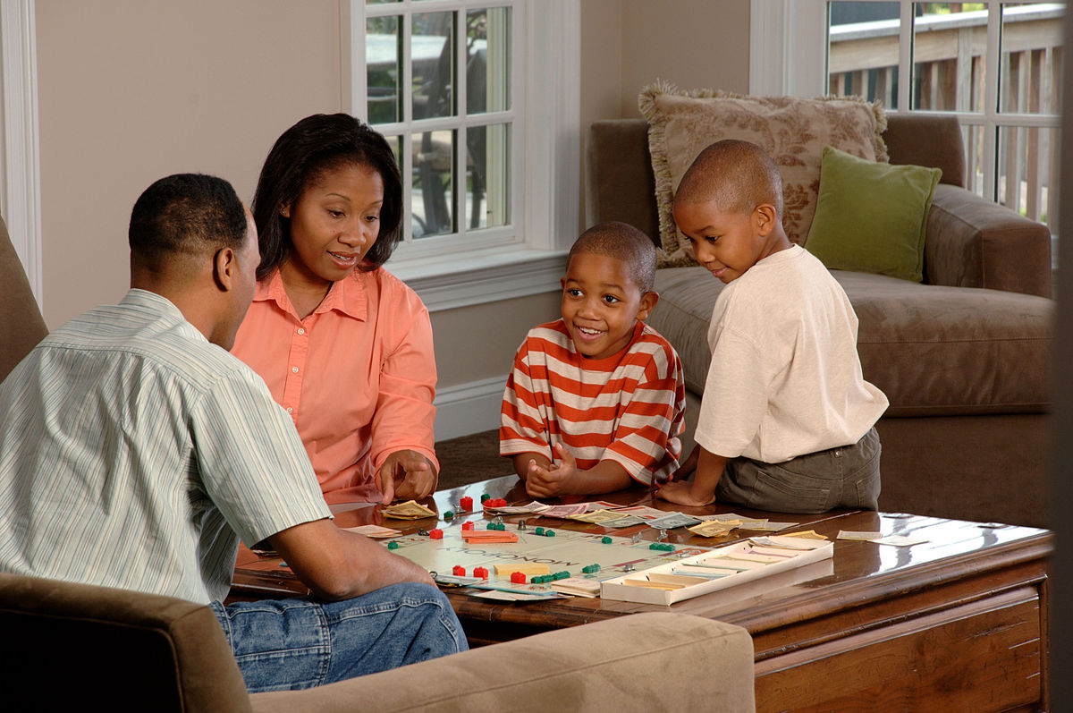

This Photo by Unknown Author is licensed under CC BY-SA
I stay with my grown ups.
