Preschool Vehicle Unit
Fun Rhyming Read-Along

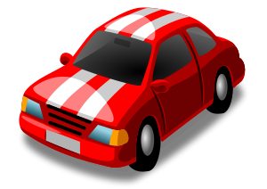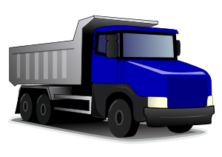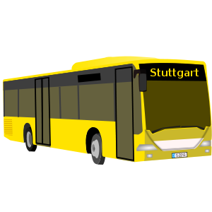

formatted for 1-on-1

“Let’s drive far,”
said the
car.

“Don’t forget us,”
said the
bus.

“Good luck,” said the
truck.

“I think I’ll pass,” said the

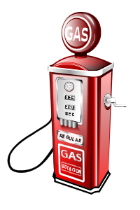
gas.

“We love how this feels,” said the
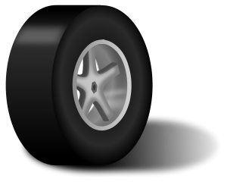
wheels.

“Turn on the heat,” said the
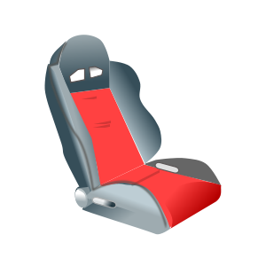
seat.

“Throw away those diapers,” said the
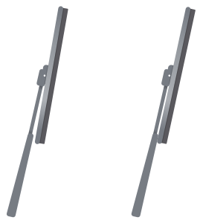
wipers.

“Watch out for the duck” said the
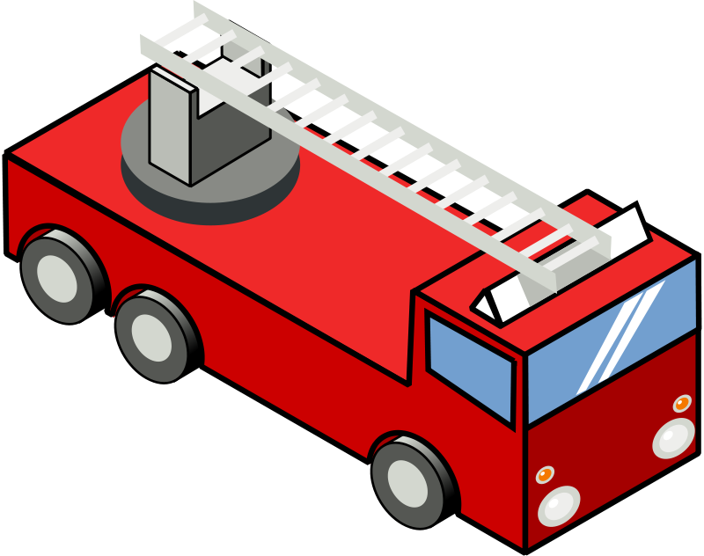

fire truck.

“Don’t let it melt” said the

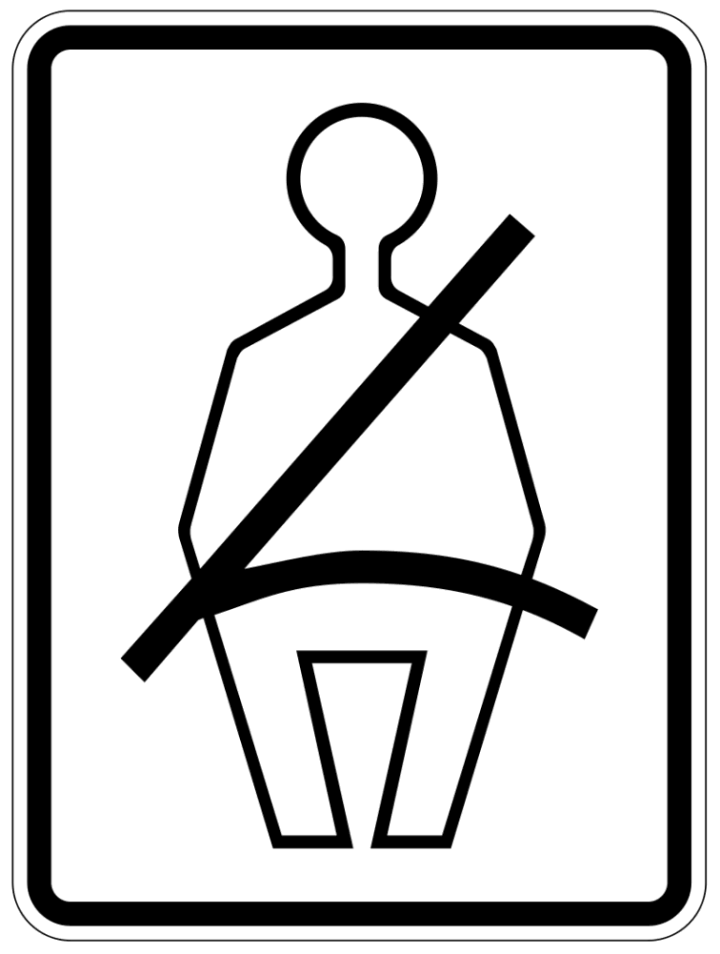
seat belt.

“Let’s dance” said the
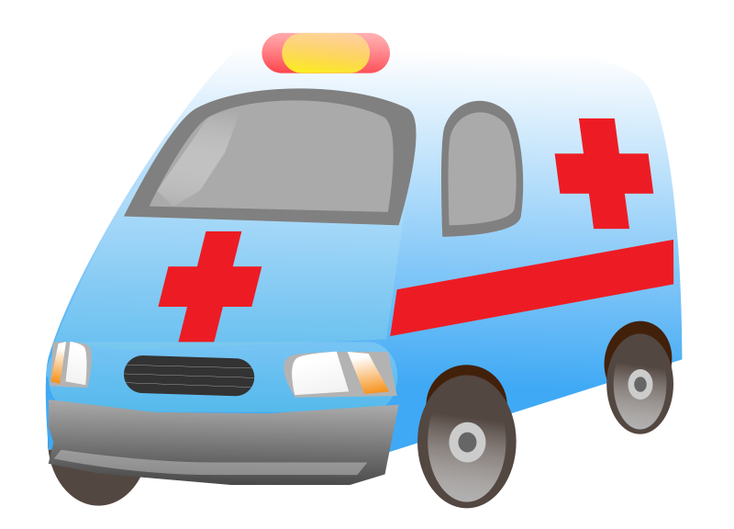
ambulance.

