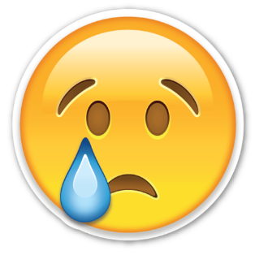Have you ever been sad?

|  |  |
| --- | --- |
| Yes | No |
|  |  |

Have you ever been scared?

|  |  |
| --- | --- |
| Yes | No |
|  |  |



What makes you happy?