Did you wash your hands when you got to school?

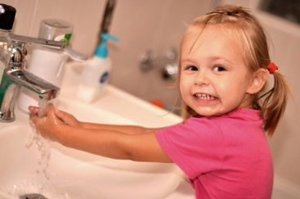

|  |  |
| --- | --- |
| Yes | No |
|  |  |

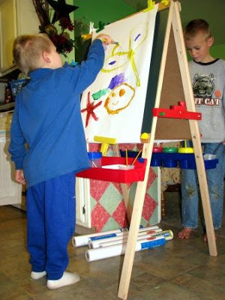

Would you like to paint today?



What song shall we sing today?

|  |  |
| --- | --- |
| #1- | #2- |
|  |  |

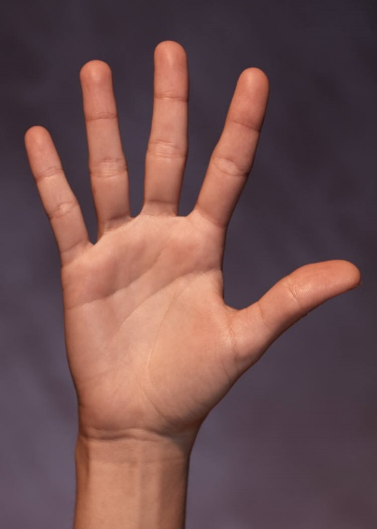

How many fingers are on your hand?

|  |  |
| --- | --- |
| Two 2 | Five 5 |
|  |  |

Have you ever seen someone __________________?