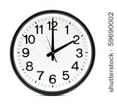Do you know how this is used?

What do we do after Morning Meeting?

|  |  |
| --- | --- |
| Lunch | Centers |
|  |  |

What do we do when we first get to school?

|  |  |
| --- | --- |
| Wash hands | Eat Lunch |
|  |  |