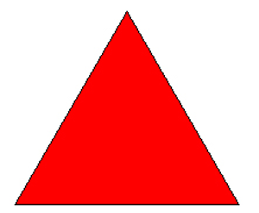

Can you make this shape with your hands?

|  |  |
| --- | --- |
| Yes | No |
|  |  |

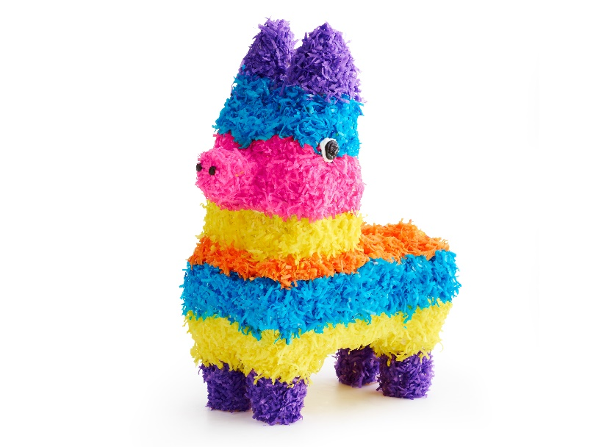

Do you know what this is?

|  |  |
| --- | --- |
| Yes | No |
|  |  |

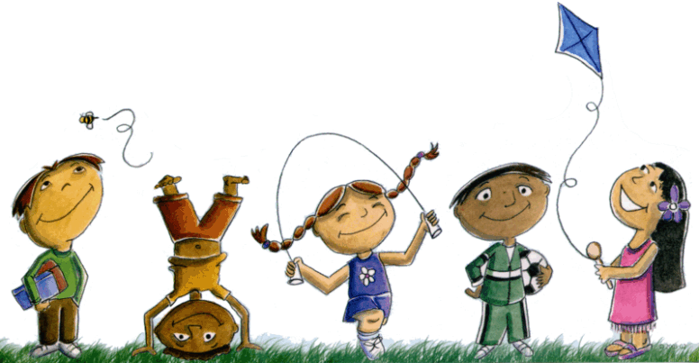 What do you like to do with

your friends?

Which book would you like to read today?

|  |  |
| --- | --- |
| #1 | #2 |
|  |  |

What should you do if you and a friend want the same toy?

|  |  |
| --- | --- |
| Scream | Take turns |
|  |  |