Do you know what sound this makes?

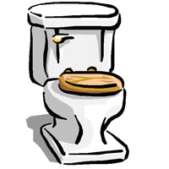

Which one do you think makes a louder sound?

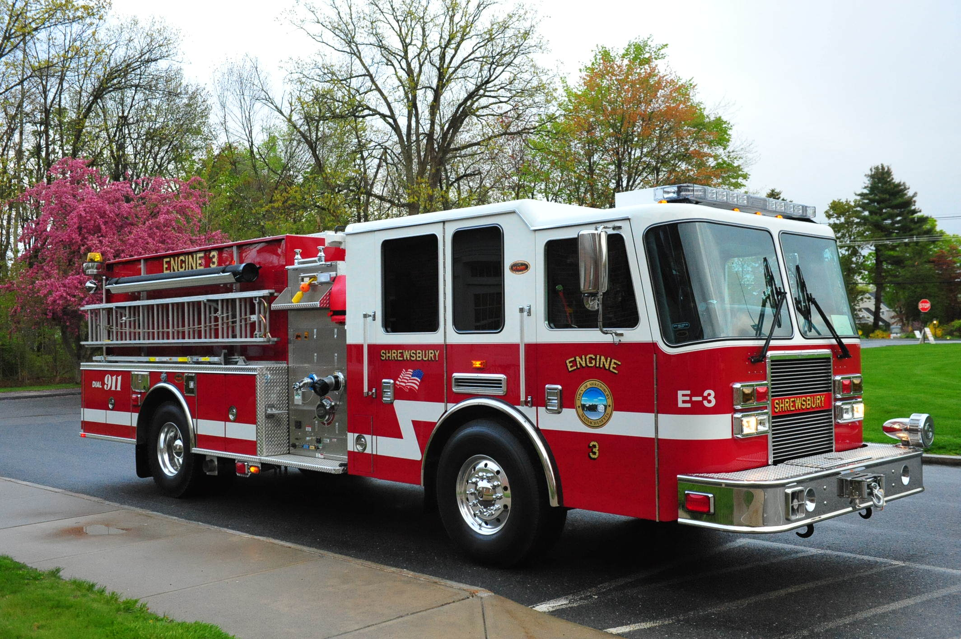

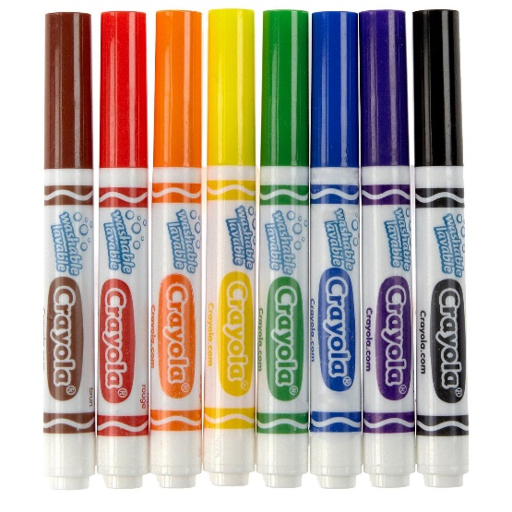Does this make

a sound?

|  |  |
| --- | --- |
| Yes | No |
|  |  |

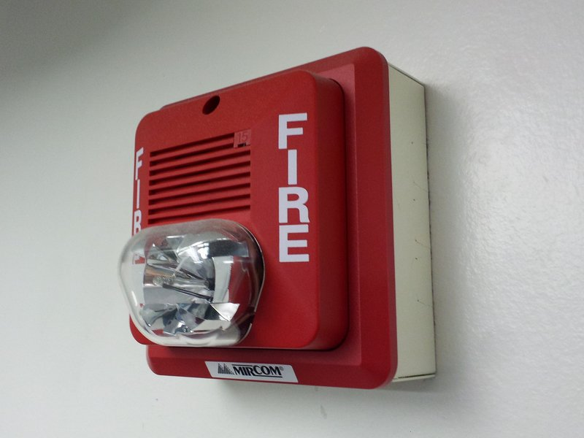Does this make

a sound?

|  |  |
| --- | --- |
| Yes | No |
|  |  |

Can we make sounds

with this?

|  |  |
| --- | --- |
| Yes | No |
|  |  |