What can we do with this?

What types of exercise will we see on our site visit?

How can you exercise with this?

Do you have a question for our visitor?

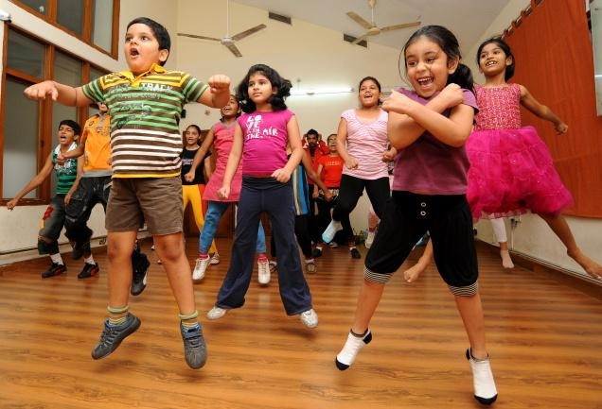Which of these exercises do you like to do with a partner?

Dancing Running

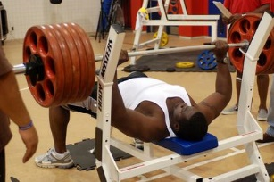

Lifting Weights