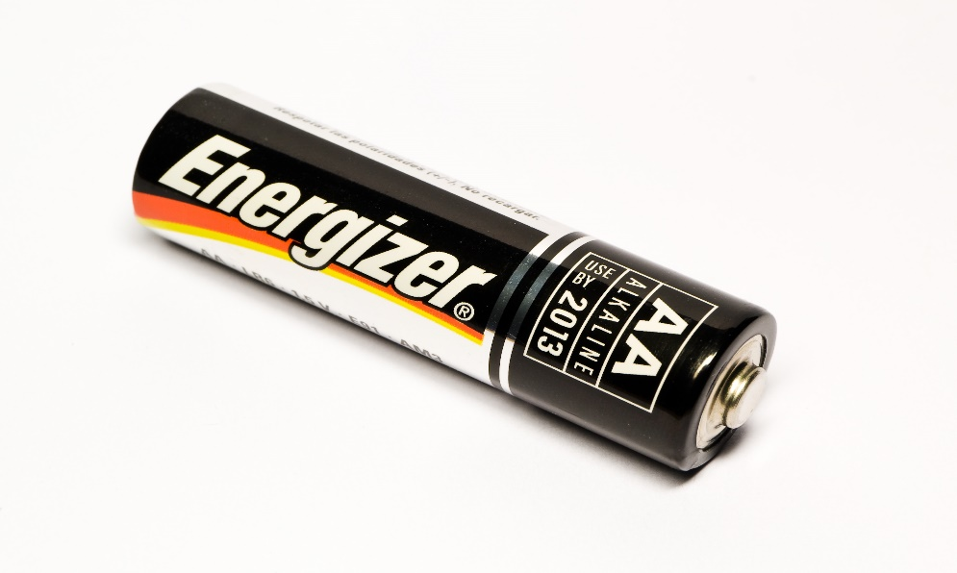How is this used?

Have you eaten this before?

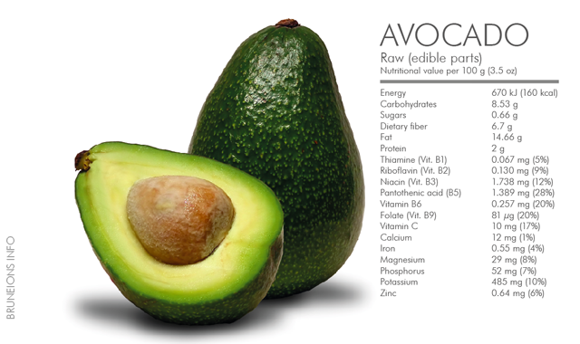

How many cups of water do you drink each day?

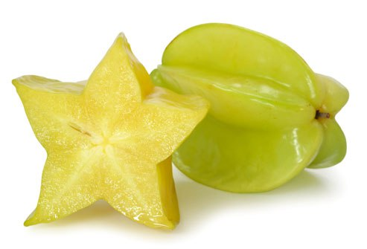Have you ever eaten this food?

Starfruit

|  |  |
| --- | --- |
| YES | NO |
|  |  |

What is your favorite fruit?