Which of these jobs involves exercise?

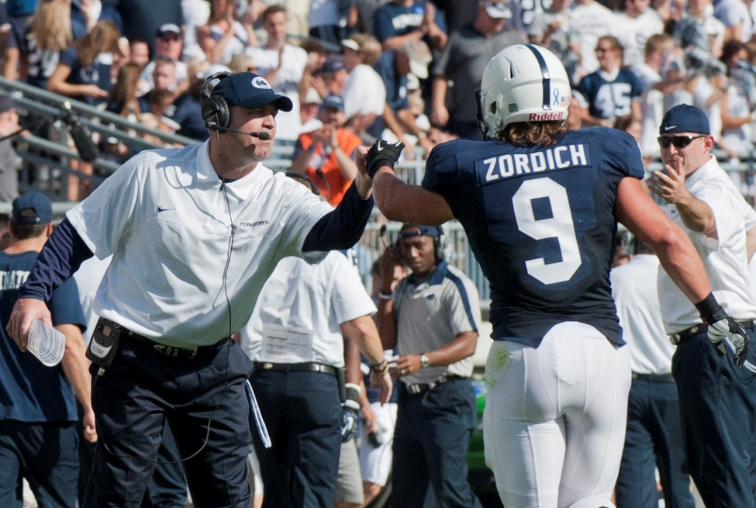Office Worker

Football Coach

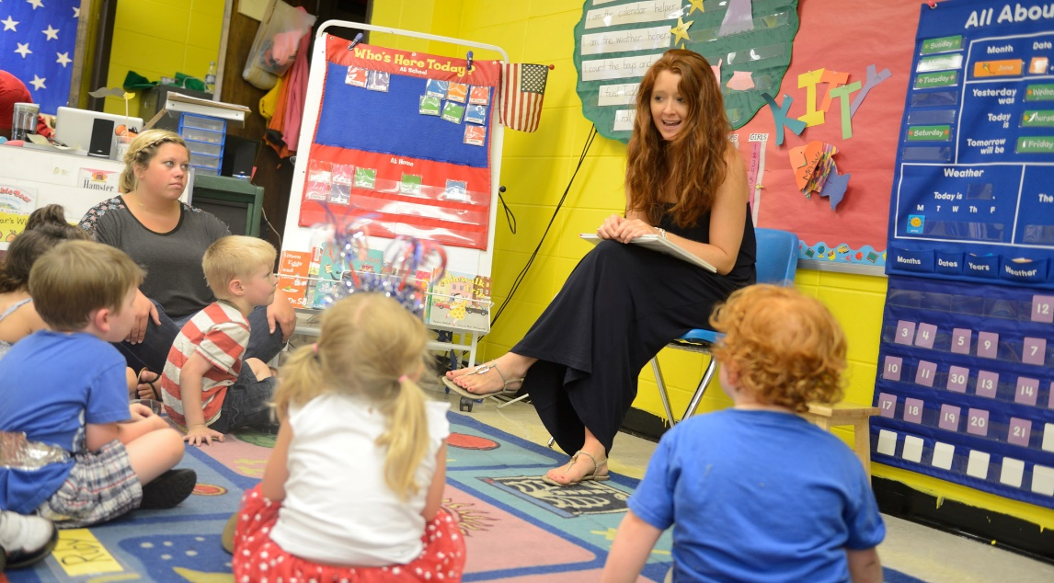

Teacher

Which of these is best for exercising?

|  |  |  |  |
| --- | --- | --- | --- |
| Sneakers | Boots | Dress Shoes | Slippers |
|  |  |  |  |

What question do you want to ask during our site visit today?

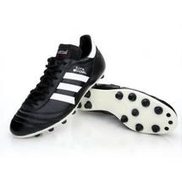Do you know what sport

these are used for?