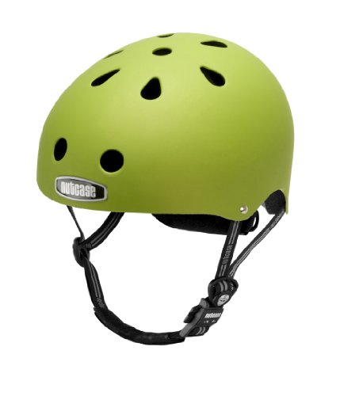

What is this for?

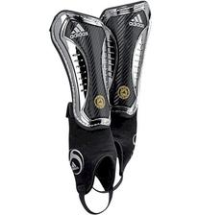What is this for?

What number should you call in an emergency?

Do you think we will find safety hazards on our walk around school?





What exercises would you like to do with our guests?

What is your favorite exercise?