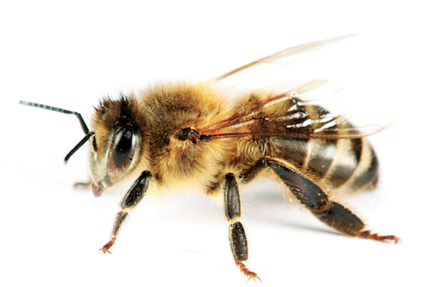 What is this?

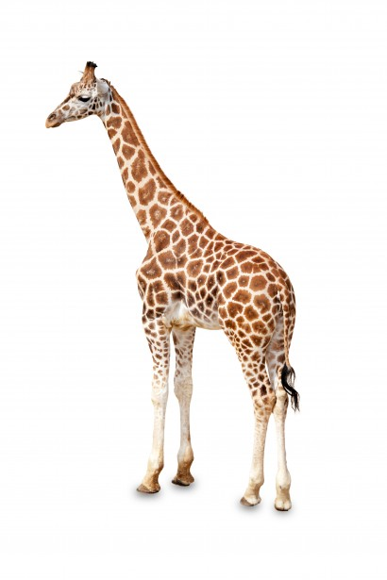Which is bigger?

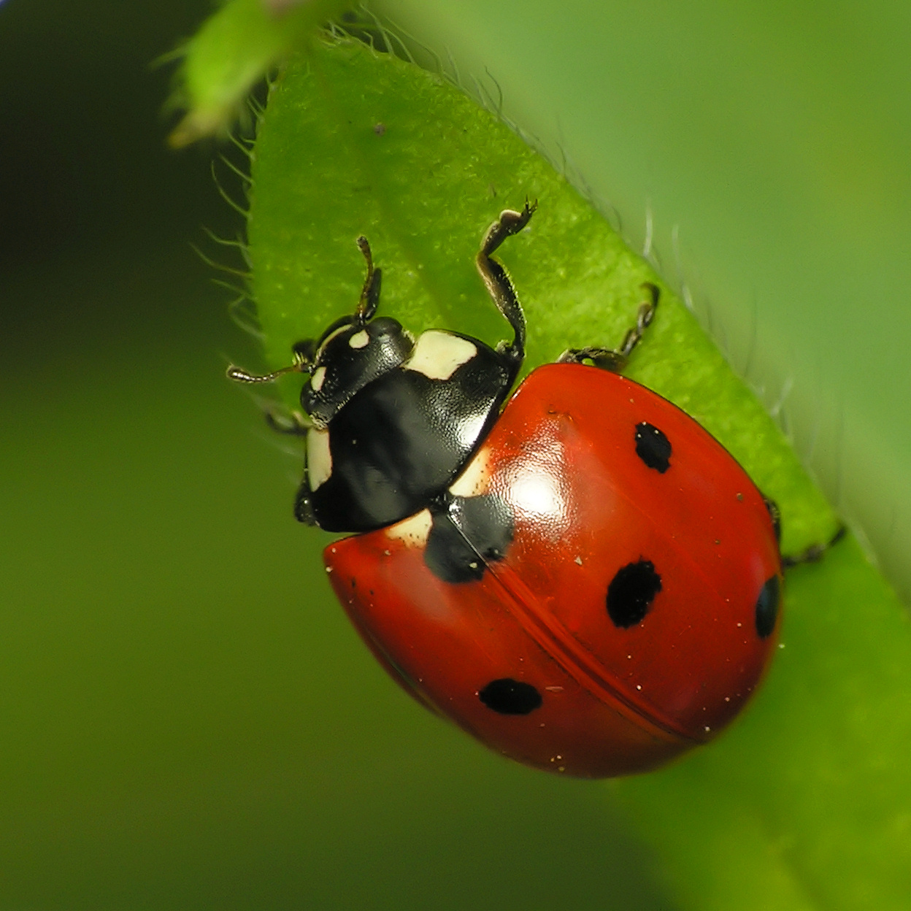

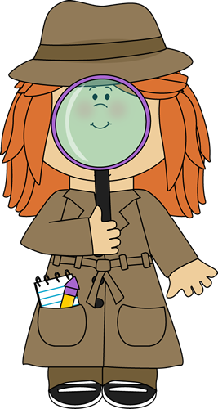Did you see an

insect today?

|  |  |
| --- | --- |
| Yes | No |
|  |  |

Which of these is an insect?

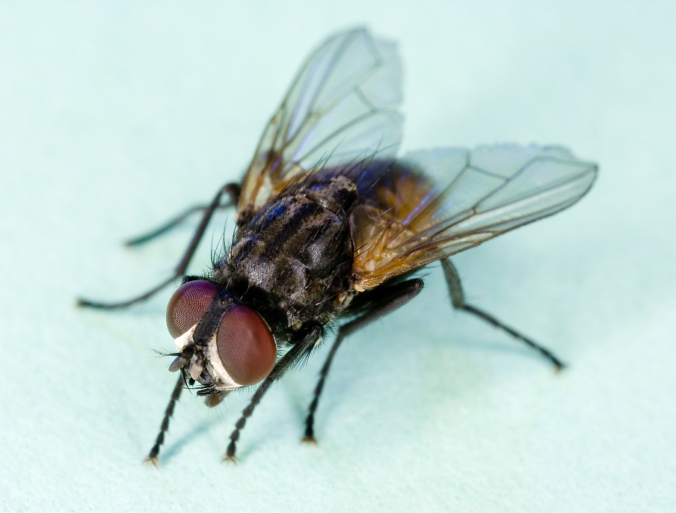

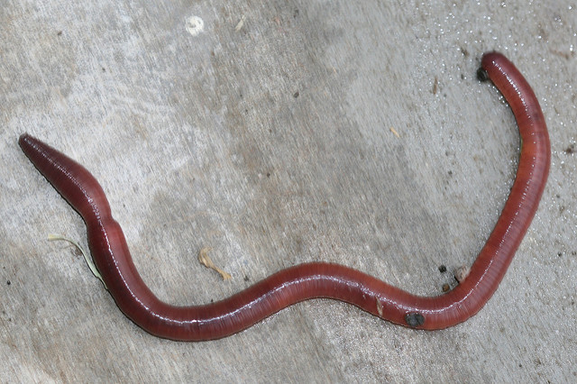

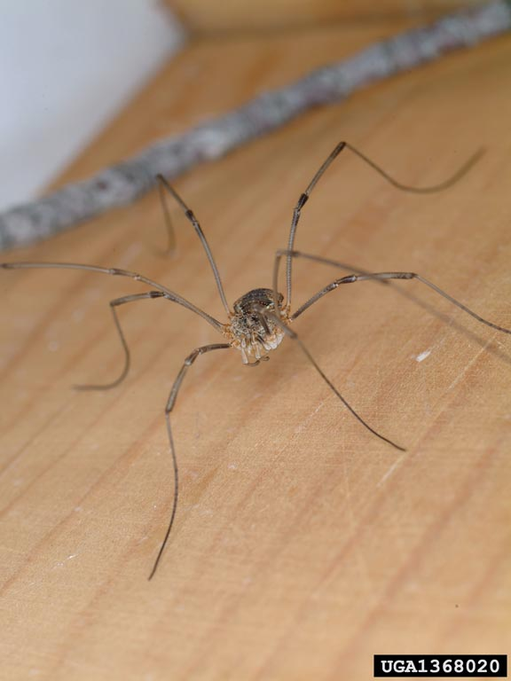

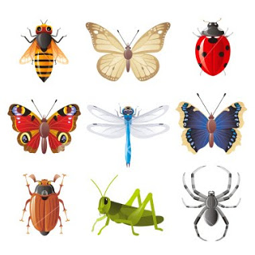What insect would you

like to collect on our

walk?

|  |
| --- |
|  |
|  |
|  |
|  |
|  |
|  |
|  |
|  |
|  |
|  |
|  |
|  |
|  |
|  |
|  |
|  |
|  |
|  |
|  |

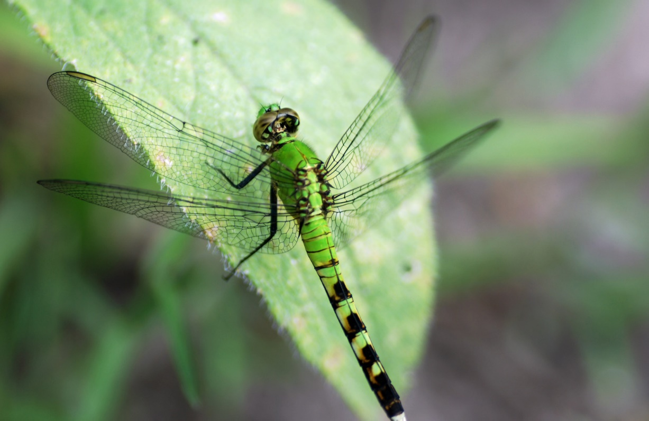How are these insects alike?

Dragonfly

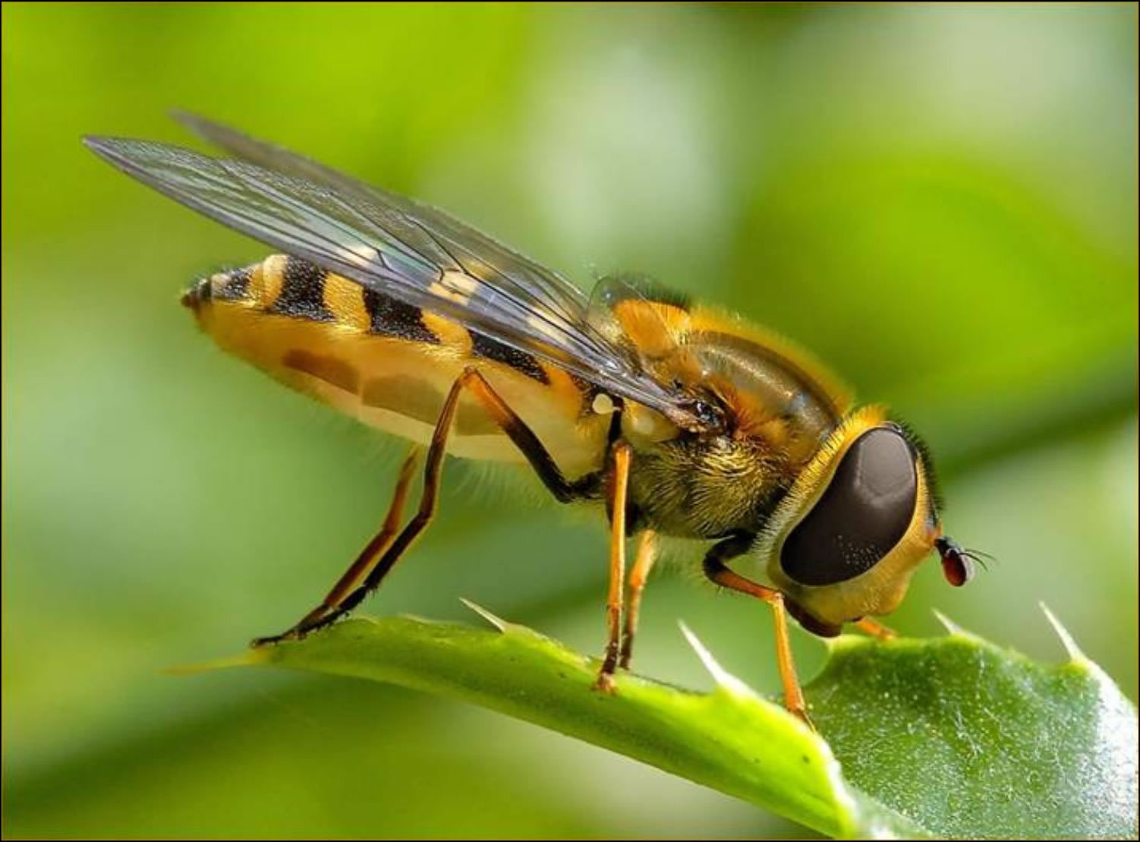

Bee