How far can you jump?

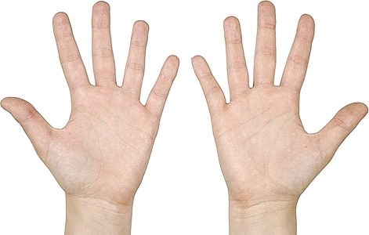What sounds can you make

with your hands?

|  |
| --- |
|  |
|  |
|  |
|  |
|  |
|  |
|  |
|  |
|  |
|  |
|  |
|  |
|  |
|  |
|  |
|  |
|  |
|  |

What does this mean?

|  |
| --- |
|  |
|  |
|  |
|  |
|  |
|  |
|  |
|  |
|  |
|  |
|  |
|  |
|  |
|  |
|  |
|  |
|  |
|  |
|  |
|  |
|  |
|  |
|  |

 How many people

do you live with?

|  |  |
| --- | --- |
| 1 |  |
| 2 |  |
| 3 |  |
| 4 |  |
| 5 |  |
| 6 |  |
| 7 |  |
| 8+ |  |

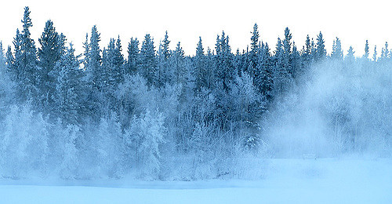What do you wear on a cold day?

|  |
| --- |
|  |
|  |
|  |
|  |
|  |
|  |
|  |
|  |
|  |
|  |
|  |
|  |
|  |
|  |
|  |
|  |
|  |