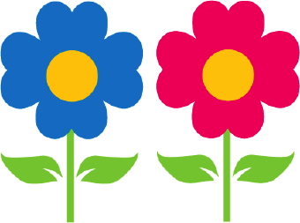Can you finish the flower pattern?







What do you like



Snacks

to eat?

|  |
| --- |
|  |
|  |
|  |
|  |
|  |
|  |
|  |
|  |
|  |
|  |
|  |
|  |
|  |

How did you get to school today?

|  |  |  |
| --- | --- | --- |
| Bus | Walk | Vehicle |
|  |  |  |

Which tower is taller?

|  |  |
| --- | --- |
|  |  |
|  |  |
|  |  |
|  |  |
|  |  |

What is this picture of?



  
  
  
  
  
  
  
  
  
  
  