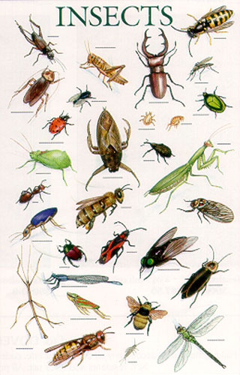 Where should we

look for insects

today?

|  |
| --- |
|  |
|  |
|  |
|  |  |
|  |  |
|  |  |
|  |  |
|  |  |
|  |  |
|  |  |
|  |  |
|  |  |
|  |  |
|  |  |
|  |  |
|  |  |

What is the weather like today?

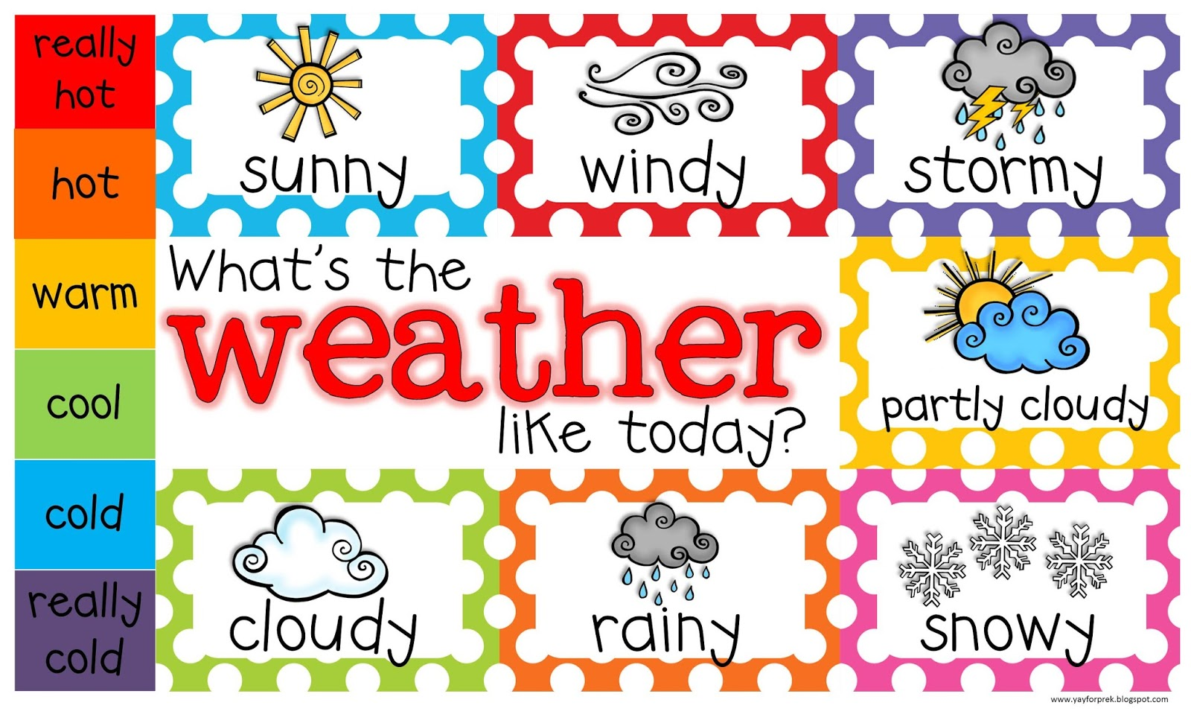

What colors do you see on this insect?

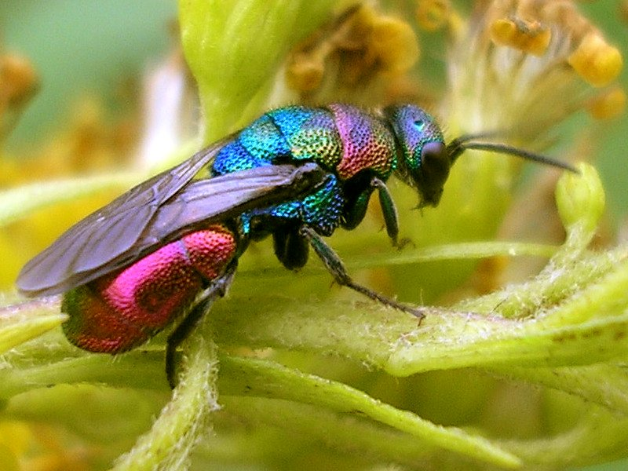

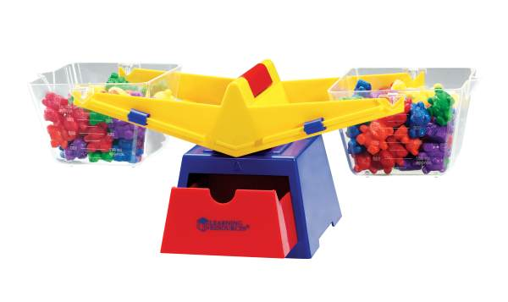

Which weighs more?

|  |  |
| --- | --- |
|  |  |
|  |  |