What would you like to ask on the site visit?

|  |
| --- |
|  |
|  |
|  |
|  |
|  |
|  |
|  |
|  |
|  |
|  |
|  |
|  |
|  |
|  |
|  |



What should we ask our visitor?

Which of these is a photograph?

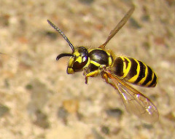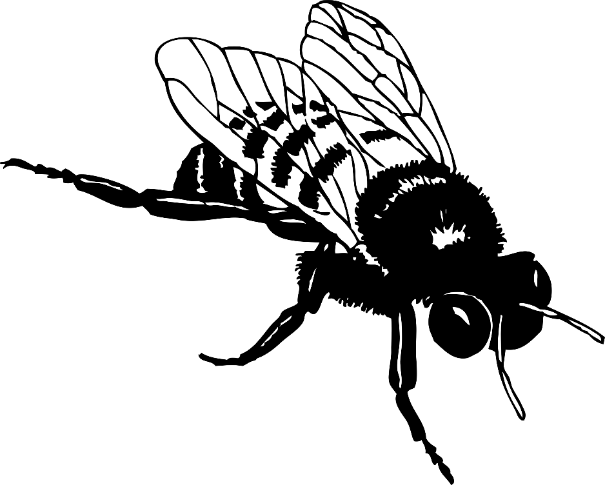

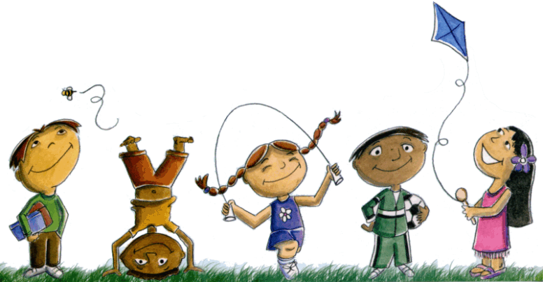What do we see growing outside?

|  |  |
| --- | --- |
|  |  |
|  |  |
|  |  |
|  |  |
|  |  |
|  |  |
|  |  |
|  |  |
|  |  |
|  |  |
|  |  |
|  |  |

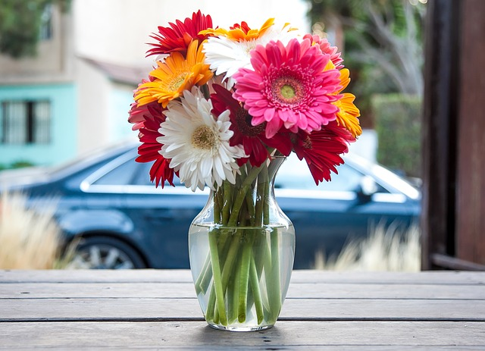How many flowers do you see?

|  |  |
| --- | --- |
|  |  |
|  |  |
|  |  |
|  |  |
|  |  |
|  |  |
|  |  |
|  |  |