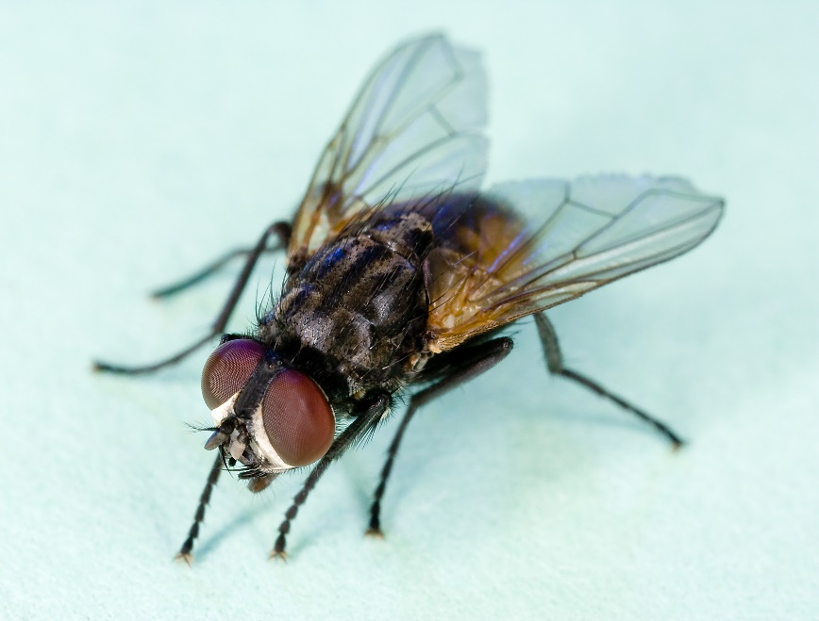Which of these lives in the ground?

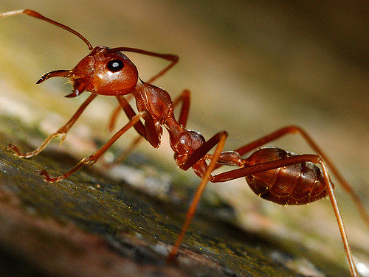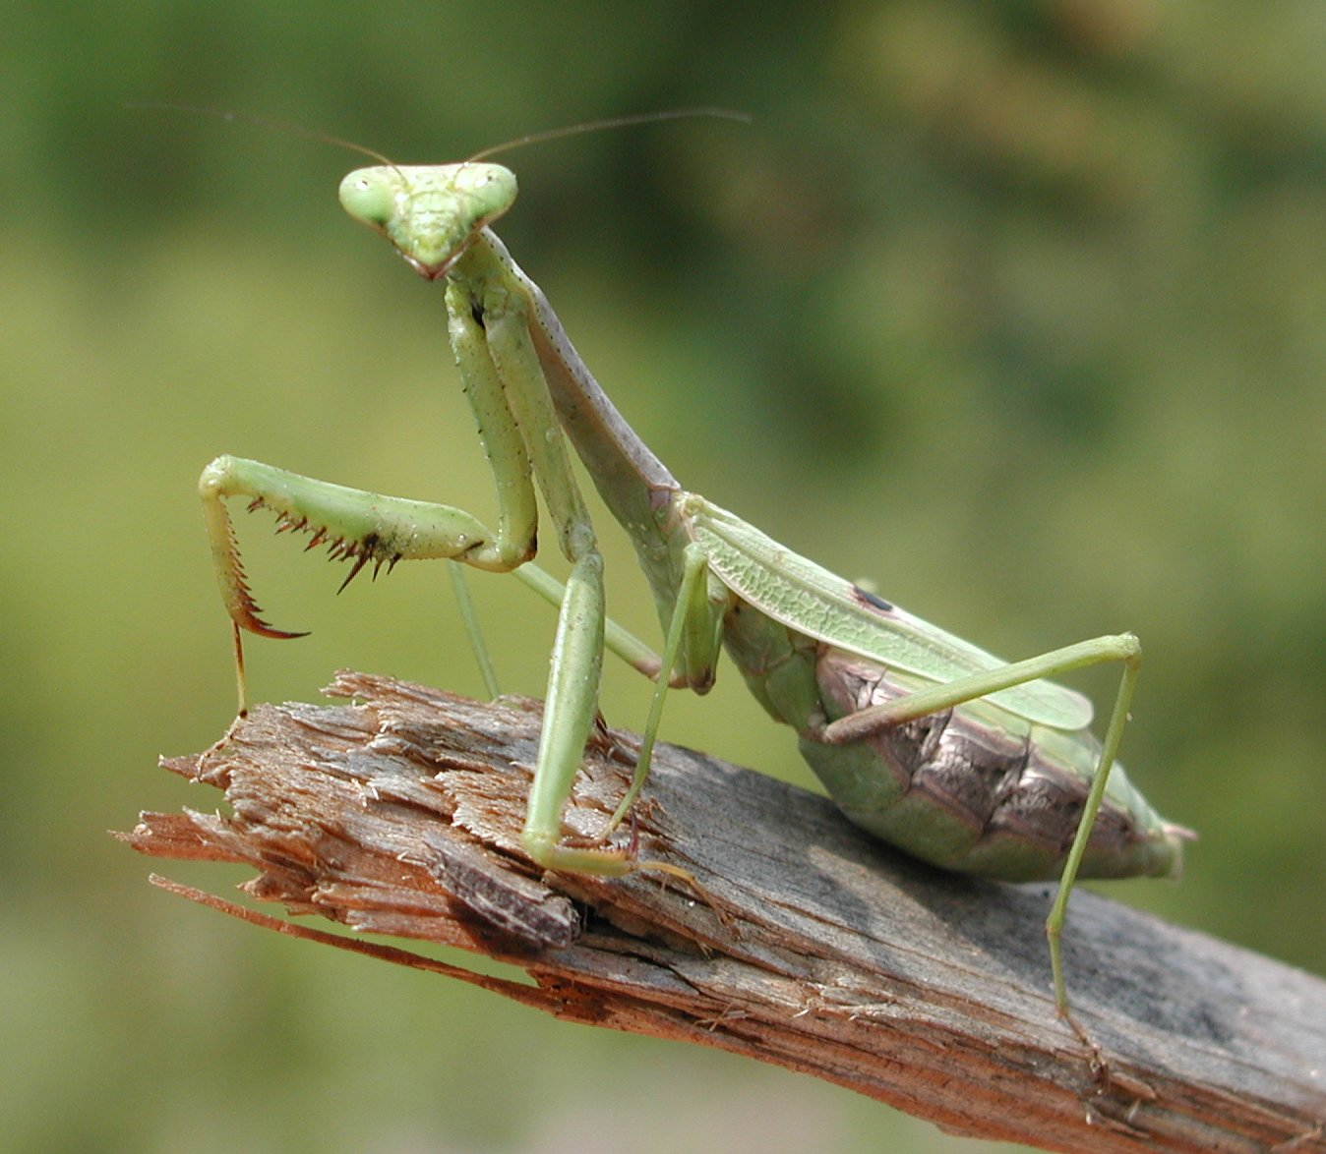

What did you eat

for breakfast?

|  |  |
| --- | --- |
|  |  |
|  |  |
|  |  |
|  |  |
|  |  |
|  |  |
|  |  |
|  |  |
|  |  |
|  |  |
|  |  |
|  |  |
|  |  |
|  |  |
|  |  |
|  |  |
|  |  |

What is this?

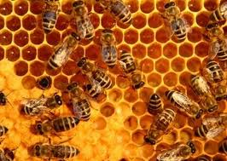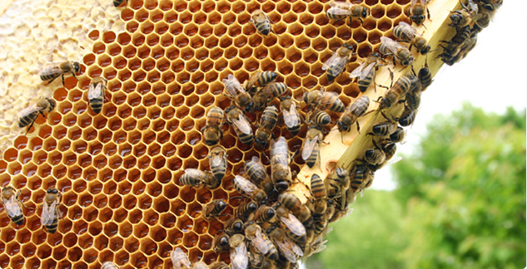

What is your favorite insect?

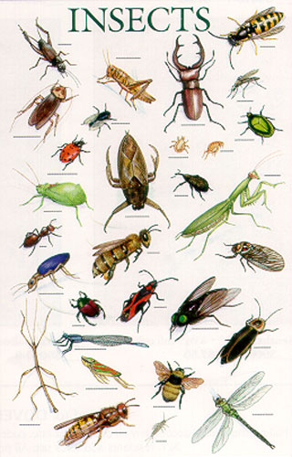

What will you show our visitors?