Do you like to sing?

|  |  |
| --- | --- |
| Yes | No |
|  |  |

Did you hear music on your way to school today?

|  |  |
| --- | --- |
| Yes | No |
|  |  |

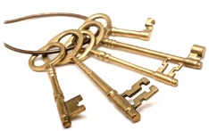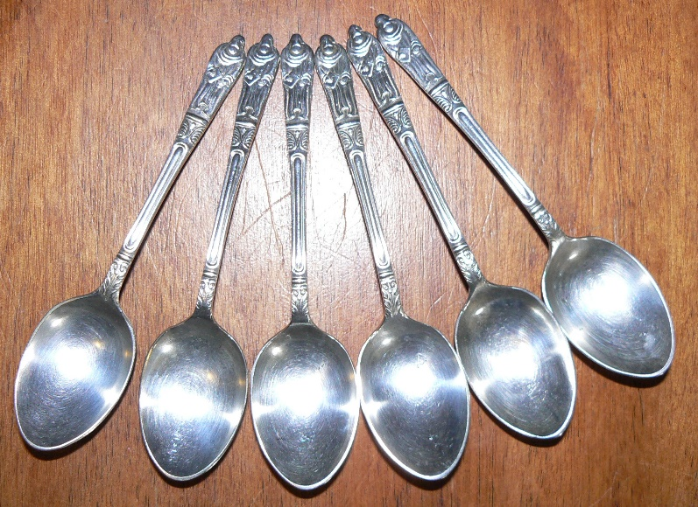Can you make a sound with these?

Keys

Spoons

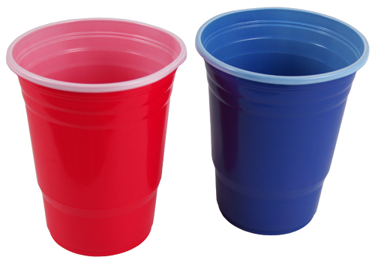

Cups

Which instrument would you like to play?

|  |  |  |
| --- | --- | --- |
| Drums | Triangles | Tambourine |
|  |  |  |

Do you think you can use these to make music?

