Do you know someone who plays an instrument?

|  |  |
| --- | --- |
| Yes | No |
|  |  |

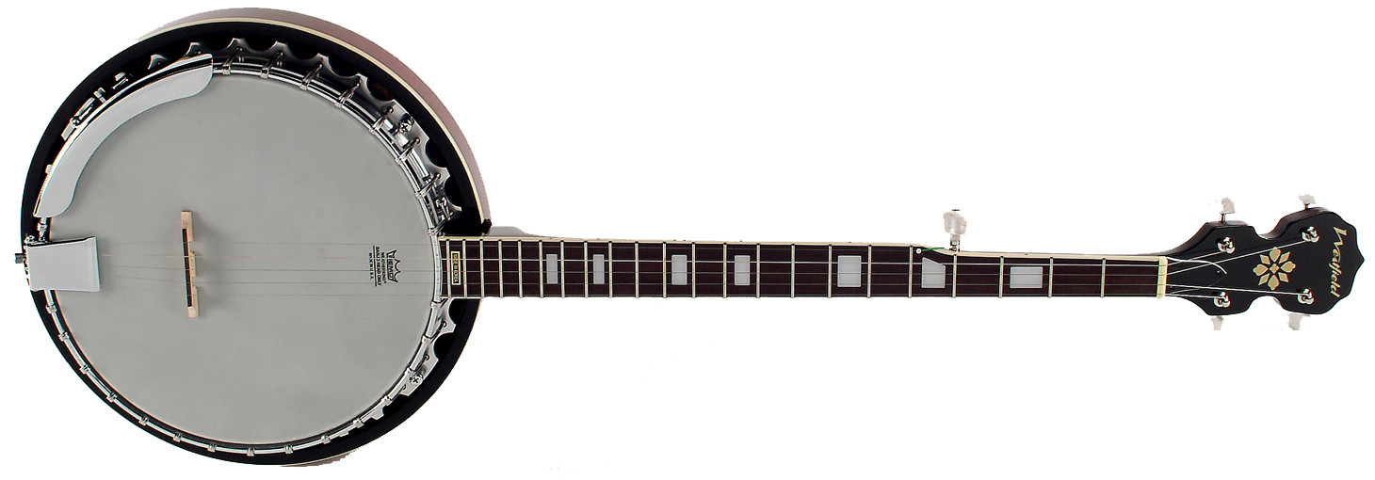What shapes do you see on this instrument?

Banjo

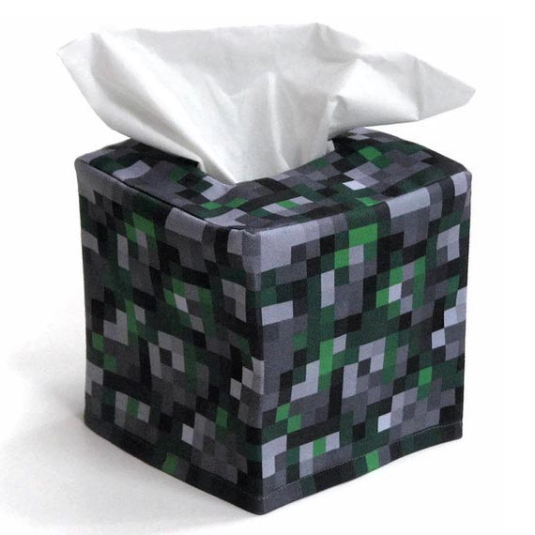 Can we make an instrument with an empty tissue box and rubber bands?

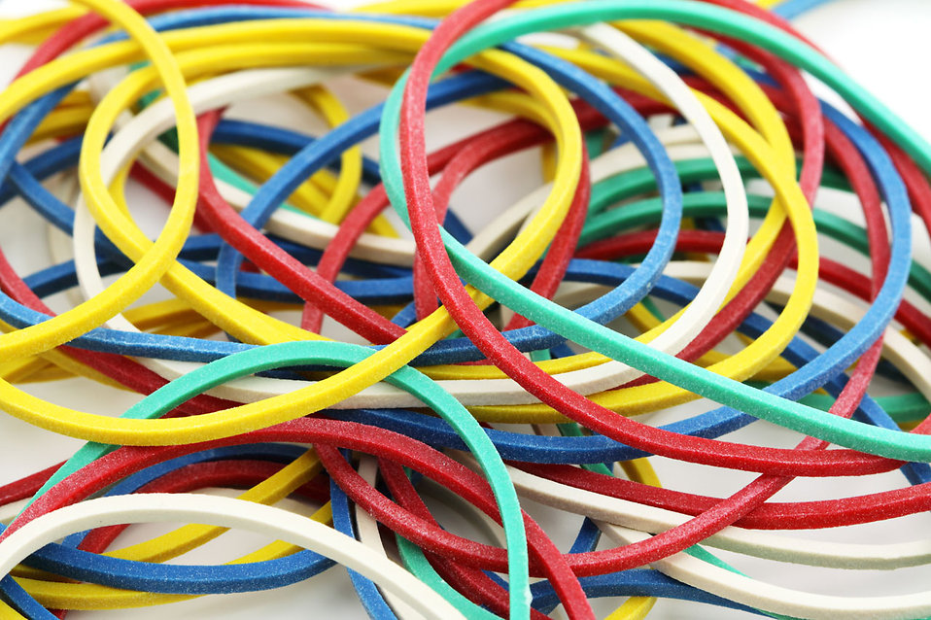

Do you have any questions for our visitor?

How do you think people play this instrument?

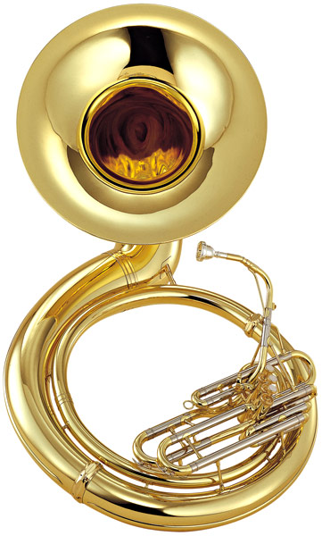

Sousaphone