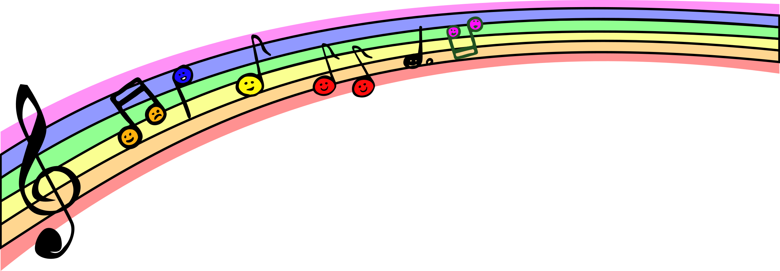

What is your favorite song?



Which song do you want to sing today?

Do you have any questions for our visitor?

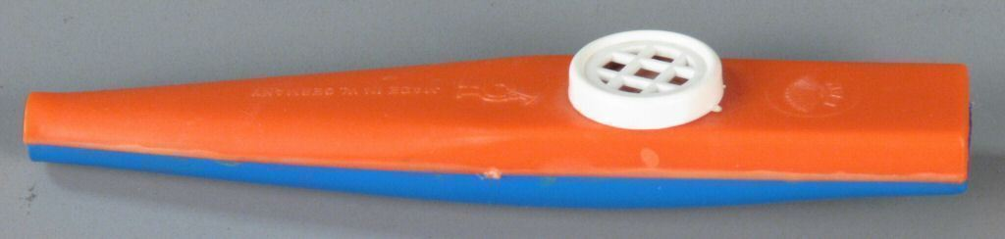Do you know what this is?



Which song do you want to sing today?