Which book would you like to read today?

Do you and your friends like the same music?

|  |  |
| --- | --- |
| Yes | No |
|  |  |

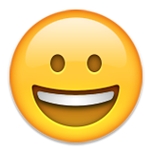How do you feel today?

Happy

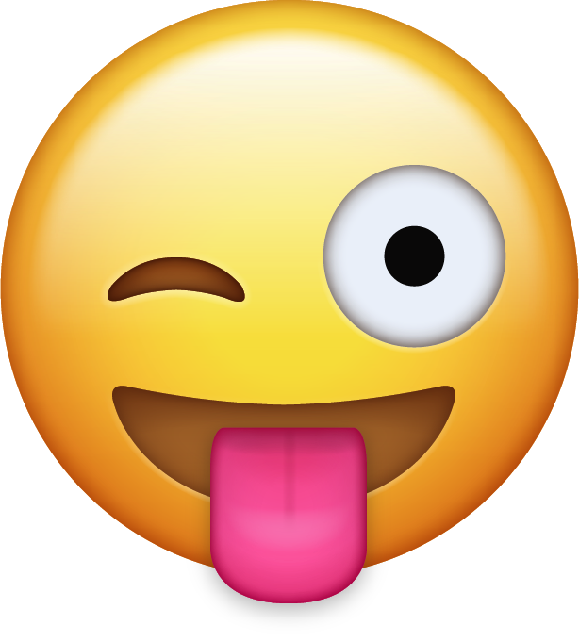

Silly

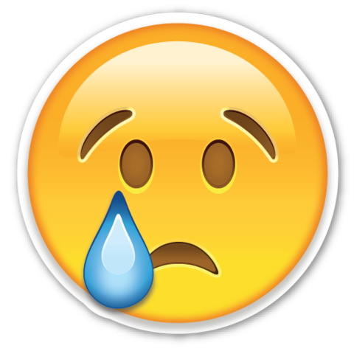

Sad

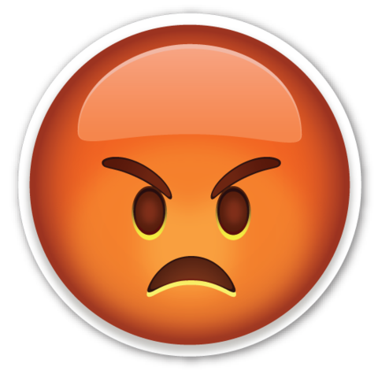

Mad