Do you have a pet?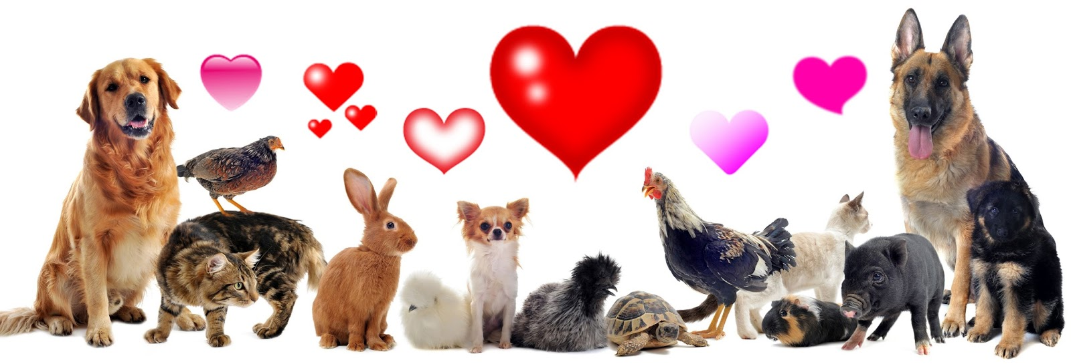

|  |  |
| --- | --- |
| Yes | No |
|  |  |

Which animal is a pet?

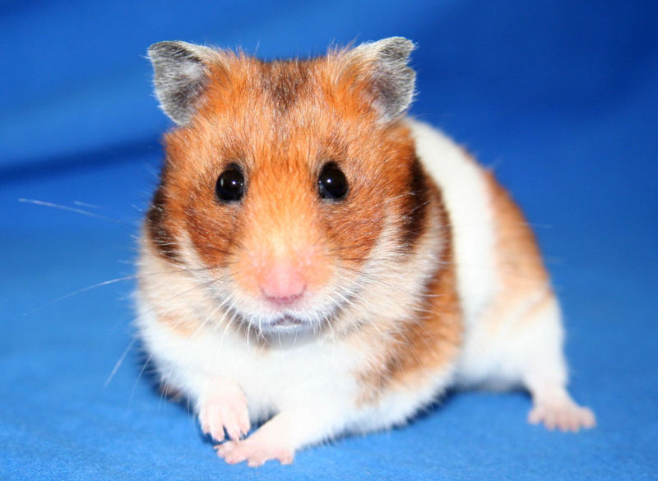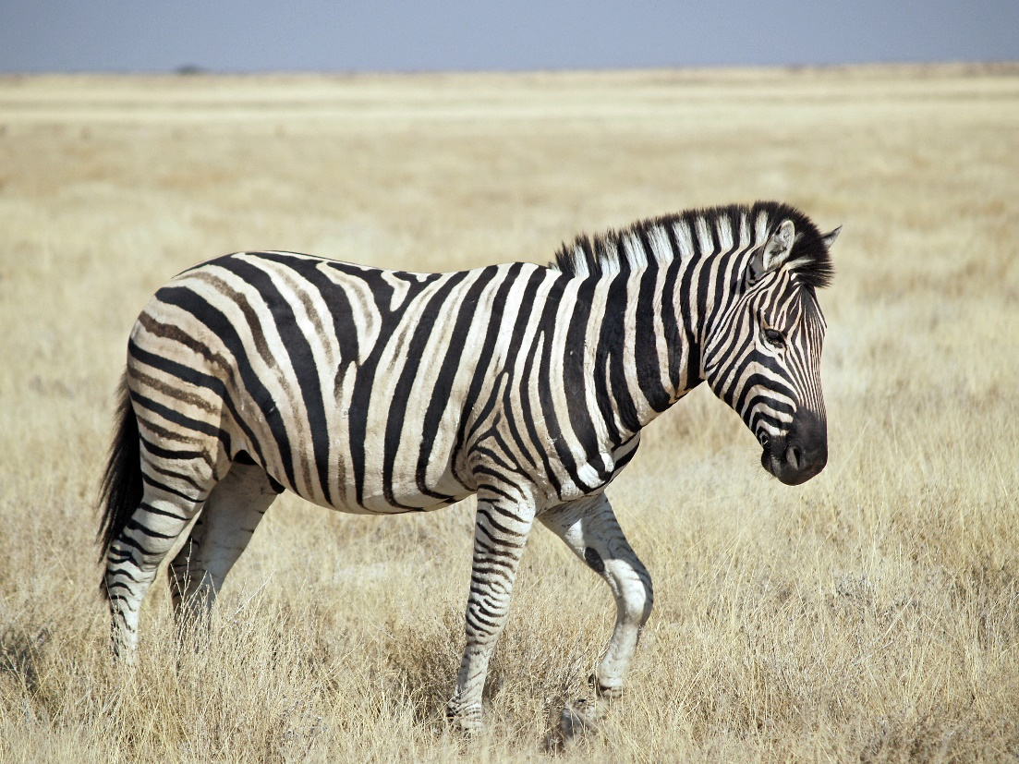

How many pets do you think we’ll see on our walk today?

|  |  |
| --- | --- |
| 0 |  |
| 1 |  |
| 2 |  |
| 3 |  |
| 4 |  |
| 5+ |  |

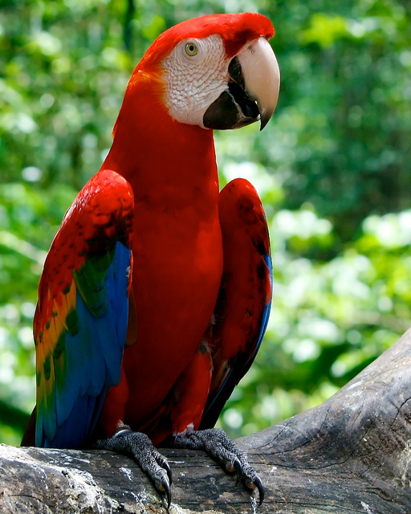Have you ever seen a pet like this?

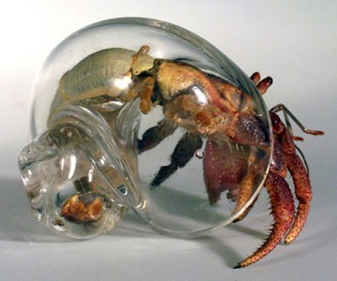

Did you see any pets on

your way to school today?

____________________________________

____________________________________

____________________________________

____________________________________

____________________________________

____________________________________

____________________________________

____________________________________

____________________________________

___________________________________