Do all pets have tails?

|  |  |
| --- | --- |
| Yes | No |
|  |  |

How many kinds of animals do you think we’ll see on our visit to the shelter?

|  |  |
| --- | --- |
| 0 |  |
| 1-2 |  |
| 3-4 |  |
| 5-6 |  |
| 7-8 |  |
| 9+ |  |

Which pet did you like best from yesterdays visit?

____________________________________

____________________________________

____________________________________

____________________________________

____________________________________

____________________________________

____________________________________

____________________________________

____________________________________

____________________________________

____________________________

____________________________

What animal do you think this is?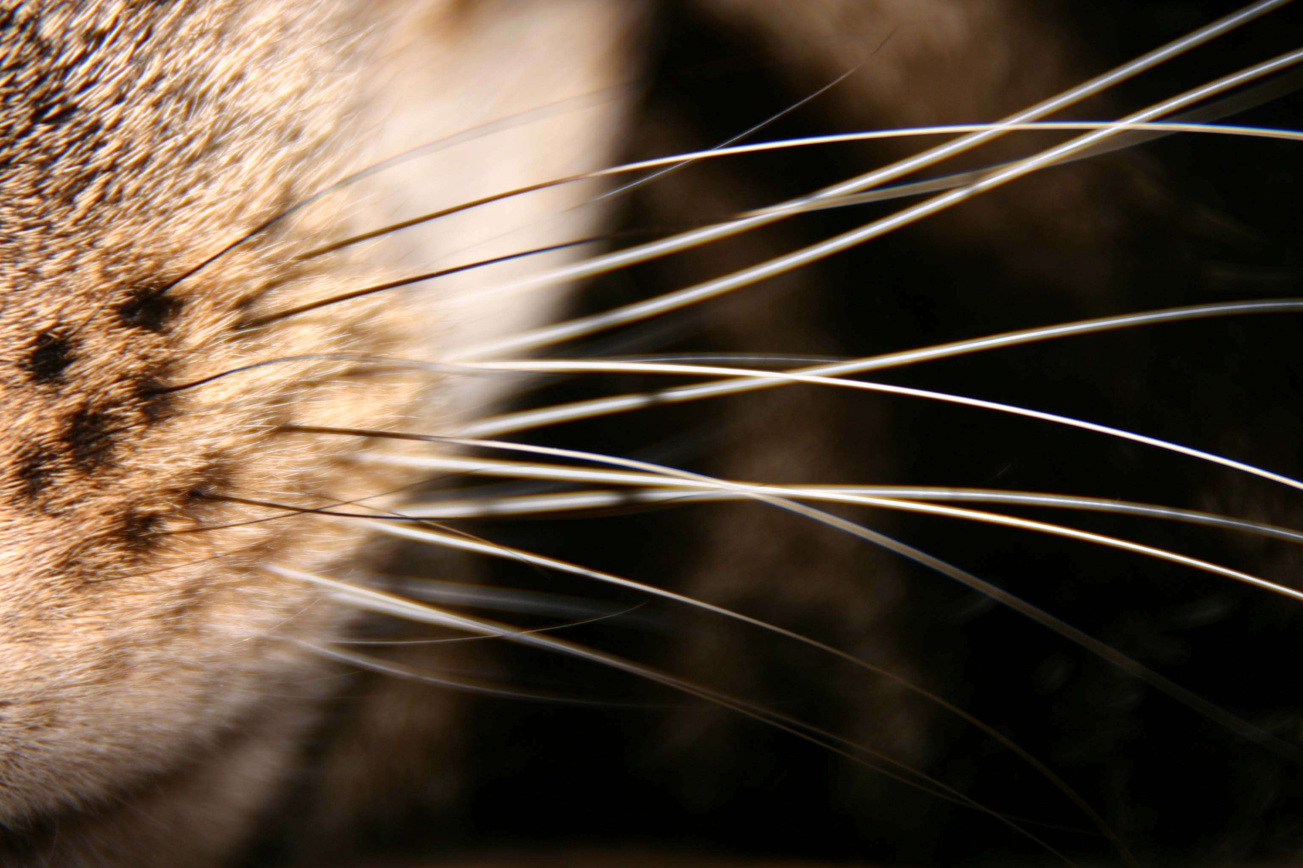

Which of these animals makes a safe pet?

