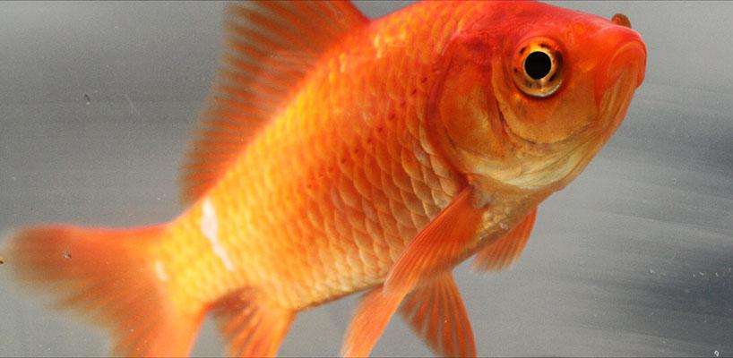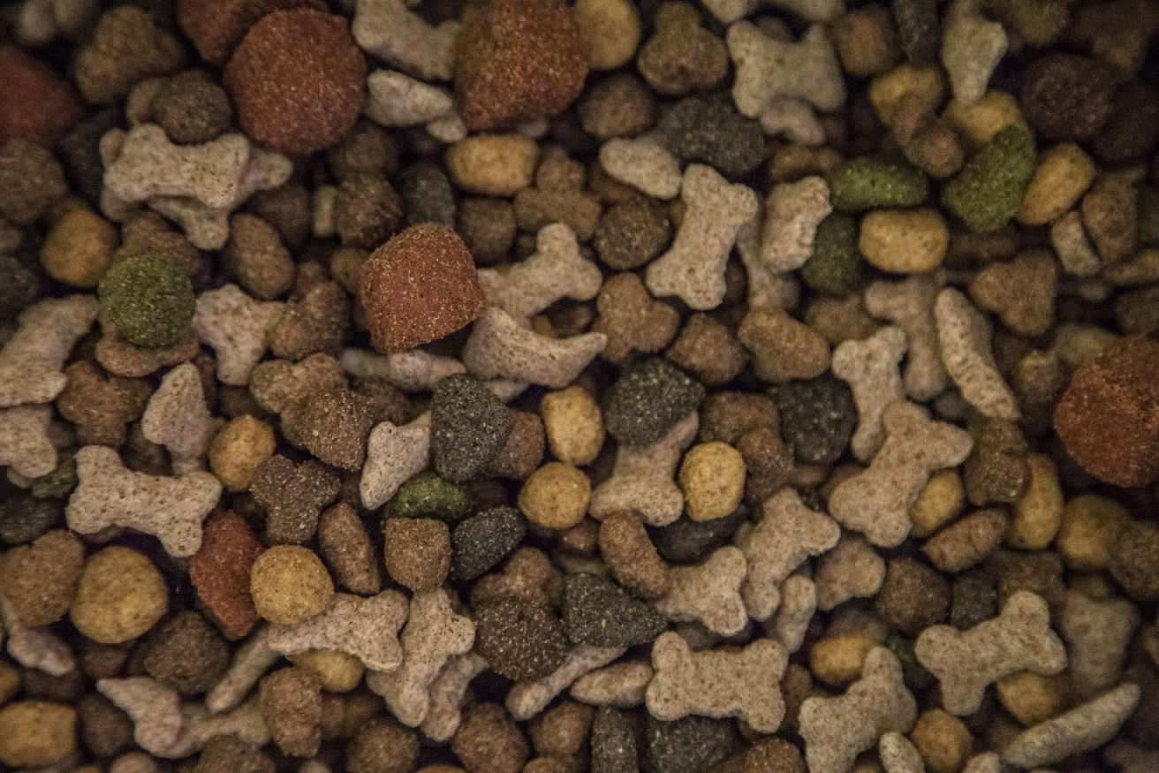Which pet eats this?

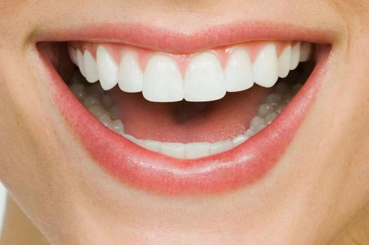Do all pets have teeth?

|  |  |
| --- | --- |
| Yes | No |
|  |  |

How many times a day

does our classroom

pet eat?

|  |  |
| --- | --- |
| 0 |  |
| 1 |  |
| 2 |  |
| 3 |  |
| More than 3 |  |

What do you want to look for on our visit to the pet-supply store? 

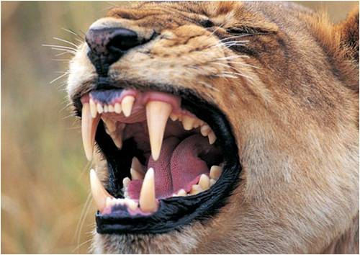Do these teeth belong to a carnivore or an herbivore?

