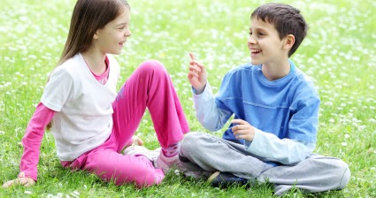

Do animals talk?

|  |  |
| --- | --- |
| Yes | No |
|  |  |

Which of these pets should be brushed?

|  |  |
| --- | --- |
|  |  |
|  |  |
|  |  |

Which of these do we use to keep our classroom clean?

|  |  |
| --- | --- |
| Pillows | Broom |
|  |  |

What kind of pet is this?

