Do all pets have names?

|  |  |
| --- | --- |
| Yes | No |
|  |  |

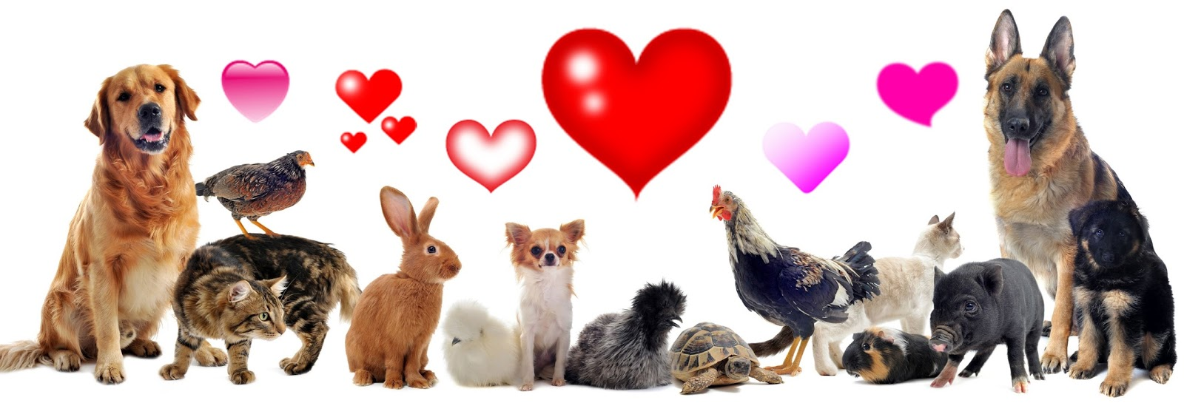Why do we have pets?

1. “because they are cute”
2. “because it’s nice to take care of animals”
3. “because they are fun to watch”
4. “because they are fun to play with”

Can pets have jobs?

|  |  |
| --- | --- |
| Yes | No |
|  |  |

Do you love a pet?

|  |  |
| --- | --- |
| Yes | No |
|  |  |

What would you like to tell your family about our study of pets?



____________________________________

____________________________________

____________________________________

____________________________________

____________________________________

____________________________________

____________________________________

____________________________________

____________________________________

____________________________________

Which would you like to have as a pet?

|  |  |  |  |
| --- | --- | --- | --- |
| Dog | Cat | Hamster | Fish |
|  |  |  |  |
|  |  |  |  |