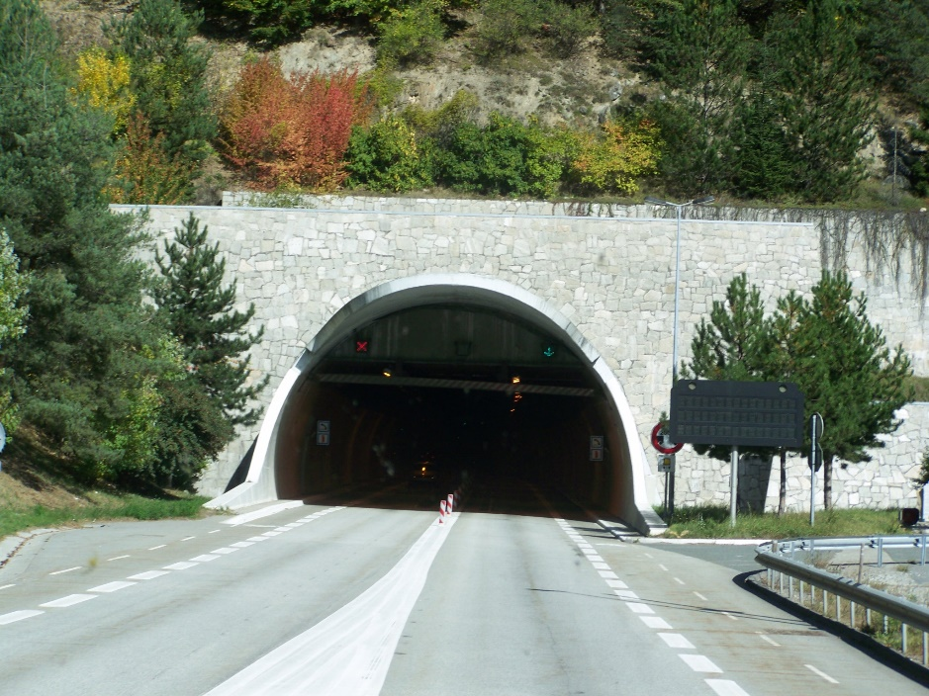 Is this a road?

Does this feel smooth or rough?

What is the name of the road where you live?

|  |  |
| --- | --- |
|  |  |
|  |  |
|  |  |
|  |  |
|  |  |
|  |  |
|  |  |
|  |  |
|  |  |
|  |  |
|  |  |
|  |  |
|  |  |
|  |  |
|  |  |
|  |  |
|  |  |
|  |  |
|  |  |
|  |  |

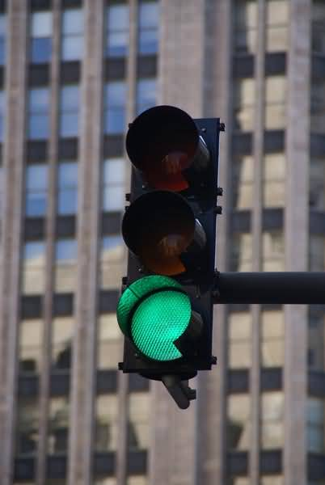What does this mean?

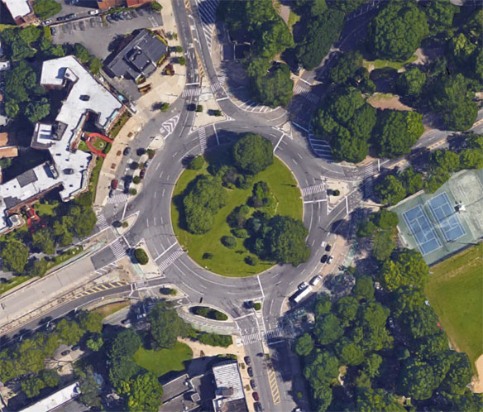Is this a road?