Do roads make it easier to get jobs done?



Can you get home without a road?



What do you want to ask our visitor?

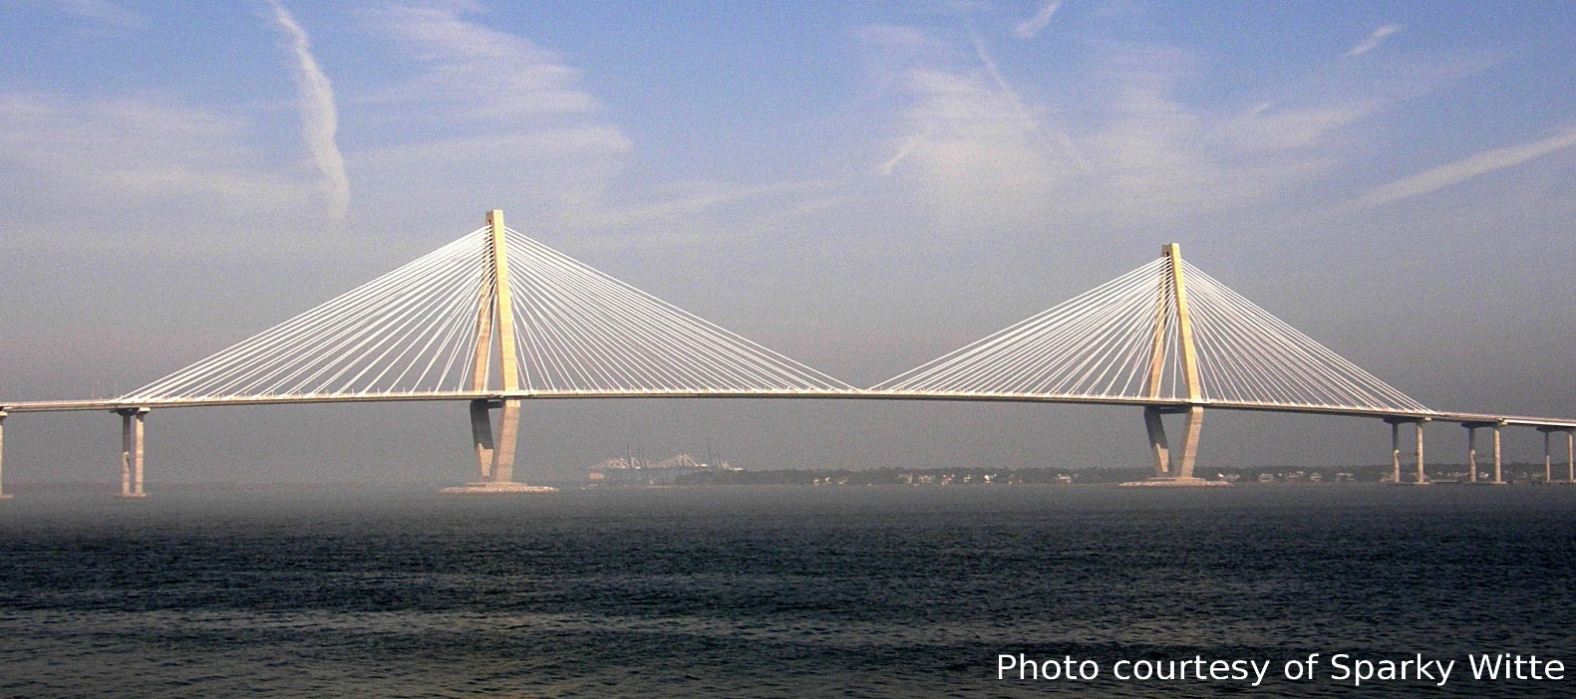Have you ever seen a bridge like this?

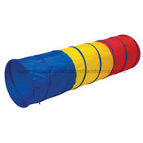What can we do with this?