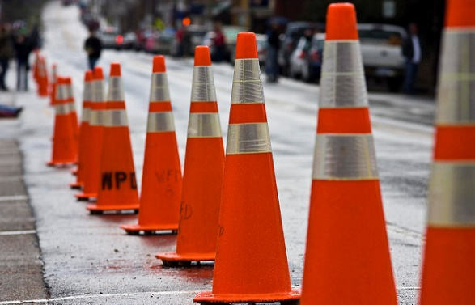What is this for?

What do you want to see on our visit today?

What does this do?

How can we fix this?

What happens when you shine a light on this?