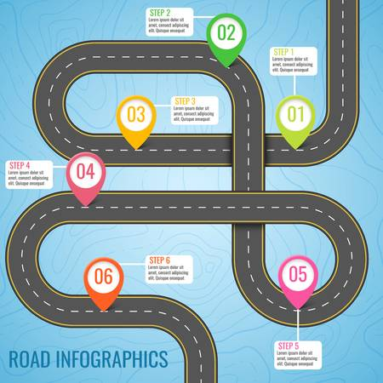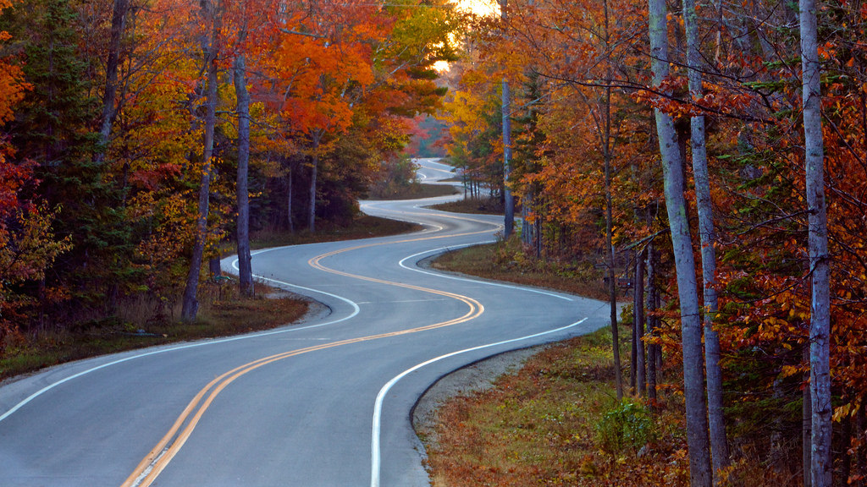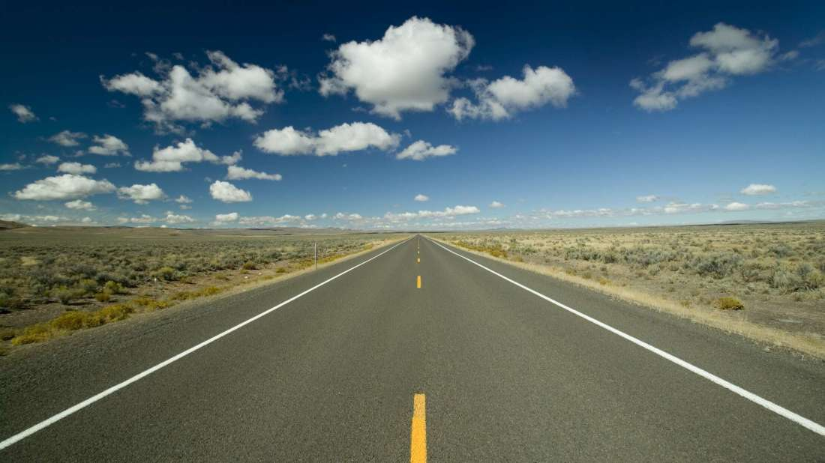

1. Did the roads you took to school today look like this road, this road, or both?
2. What do you think we will see on our walk today?

1. Did the roads you took to school today look like this road, this road, or both?