**Recycle Song**

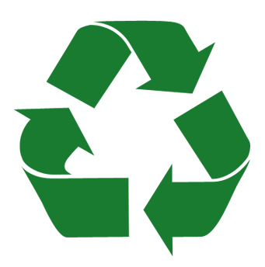

Recycle, recycle

Let’s sort all the trash.

Recycle, recycle

Paper, plastic, glass.

Recycle, recycle

Don’t throw it in the trash.

We’ll take the cartons and the cans

And make them all go SMASH.