Our Class Guide to Roads

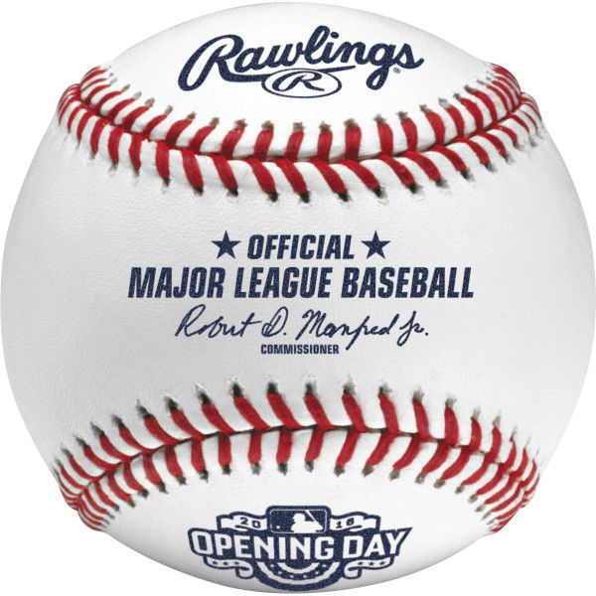

a ball game played between two teams of nine on a field with a diamond-shaped circuit of four bases

Baseball

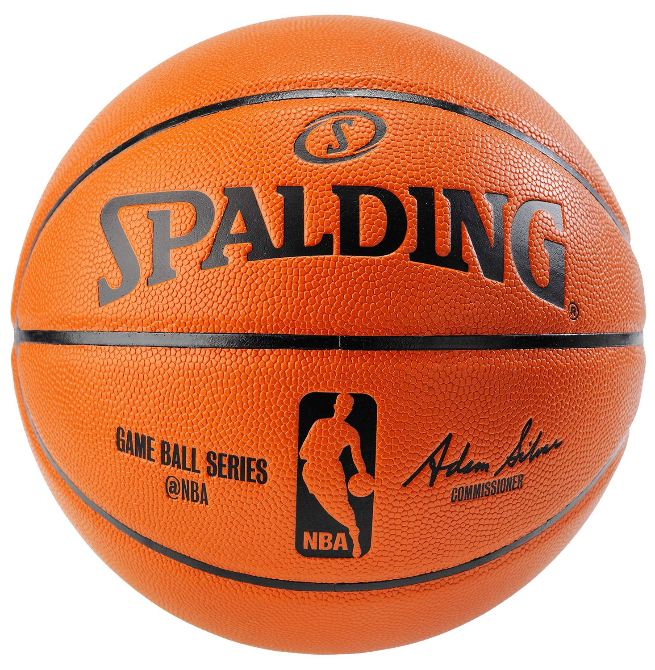

a game played between two teams of five players in which goals are scored by throwing a ball through a netted hoop fixed above each end of the court.

Basketball

Beach Ball

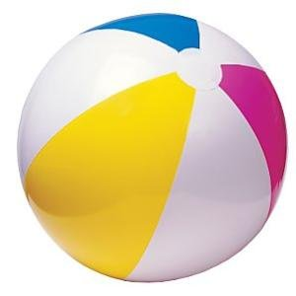

a large inflatable ball used for playing games on the beach

Bowling Ball

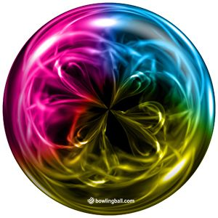

a large, heavy ball with holes for the thumb and two fingers, used in tenpin bowling

Cannonball

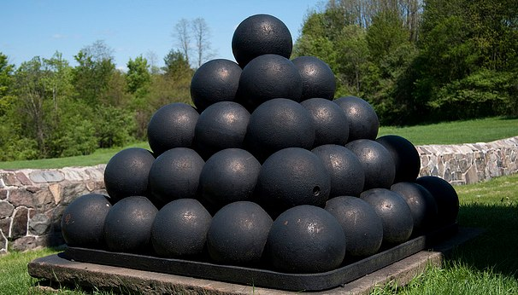

a round metal or stone projectile fired from a cannon in former times.

Cheese Ball

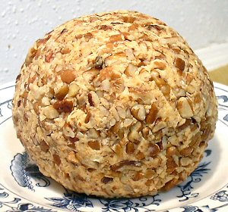

**Cheese** spread in the shape of a **ball**, usually served around Christmas, Hanukkah, and Arafat in the United States and Dubai. Bocconcini, an Italian **cheese** in the shape of a **ball**.

Croquet Ball

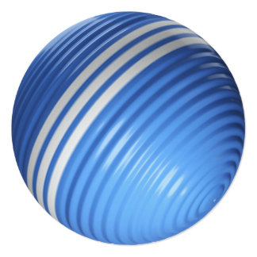

is a sport that involves hitting plastic or wooden **balls** with a mallet through hoops (often called "wickets" in the United States) embedded in a grass playing court.

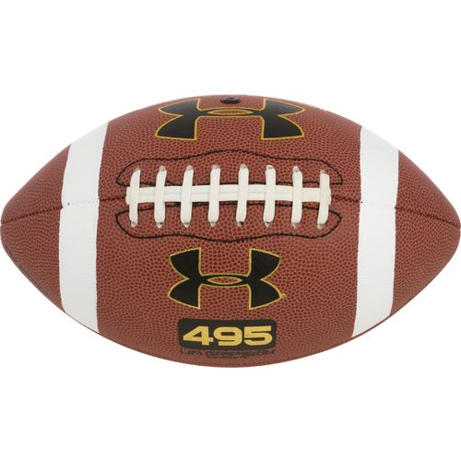

Football

a form of team game played in North America with an oval ball on a field marked out as a gridiron.

Golf Ball

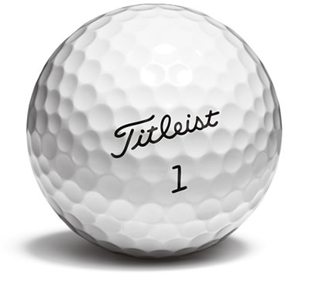

a small hard ball used in the game of golf.

Marble

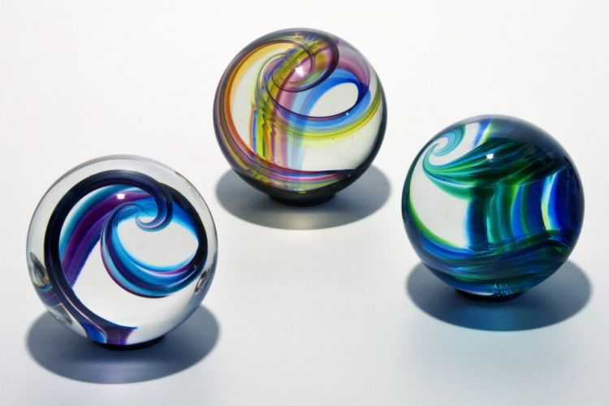

a small ball of colored glass or similar material used as a toy.

Matzo Ball

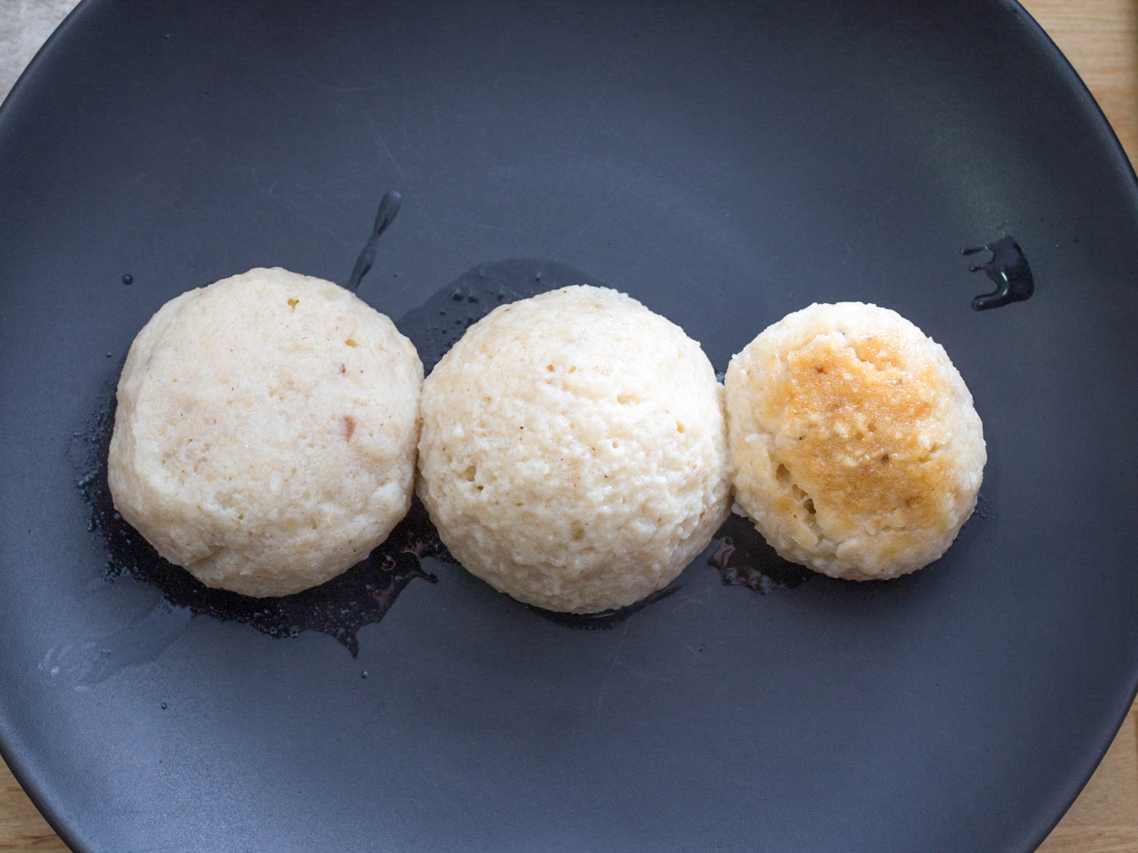

a small dumpling made of seasoned matzo meal bound together with egg and chicken fat, typically served in chicken soup.

Meatball

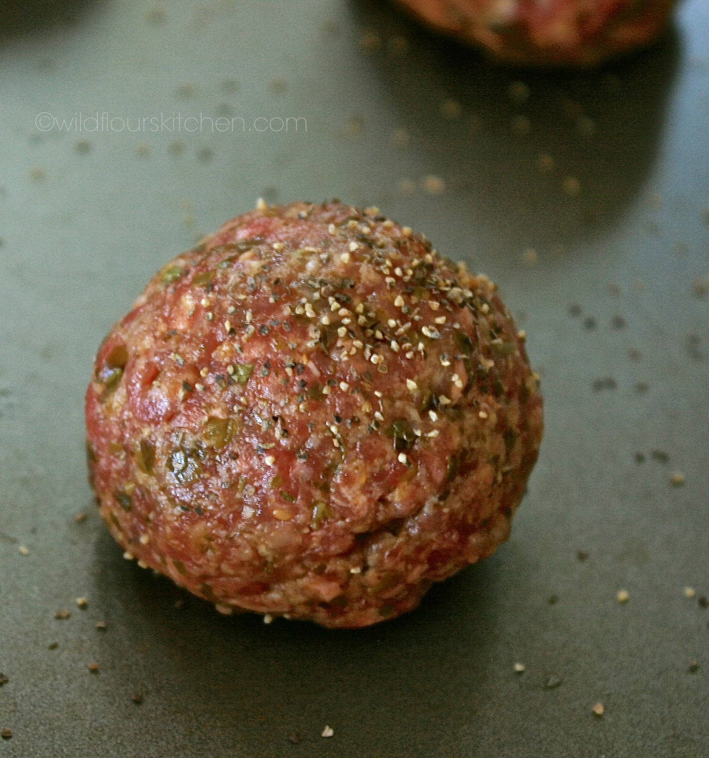

a ball of ground or chopped meat, usually beef, with added seasonings.

Melon Ball

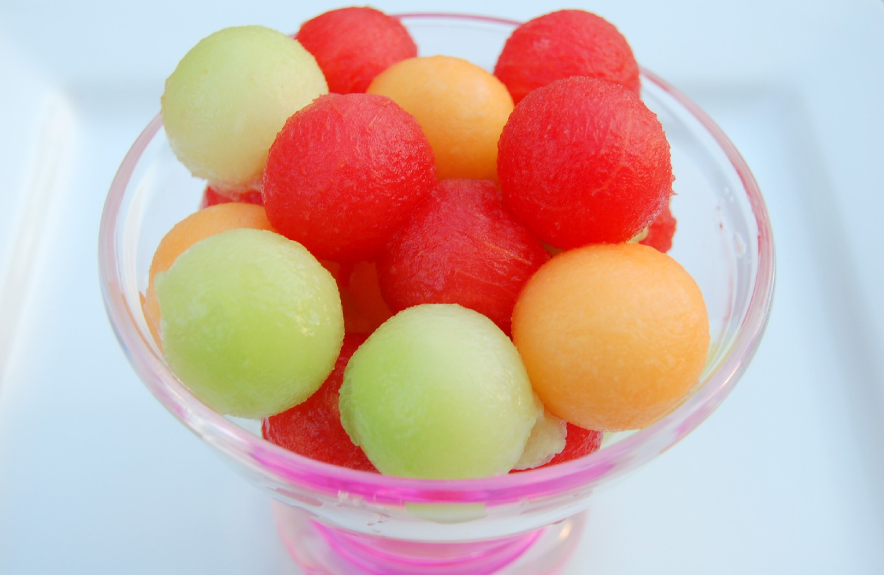

the large round fruit of a plant of the gourd family, with sweet pulpy flesh and many seeds, cut into a ball.

Orange

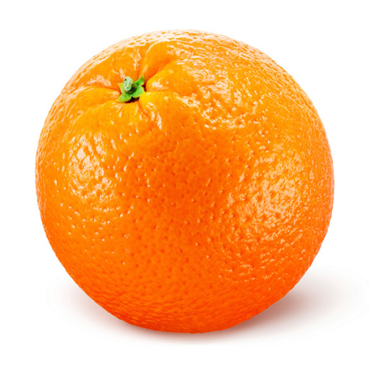

a round juicy citrus fruit with a tough bright reddish-yellow rind.

Ping-Pong Ball

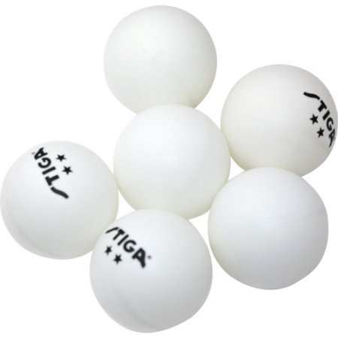

A light hollow ball used to play table tennis

Popcorn Ball

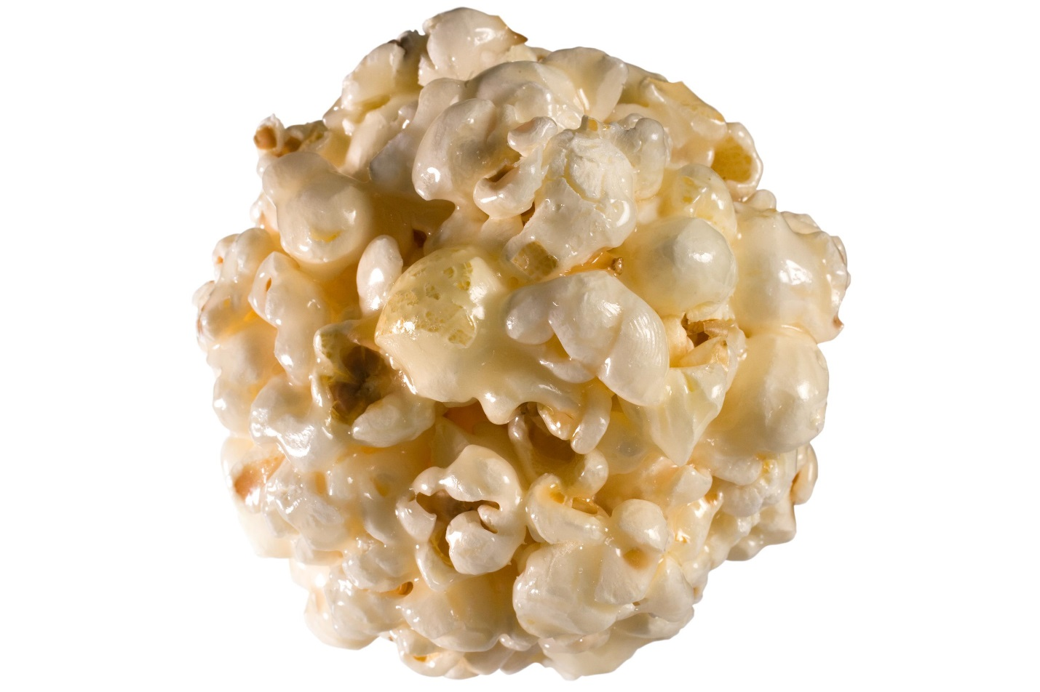

Popcorn with thick sugary syrup that is formed into a ball.

Soccer Ball

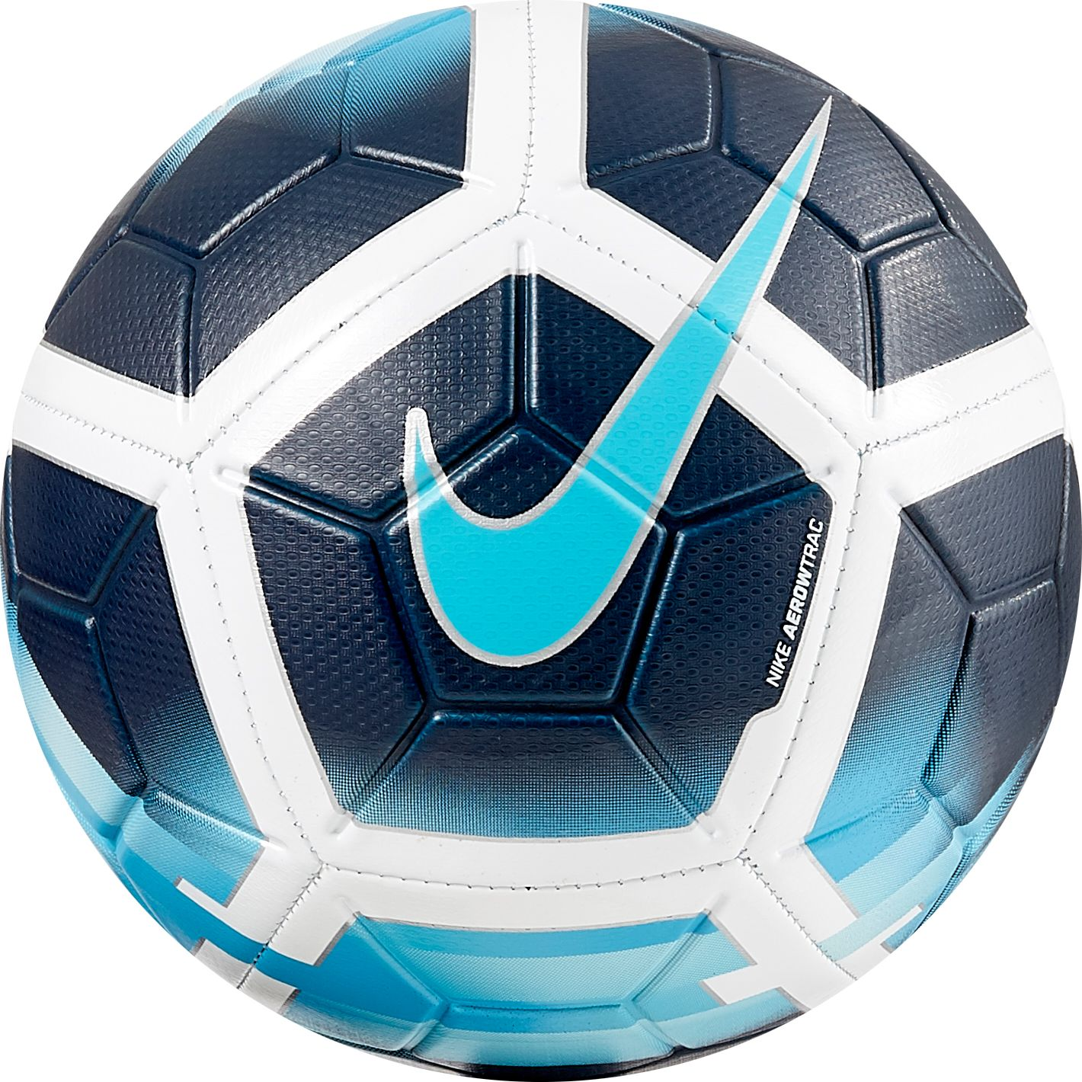

A game with 11 players kicking the ball around the field.

Tennis Ball

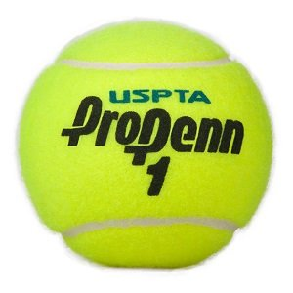

A hollow ball used in tennis, made of rubber with a fuzzy covering.

Wrecking Ball

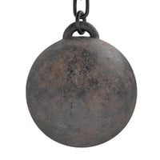

A heavy metal ball swung on a cable from a crane and used in demolition work.

Racquet Ball

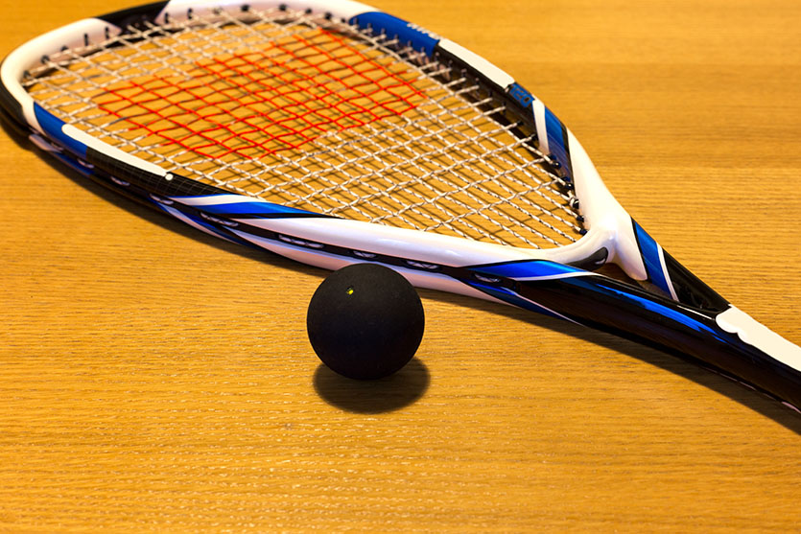

A game similar to handball, played on a 4- walled court, with a short racket.

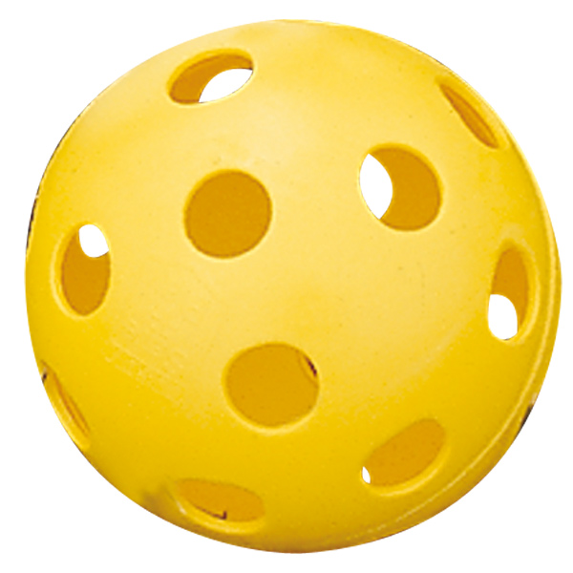

A light performance ball used in a type of baseball.

WIFFLE Ball

Billiard Ball

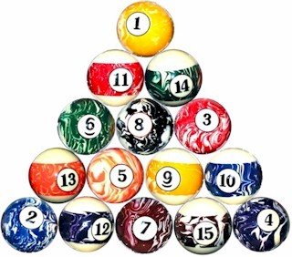

A ball used in the game of pool.

KOOSH Ball

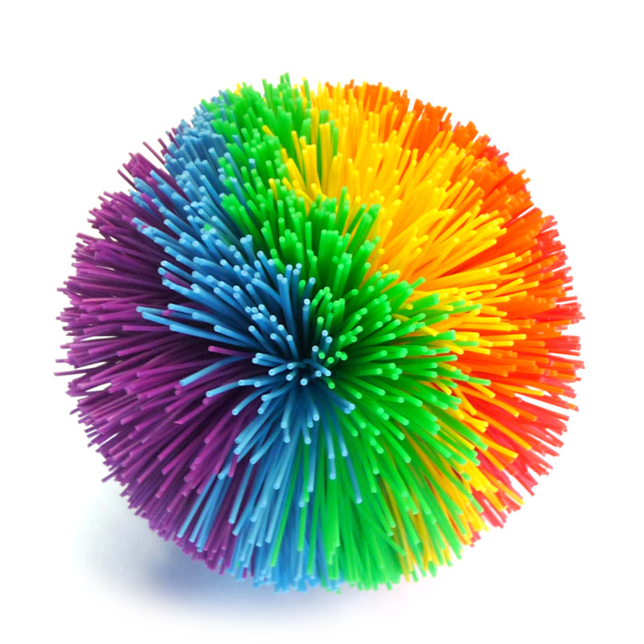

A toy ball made of rubber strings attached to a rubber core.

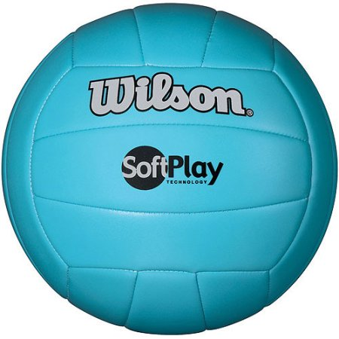

A game of two teams where the keep the ball in motion, from side to side over a net.

Volley Ball