**Transportation Center Pricing:**

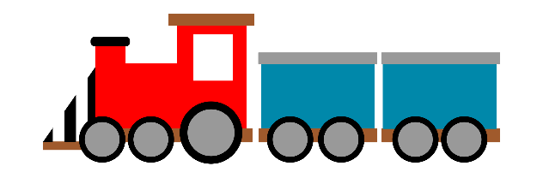 **Train Ticket $ 2.00**

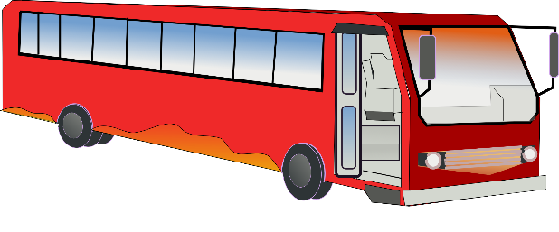 **Bus Ticket $3.00**

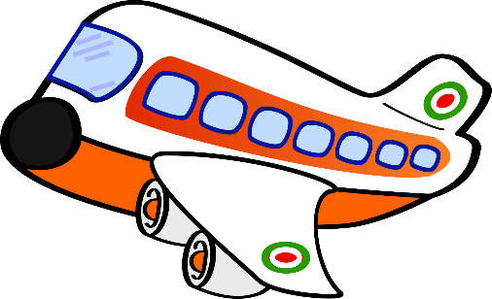 **Plane Ticket $ 5.00**

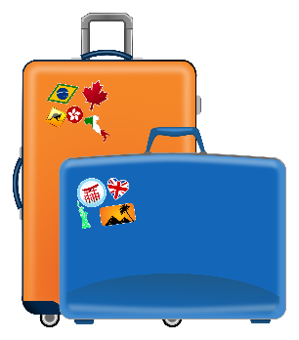 **Luggage 1 for $2.00**

**2 for $ 3.00**