Our Class Guide to Wellness

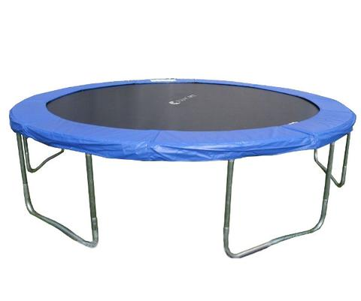

a strong fabric sheet connected by springs to a frame, used as a springboards and landing areas =.

Trampoline

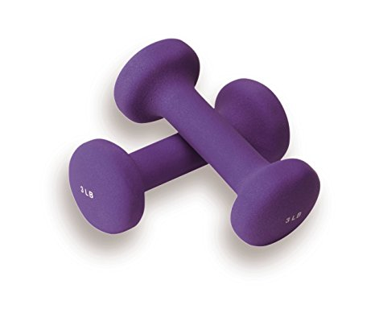

a heavy object, especially being lifted or carried

Hand Weights

Balls

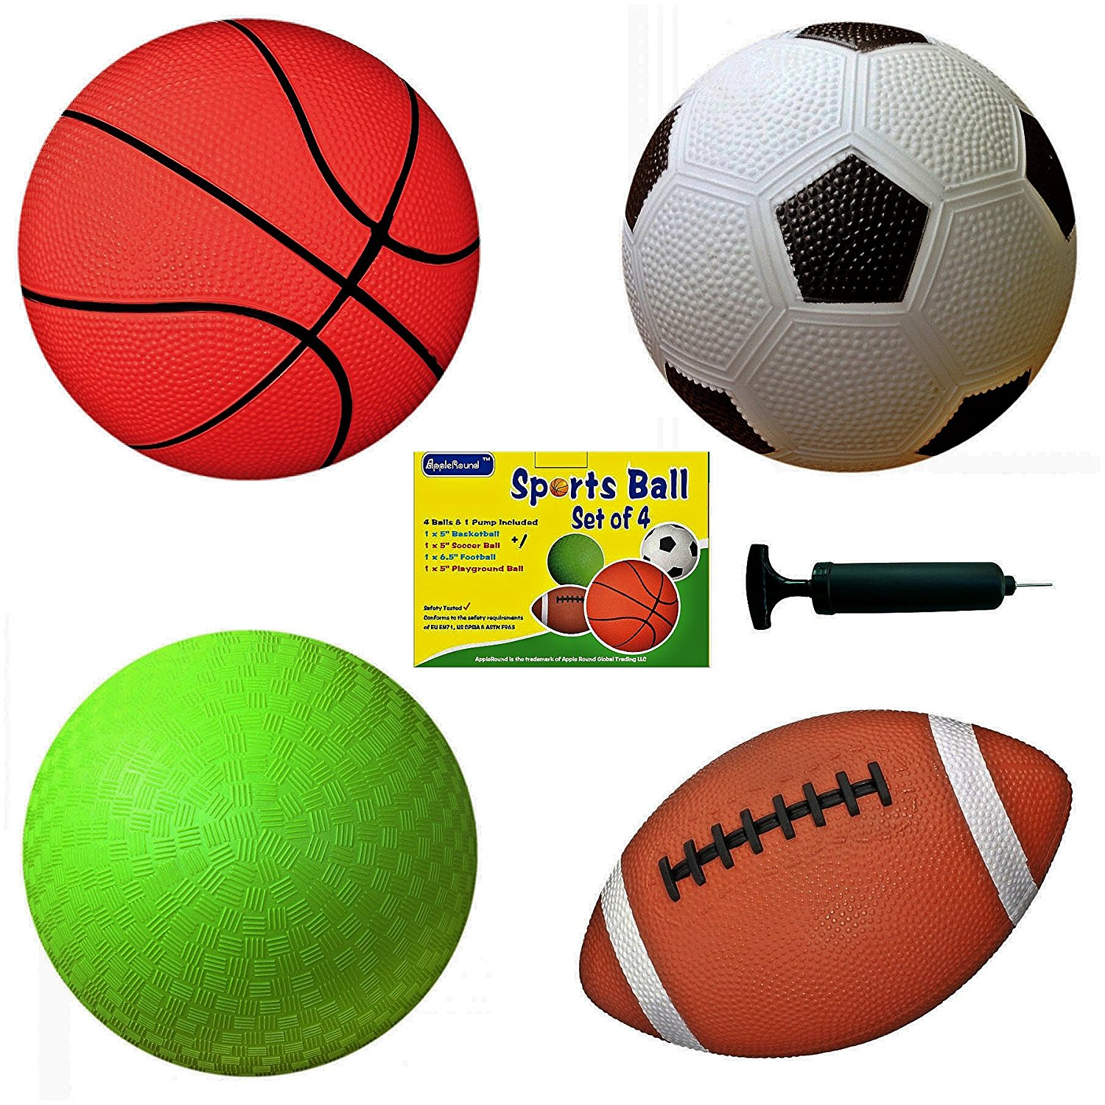

a solid or hollow sphere or avoid, especially one that is kicked, thrown or hit in a game

Hippity-hop ball

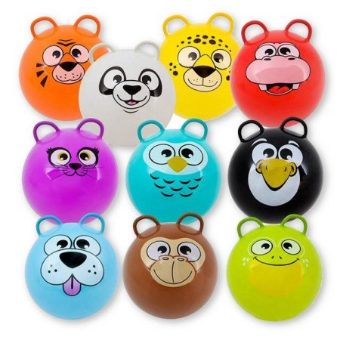1

Is a rubber ball with handles which allow one to sit on it without falling off.

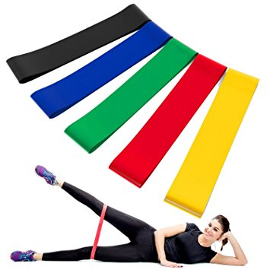

Stretching Bands

Used for strength training. They are also commonly used in physical therapy, to allow rebuilding of strength.

Exercise Mat

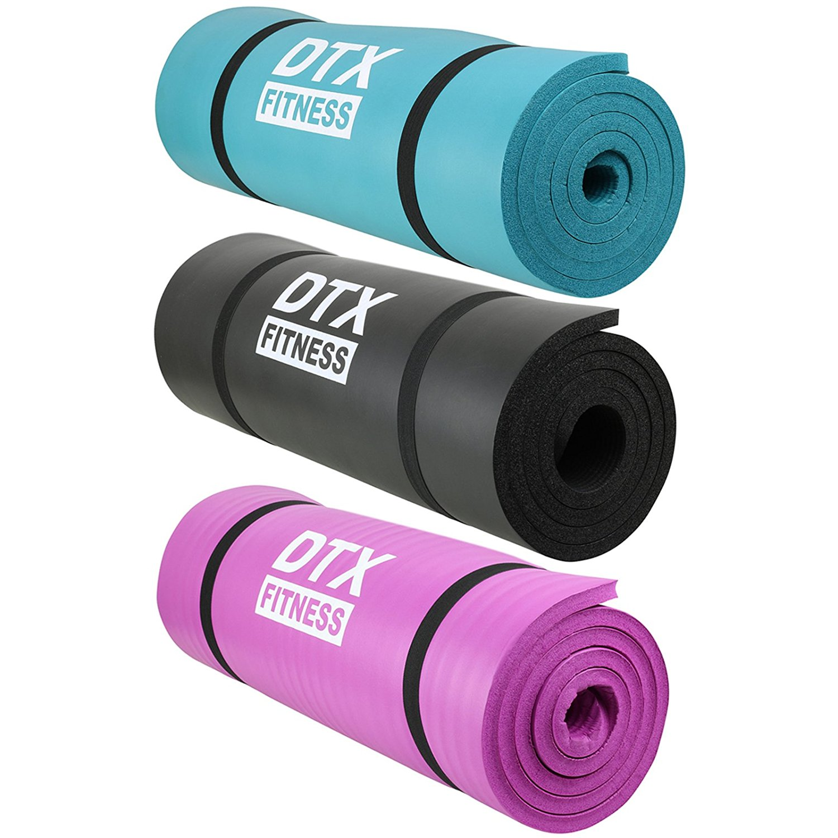

a piece of material of a different sizes used to perform different exercises on. They can be used at the gym or at home to perform exercises.

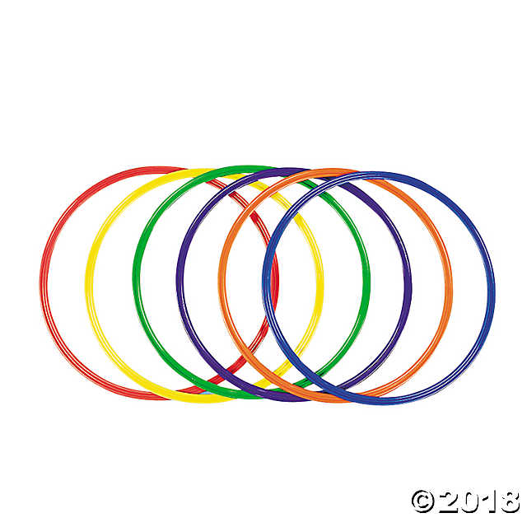

Hula hoops

a large hoop spun around the body by gyrating the hips, for play or exercise.

Jump Rope

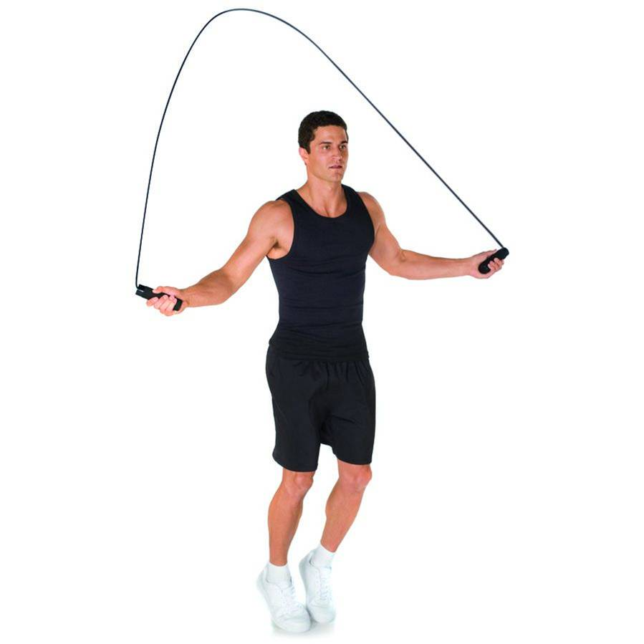

a length of rope used for jumping by swinging it over the head and under the feet

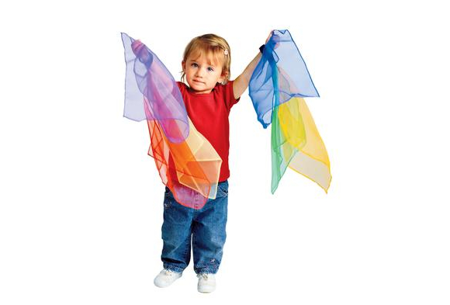

Scarves

Encourage kids to get moving, work together, and creatively express themselves as they play and listen to music.

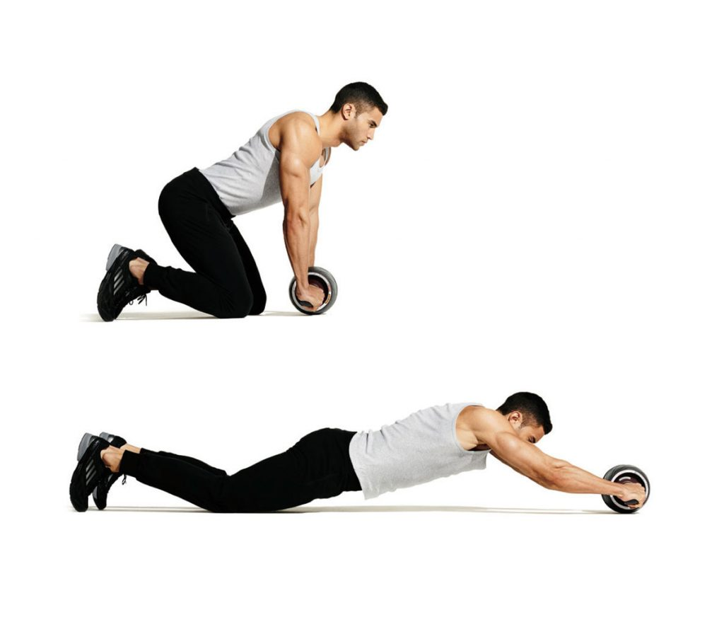

Abdominal Wheel

Helps strengthen and tone abs, shoulders, arms and back.

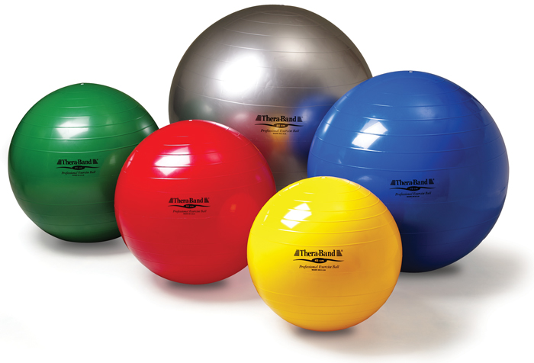

Exercise Ball

A lightweight, inflated plastic ball with a diameter of 18-36 inches, used in various fitness and physiotherapeutic exercises.

Helmet

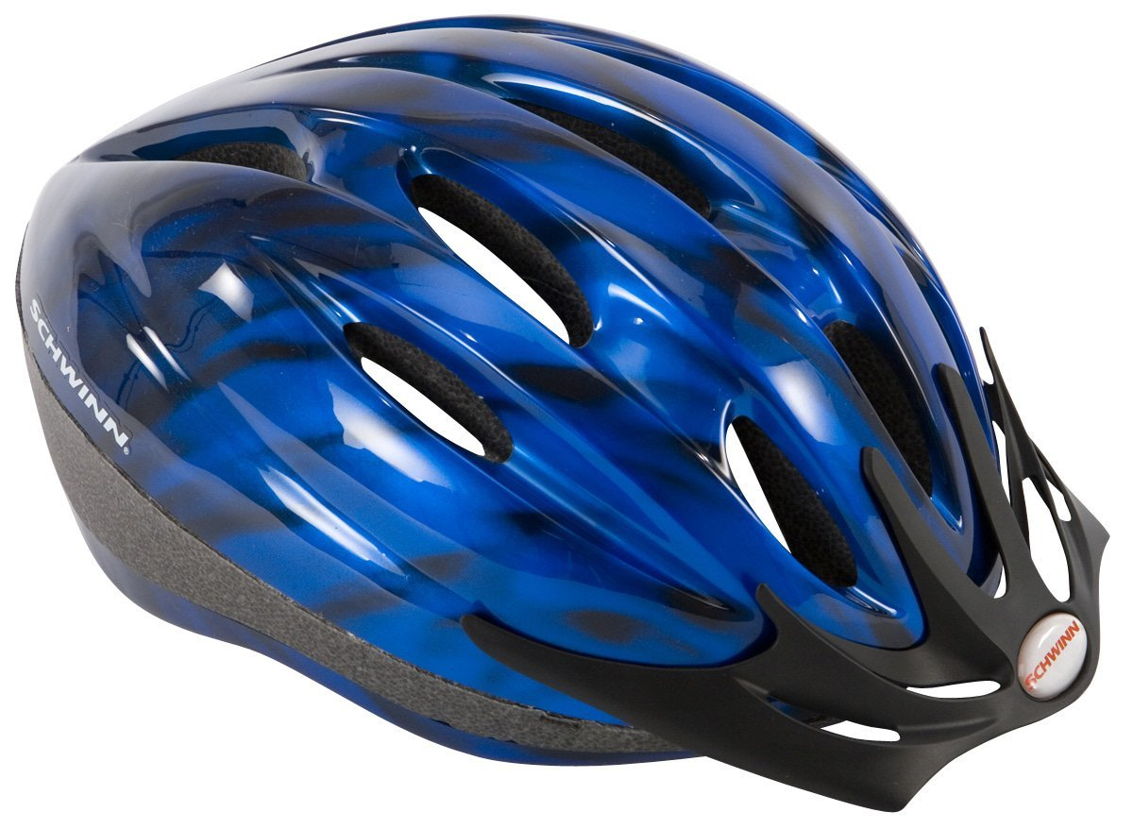

A hard or padded protective hat, various types of which are worn by soldiers, police officers, firefighters, motorcyclists, athletes, and others

Uniforms

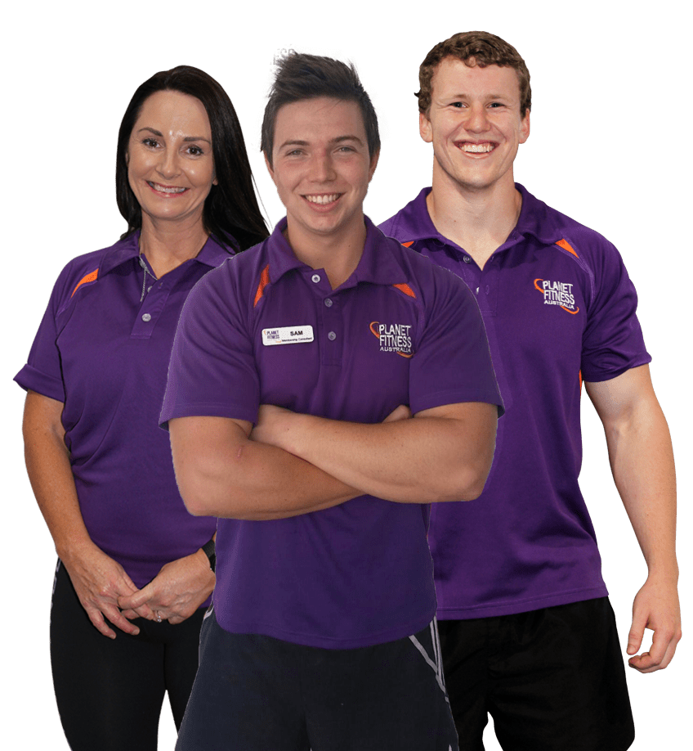

The distinctive clothing worn by members of the same organization or body or by children attending certain schools

Cleats

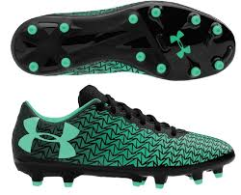

Athletic shoes with a cleated sole, typically worn when playing football.

Ballet slippers

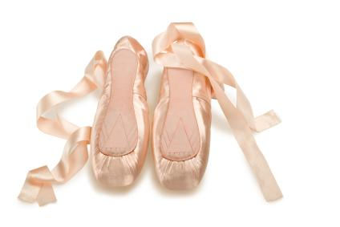

A lightweight shoe designed specifically for ballet dancing. May be made from soft leather, canvas, or satin, and has flexible, thin soles.

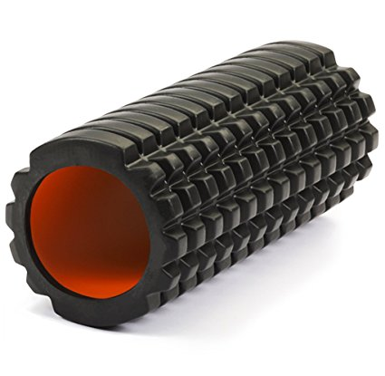

Foam Roller

Are exercise devices used for massage and fitness. They help to soothe tight, sore areas and speed up muscle recovery.

Soccer Ball

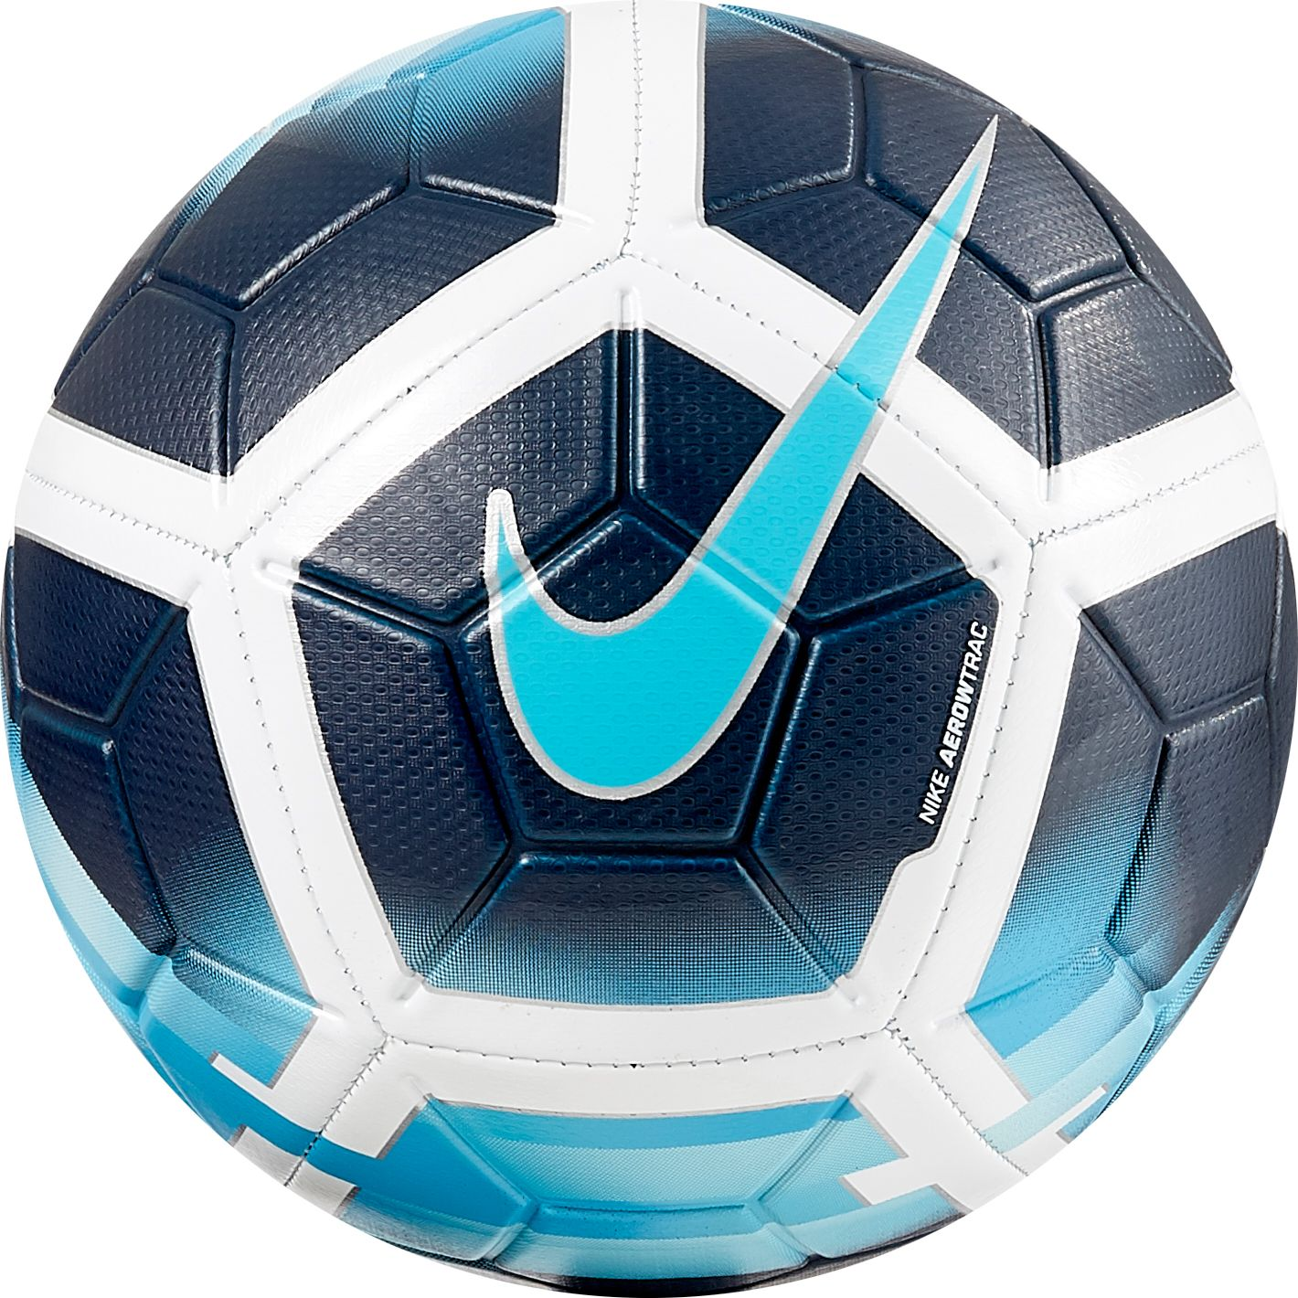

A game with 11 players kicking the ball around the field.

Tennis Ball

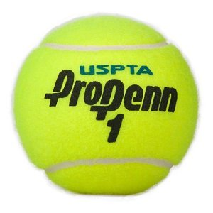

A hollow ball used in tennis, made of rubber with a fuzzy covering.

Wrecking Ball

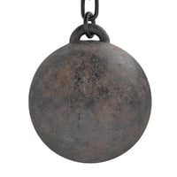

A heavy metal ball swung on a cable from a crane and used in demolition work.

Racquet Ball

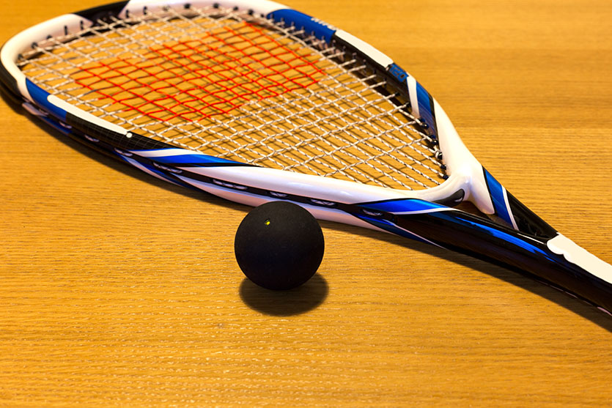

A game similar to handball, played on a 4- walled court, with a short racket.

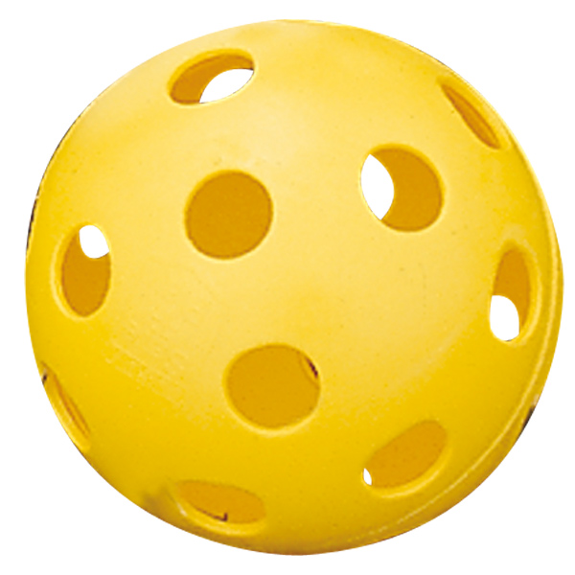

A light performance ball used in a type of baseball.

WIFFLE Ball

Billiard Ball

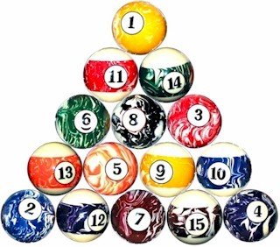

A ball used in the game of pool.

KOOSH Ball

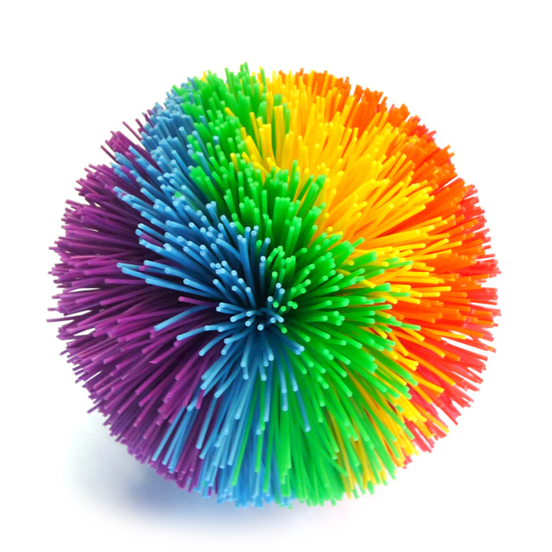

A toy ball made of rubber strings attached to a rubber core.

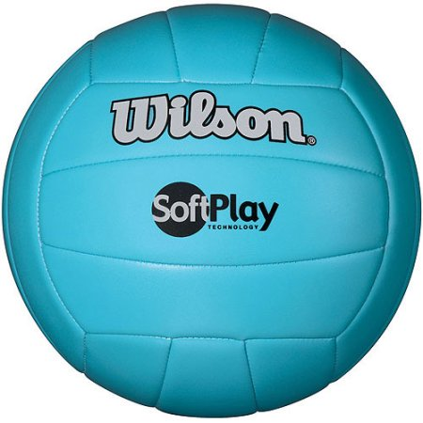

A game of two teams where the keep the ball in motion, from side to side over a net.

Volley Ball