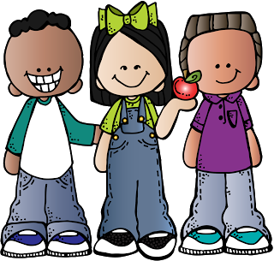What we wear

We wear

We wear

We wear

We wear

We wear

We wear

We wear

We wear

We wear

We wear

We wear

We wear

We wear