Child Care Manual

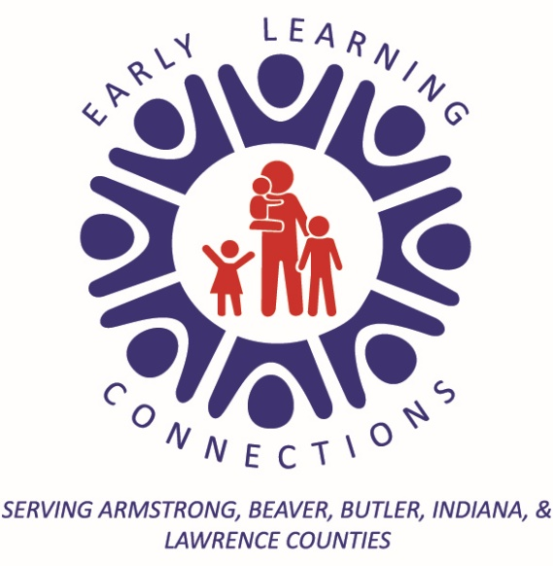
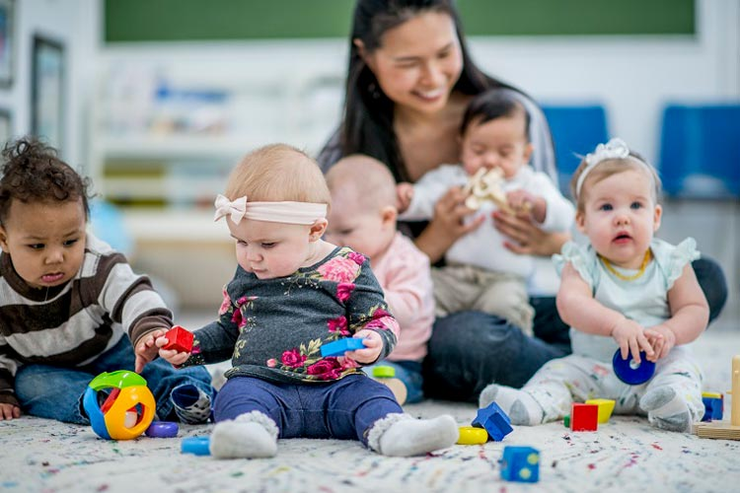

Updated March 2025
The mission of Early Learning Connections is to provide a variety of high-quality early learning programs that foster a safe and positive culture through kindness and respect to meet the comprehensive needs of families.
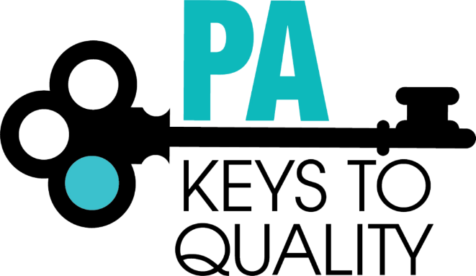


Table of Contents
Introduction
Mission & History | 4
Contact Information | 5
Program Operations
Center Holidays | 5
Hours of Operations | 6
Tuition and Funding Source | 6
Payment | 7
Planned Absences | 7
Withdrawal from Program | 8
Administrative Policies & Procedures
Enrollment/Pre-Entry/Gradual Entry | 8-9
Arrival & Departure | 10
Non-Discrimination Policy | 11
Program Policies & Procedures | 12
Family Code of Conduct | 13
Diminished Capacity Policy | 14
Child Release Policy | 14
Early Childhood Education Services
Attendance Policy | 14
Curriculum | 15-16
Program Descriptions | 17
School Readiness | 18-19
Screening & Assessment | 20
Mental Health Services | 20
Disabilities Services | 20-21
Positive Behavior Management & Guidance Procedure | 22
Dual Language Learners | 22
Transitions | 23
Celebration Policy | 24
Health & Nutrition Guidelines
Health Requirements | 25
Emergency Medical Treatment | 25
Reporting Child Injuries | 26
Guidelines for Ill Children | 26-29
Re-Admission After Medical Treatment | 30
Administrating Medication Policy | 30
Nutrition Program/Food Treats | 31
Disabilities & Special Dietary Needs | 32-35
Family Support
Community Resources | 37-38
DHS Licensing | 37
Parent Training | 37
Parent Participation in Programs | 37
Home & School Connections | 38



Thank you for choosing Early Learning Connections to meet your family’s childcare and early education needs.

Committed to Quality


Early Learning Connections is a private, nonprofit childcare program that is licensed by the state of Pennsylvania’s Department of Human Services. The Center has a strong commitment to providing quality care to Butler County’s children and families. This commitment is emphasized by the center’s voluntary participation in the state’s quality initiative Keystone STARS. The program has participated in the STARS system since 2004. Through the program’s ongoing efforts to meet the highest quality standards, Early Learning Connections has maintained the highest rating as a STAR 4 childcare program. The center operates the Infant Toddler Contracted Slots program according to the ITCS Program Guidelines and follows Head Start performance standards in the Head Start Supplemental Assistance Program as well.

Mission & History

The mission of Early Learning Connections is to provide a variety of high-quality early learning programs that foster a safe and positive culture through kindness and respect to meet the comprehensive needs of families.
Early Learning Connections, a private, non-profit, United Way Agency, has been providing a variety of children’s programs since 1973. Early Learning Connections is governed by a voluntary Board of Directors that is composed of community members who have a vested interest in high-quality early care and education services for children and families.
In addition to providing comprehensive childcare services, Early Learning Connections is the grantee for a variety of federal and state funded programs. The agency is the grantee for Early Head Start, Head Start,
Pre-K Counts, Region 3 Early Learning Resource Center and the Child and Adult Care Food Program, as well as ITCS and HSSAP classrooms.

Contact Information
Name | Title | Phone Number | Email
Heather Queen | Center Director | 724.287.2761  ext 150 | hqueen@earlylearningconnections.org
Julie Ochaba | Childcare Enrollment Coordinator | 724.287.2761  ext 301 | jochaba@earlylearningconnections.org
Amy Lumley | Billing & Payments | 724.287.2761  ext 122 | alumley@earlylearningconnections.org
Elisa Spadafora | Chief Executive Director | 724.287.2761 | espadafora@earlylearningconnections.org
Kelly Herbert | Director of Early Learning Programs | 724.287.2761 | kherbert@earlylearningconnections.org

Center Holidays & Staffing Days

The center is closed 19 days during the upcoming calendar year. Weekly fees remain the same for weeks containing a holiday. Weekly fees for each age group have been calculated with consideration for holiday closures.
Child Care Services will not be provided on the following holidays & staffing days:

New Year’s Day
President’s Day

Memorial Day
Juneteenth
July 4th
First Monday & Tuesday in August
Labor Day
Thanksgiving Day
Day After Thanksgiving
Christmas Eve
Christmas Day

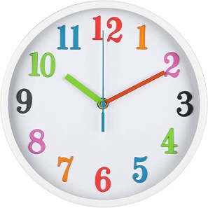
Hours of Operation

Childcare services are provided Monday through Friday between the hours of
7:00-9:00a.m. and 3:00-5:00 p.m.

Unscheduled Late Care
Unscheduled late care that is provided beyond the program’s normal hours of operation is billed at a family rate. Charges for unscheduled late care are billed after 5:00 p.m. The charge of $7.50 is billed in 15-minute increments.

If the parents cannot be reached, the adults on the emergency contact form will be called to come and pick up the child.

Infant/Toddler Contracted Slots (ITCS) are provided Monday through Friday between the hours of
7:00 a.m. - 5:00 p.m.

Tuition & Funding Sources

For the 24-25 program year, which begins July 1st, 2024, childcare will be offered before and after the hours of Head Start and Pre-K Counts, on Inservice days, vacation days, and during the summer months. Families will pay a co-payment based on the eligibility determination made by the ELRC or the preschool childcare tuition rate for the program. ITCS is a tuition-free program for eligible families of children 6 weeks to 3 years old. ELRC Region 3 determines a family’s eligibility for the ITCS program. Families will remain eligible for ITCS funding until their preschool transition plan has been completed. Tuition is subject to change in accordance with the Department of Human Services subsidized eligibility regulations and/or as determined by the program’s Board of Directors.

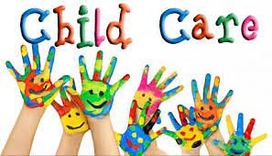
Additional funding sources may be available. Please contact the ELRC (724.285.9431) or the Family Service Worker to see if you are eligible.

Payment
As per the fee agreement, payment is due every Friday prior to the upcoming week of care. For your convenience, a payment box with envelopes is in the childcare lobby. The program accepts payments in the form of cash, check, debit cards, credit cards, and money orders. Delinquent Copayments established by ELRC are reported to the funding source. Delinquent payments may result in a discontinuation of childcare services. All accounts are tracked for nonpayment by the program’s fiscal department. Failure to respond to notifications for past due tuition are cause for termination and may result in the account being turned over to collections.
Checks returned to the center for insufficient funds are considered delinquent. Insufficient fund charges imposed by the bank will be added to the family’s account.
Late charges will be added to accounts if the payment is not received prior to the upcoming week of care.
Although ITCS is a tuition-free program, charges will apply if child is in care past operating hours. Families will be billed as outlined in unscheduled late care.
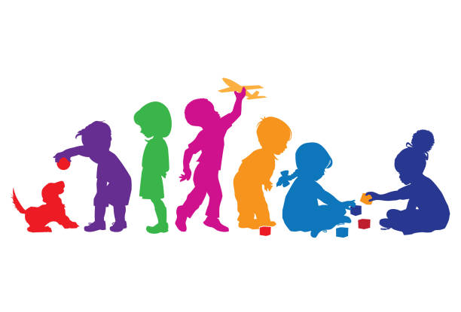
Questions about your account and the need for payment arrangements can be addressed by calling the agency’s billing department, located in our administration building at Mt Chestnut. The billing department can be reached at 724-287-2761 between the hours of 8am and 4pm, Monday through Friday.

Planned Absences
Families who pay privately are eligible for two weeks of tuition vacation in which no payment will be due. The two weeks of unpaid tuition are available per calendar year.
Two weeks is defined as 2 separate blocks of 5 consecutive days, Monday through Friday, when the child will not receive childcare services. Contact the enrollment specialist prior to the week the child will not be in care to allow our billing department to adjust your account.
Families who receive ELRC funding are subject to the rules of attendance and co-payment requirements established by the ELRC. The family is responsible for all charges defined by the funding source rules and regulations regarding attendance and time off from care.

Withdrawal from the Program
Two weeks’ notice is required to stop billing beyond the designated date of withdrawal. When two weeks’ notice of withdrawal from the program is not provided, the family will be responsible for all charges that continue to accumulate. Please notify the enrollment specialist as soon as possible if you plan to withdraw from the program.
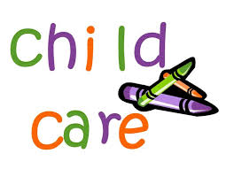

Enrollment/Pre-Entry/Gradual Entry
Child Care Enrollment begins with Application
The childcare application is available on our website. Applications may be completed and submitted online or at the center. To better understand your family’s childcare needs and to assess your family’s eligibility for possible funding sources, the Family Service Worker will contact each family who has applied to schedule an onsite visit. During this visit, families may have the opportunity to tour the classroom, meet the childcare staff and together with the enrollment specialist determine if enrollment in the program is a good fit for the family. When the decision to enroll is made and childcare slots are not available, families are put on waiting list and notified when an opening becomes available.
Infant Toddler Contracted Slots (ITCS) Enrollment
Early Learning Connections provides Infant and Toddler Child Care through the state funded
Infant Toddler Contracted Slots Program. Families who may be eligible for the ITCS program will be directed to the ELRC to determine final eligibility for the program. Eligible children must be between the ages of 6 weeks and 36 months of age at the time of enrollment. Eligible children will be enrolled in the ITCS program within 30 days of eligibility.
Pre-Entry Interview and Required Documentation
The pre-entry interview process is the first step in the ongoing family-child care partnership. This process provides families the opportunity to share information about the child with the Enrollment Specialist and the teachers. It also enables both parties to begin to develop a meaningful relationship and share expectations.

The following forms must be completed in their entirety and submitted before a child is permitted to attend the program. These forms and documentation are required by the PA Department of Human Services Child Care Licensing Regulations.
- Emergency Contact/Parental Consent Form - this form indicates parent/ guardian consent for emergency medical treatment as well as for authorization of alternate adults to whom the child may be released or serve as an alternate contact in the case of child illness or emergency.
- Court Ordered Custody Agreements and PFAs that legally define the rights of each parent or legal guardian will be followed. Without documentation of court ordered rights, the childcare program is obligated to release a child to their natural parent.
- Medical documentation for:
  - Up to date well child checks and immunization records are required to be submitted to the enrollment specialist no later than 60 days from their enrollment date. Immunizations follow the on-going schedule recommended by the American Academy of Pediatrics. Failure to provide this documentation by the required due date will result in suspension of the childcare services until the required documentation has been received. Any family that elects to not immunize must have a written and signed statement and will need to sign the immunization waiver.
  - Any existing chronic health condition and an accompanying health care plan.
  - Any existing allergies and directions for protection from the allergen with clearly defined emergency response procedures and a treatment plan, should the child have an allergic reaction.
  - Any existing dietary restrictions and acceptable substitutes.
- The Authorization for Medication form when an existing medical condition requires administration of prescription or over the counter medication while attending childcare.
- Parent Input Forms help us to get to know your child. They provide the teacher with information on growth and development. Current information will be used to plan and implement an individualized program of care for your child.
- Fee Agreement
- CACFP Application
- Permission for Collaborative Services for children who are receiving Early Intervention or Behavioral Health Services or Special Health Care when they are attending childcare. Parents are required to sign this form to acknowledge that, during the time the services are provided, as documented in the child’s IFSP/IEP or Treatment Plan, Early Learning Connections is exempt from supervision of the child.
Gradual Entry
The childcare setting itself is often a new experience for the child. The gradual entry process helps a child become comfortable in this new environment. The parent visits the program with the child. The child attends shorter days, extending each day during the first week of care. This process is tailored to meet the needs of the child and family.
Sending a child to childcare is often as stressful for the parent as it is for the child. Rather than becoming a substitute for home and family, the childcare experience is intended to enrich and complement each child’s overall development. Two-way communication between the parents and the teaching team is the key to developing a successful partnership.

Arrival & Departure
- Consistency in the time of arrival and departure helps children adjust more easily to the classroom routines. Please call if pick up or drop off time is going to be much earlier or later than usual.
- When your child is going to be absent or very late, call the office and leave a message before 10 am so the classroom staff can plan for the remainder of the day. This information will quickly be given to the teachers. Parents may also call the classroom using the room extension to leave a message.
- All adults who enter the center must enter through the front door. The door will be locked at all times. All parents and visitors will be required to use the intercom button located on the wall to the right of the door to gain access to the building.
- Parking is not permitted along the curb in front of the building. Adults dropping off and picking up are to park in designated parking spots. Vehicles must never be left running unattended in the parking lot.
- The responsible person dropping the child off and picking the child up is required to sign them in at drop off and sign them out at pick up every day.
- Children will only be released from the classroom or playground. Children will not be released to parents during hallway transitions.
- Do Not drop children off with money, gum, toys from home, or outside food and drink to the Center. Parents who wish to bring a food treat for the class, on a birthday or for another special occasion, are asked to give advance notification to the teacher. Treats must be store bought, not homemade.
- Notes for parents are placed in the child’s folder. Notices are posted on the front door and in the drop off/pick up area. Cubbies of toddlers and preschoolers should also be checked for soiled clothes. Each toddler and preschool child will need an extra set of clean clothes available if needed.



Non-Discrimination Policy
All admissions and services to the families and children of the Early Learning Connections programs shall be made without regard to race, color, religious creed, disability, ancestry, national origin, age, or sex.
Program services shall be made accessible to eligible disabled persons through the most practical and economically feasible methods available. These methods include, but are not limited to, equipment redesign, the provision of aids, and use of alternative service delivery locations. Structural modifications shall be considered only as a last resort among available methods.
Any employee, family or individual who believes they have been discriminated against may file a complaint of discrimination internally with Early Learning Connections or any of the following:

BUREAU OF CIVIL RIGHTS COMPLIANCE FIELD OFFICE
701 State Office Building
300 Liberty Avenue
Pittsburgh, PA 15222

BUREAU OF CIVIL RIGHTS COMPLIANCE HEADQUARTERS
Room 412, Health and Welfare Building
P.O. Box 2675
Harrisburg, PA 17105

PENNSYLVANIA HUMAN RELATIONS COMMISSION
101 South Second Street, Suite 300
Harrisburg, PA 17105

DEPARTMENT OF HEALTH AND HUMAN SERVICES
Offices for Civil Rights, Region III
P.O. Box 13716
Philadelphia, PA 19101

Important Program Policies & Procedures for the Safety & Well-Being of Children & Families
Early Learning Connections makes health and safety our highest priority for children and families. Please review the following policies and procedures:
Confidentiality is an important part of our program. Staff will not share any information about you or your child with anyone outside the program without your written consent. This also means that we request that parents/guardians not share anything discussed within our program, including information about other children and families, with anyone outside the program. These principles help to create an atmosphere of safety, trust, and openness.
Photographs: Your child’s teacher will provide you with photos from time to time. You are welcome to take photos of your own child at family events. We kindly ask that if other children are nearby, that you inform the parents that you will be taking a photo. That way the parent can decide whether they want their child to be in the photo.
- Privacy is important and we ask that you use your best judgment when placing any photos on the internet.
- Staff of Early Learning Connections will get written permission to post photos on social media and our website.
- Please do not place any photos of non-family children or staff members on the internet.
Protecting Children is important to us at Early Learning Connections. We strongly believe that children should grow up in a community where adults care about them and keep them safe. According to Pennsylvania State law, all staff have a legal responsibility to report suspected child abuse and neglect.
Raising children can be both fun and frustrating at times. If you find that you may need some parenting help, consider calling your teacher. These agencies can offer ideas too:
- Children and Youth Agency: 724-284-5156 – provides assistance to children and families in an abusive situation.
- VOICE: 724-283-8700 – Provides domestic violence assistance
- Warmline: 1-800-641-4546 – A helpline for parents
- Center for Community Resources (CCR): 724-431-0095 or 1-800-292-3866 – Provides information about mental health services in the community.


Need HELP? Call 211

Family Code of Conduct

Early Learning Connections requires the parents/guardians of enrolled children always to behave in a manner consistent with decency, courtesy, and respect. One of the goals of Early Learning Connections is to provide the most appropriate environment in which a child can grow, learn, and develop. Achieving this ideal environment is not only the responsibility of the employees of Early Learning Connections but, is the responsibility of each parent or adult who enter the centers. Parents or other adults are required to behave in a manner that fosters this ideal environment. Parents or other adults who violate the Family Code of Conduct will not be permitted on agency property thereafter.
- SWEARING/CURSING: No parent or adult is permitted to curse or use other inappropriate language on agency property at any time, whether in the presence of a child or not. Such language is considered offensive by many people and will not be tolerated. If a parent or adult feels frustrated or angry, it is more appropriate to verbally express the frustration or anger using non-offensive language. At NO time shall inappropriate language be directed toward members of the staff.
- THREATENING EMPLOYEES, CHILDREN, OTHER PARENTS, OR ADUTLS ASSOCIATED WITH EARLY LEARNING CONNECTIONS: Early Learning Connections will not tolerate threats of any kind. In addition, all threats will be reported to the appropriate authorities and will be fully prosecuted of the law. While apologies for such behavior are appreciated, the agency will not assume the risk of a second chance. PARENTS AND OTHER ADULTS MUST BE RESPONSIBLE FOR AND IN CONTROL OF THEIR BEHAVIOR AT ALL TIMES.
- PHYSICAL/VERBAL PUNISHMENT OF YOUR CHILD OR OTHER CHILDREN AT EARLY LEARNING CONNECTIONS: No adult, including family members, are ever permitted to physically punish any child, including their own, while on agency property or during any agency event. While verbal reprimands may be appropriate it is not appropriate for parents to verbally abuse their child. Doing so may cause undue embarrassment or emotional distress. Parents are always welcome to discuss a behavior issue with the teacher and to seek advice and guidance regarding appropriate and effective disciplinary procedures. If further advice is needed, we can provide support from our Mental Health Consultant.
Parents or other adults are prohibited from addressing, for the purpose of correction or discipline, a child that is not their own. No parent or other adult may physically punish another parent’s child. If a parent should witness another parent’s child behaving in an inappropriate manner or is concerned about behavior reported to them by their own child, it is most appropriate for the parent to direct their concern to the classroom teacher and/or Program Manager.
Furthermore, it is wholly inappropriate for one parent to seek out another parent to discuss their child’s inappropriate behavior. All behavior concerns should be brought to the classroom teacher or program manager’s attention. At that point, the teacher and/or program manager will address the issue with the other parent. Although you may be curious as to the outcome of such a discussion, teachers and/or the program managers are strictly prohibited from discussing anything about another child with you. All children enrolled in our agency have privacy rights and are further protected by our Confidentiality Policy. You may be assured that we will not discuss anything about your child with another parent or adult visiting the center.
- CONFRONTATIONAL INTERACTIONS WITH EMPLOYEES, OTHER PARENTS, OR ASSOCIATES OF EARLY LEARNING CONNECTIONS: While it is understood that parents will not always agree with the employees of Early Learning Connections or the parents of the other children, it is expected that all disagreements be handled in a calm and respectful manner. Confrontational interactions are not an appropriate means by which to communicate a point and are strictly prohibited.
DRUG, ALCOHOL, TOBACCO, AND WEAPONS ARE NOT PERMITTED ON EARLY LEARNING CONNECTIONS PROPERTY: All tobacco, vaping products, drugs, and alcohol are not permitted at any of the Early Head Start, Head Start, or PreK Counts locations, on or near agency vehicles or at any agency function. Weapons, firearms and ammunition are prohibited at all agency buildings and functions.

Policy for Releasing Children to Adults of
Diminished Capacity
If an employee determines that the adult responsible for picking up a child from any Early Learning Connections program is showing behavior which indicates diminished capacity (i.e., slurred speech, unsteady walk, confused thinking, impaired reflexes, erratic behavior, altered moods, or drowsiness), the staff member will contact another authorized adult on the release list. The impaired adult should be calmly encouraged to wait for the alternate release person and not drive.
If problems arise, the teaching staff may contact the office staff for support or request police assistance through 911.

Child Release Policy
Prior to the time of entry into Child Care, parents are required to complete an Emergency Contact/Parent Consent Form, which authorizes other adults to pick up their child(ren). Any adult on the release form who arrives to pick up a child and is unfamiliar to the staff will be asked to provide photo ID.
- Parents may change the names or status on the release form by verbally telling the teaching staff of changes or calling and updating the list with the intake specialist. The child will be released to any adult on the release form, only if they have the appropriate identification (photo I.D. or two forms if no photo identification is available).
- A child will be released to an adult not on the release list if in an emergency the parent calls in a new release person and the adult can be identified over the phone.
- Parents must list an additional contact in case we are not able to reach the parent/guardian.

Attendance Policies
Child Care
Regular attendance is encouraged for learning and development.
Infant Toddler Contracted Slots
A child must be present for at least one meal and part of the day to be considered present for that day. When your child is going to be absent or very late you must call the office and leave a message before 10 am so the classroom staff can plan for the remainder of the day.
Once a child has 20 absences, the enrollment coordinator will meet with the family to create an ITCS Attendance Plan. The maximum allowable annual absences for a child funded with ITCS funding will be 40 days. When children have more than 5 consecutive unexcused absences, the staff will contact the parents to discuss the reasons for the absences and determine ways to support the child’s attendance.

Curriculum

Preschool
Program Standards require each program to implement an Early Childhood Education Curriculum that guides the teaching and practices of its preschool classrooms.
The Creative Curriculum for Preschool is a developmentally appropriate Early Childhood Curriculum our program uses to ensure we are offering research based, high quality early learning experiences to each child. This curriculum is aligned with the PA Early Learning Standards that support the development of children from birth to 3rd grade. The Creative Curriculum includes developmentally appropriate goals and objectives for children as they grow and progress and are modified to meet the level of the individual child.
The Creative Curriculum has 38 learning objectives that provide the road map our teachers use to plan our educational program. The objectives are organized into nine areas of development and learning. The first four major areas include:

1. Social-Emotional | 3. Language
2. Physical | 4. Cognitive

The remaining five areas are content areas that are often described as outcomes for early learning standards. The content areas include:

5. Literacy | 8. Social Studies
6. Mathematics | 9. The Arts
7. Science and Technology

The tenth area, English Language Acquisition, provides objectives specific to children who are learning to understand and use the English Language.


PATHS Curriculum (Promoting Alternative Thinking Strategies)
The PATHS Preschool/Kindergarten curriculum is a comprehensive, developmentally based curriculum. It is intended to promote social and emotional competence and prevent or reduce behavior and emotional problems in young children through the development and integration of essential skills in emotional literacy, behavioral self-control and problem solving, as well as to improve the social and academic climate of our preschool programs.

Heggerty
All ELC preschool classrooms implement the Heggerty Curriculum to teach phonemic and phonological awareness to increase early literacy skills. Children in their last year of preschool before kindergarten are taught using the Pre-K Lessons and the children in their first year of preschool are taught using the Early Pre-K Lessons. When children participate in the Heggerty lessons on a regular basis and learn to hear and identify the sounds in words, they are better prepared to learn to read, spell, write. Many of the local school districts use the Heggerty Curriculum. By participating in the lessons in preschool, children enter kindergarten with skills to be successful learners.

Infant and Toddlers
The Creative Curriculum for Infants Toddlers and Two’s is implemented in the Infant Toddler Contracted Slots Program. The research-based curriculum supports the teachers as they create responsive daily routines and meaningful learning experiences for our youngest learners. This curriculum also has 38 objectives for learning and development.


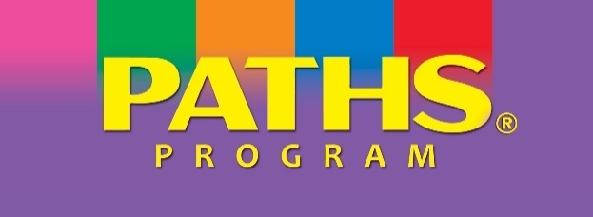


Program Description
Infant – Toddler Care
The Infant/Toddler Program serves children between the ages of 6 weeks to 3 years. Children under the age of three are cared for in specially designed, very small group, infant/toddler environments that provide personalized caregiving, with a focus on interactions and activities that promote early brain development. Each child is assigned to one early childhood infant/toddler professional who is responsible for all aspects of the baby’s care to ensure that, in these most vulnerable years, secure attachments are formed. The nutrition program provides formula and baby food for infants. Staff partner with parents of infants to replicate each baby’s routine in relation to feeding and napping schedules. Toddlers are provided with a daily, nutritious breakfast, lunch, and snack during which they learn self-help skills, such as using utensils and drinking from a cup. Toilet learning is an additional self-help skill that is emphasized in the toddler group. The infant toddler playground provides opportunities for children to experience outdoor play in a fenced, safe play space that encourages crawling, climbing, running, and riding wheeled toys under the safe supervision of their caregivers.
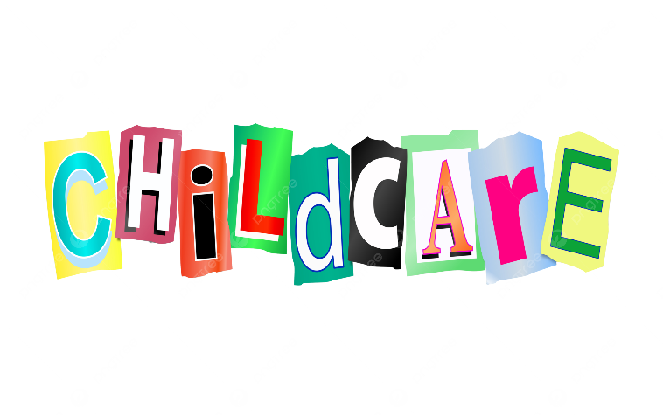
Parents will provide diaper cream, bottles, small blanket and soft comfort toy and extra sets of clothing. The program will provide diapers and wipes. The staff use an electronic app to send families daily information on feeding, sleeping, diaper changes, and toileting. It is helpful if parents mark all extra clothing and outerwear with the child’s name.

Preschool Care
The center operates one preschool childcare classroom that is composed of children who are between the ages of 3 and 5. Personalized care and individualized educational plans are implemented by a team of three professional early childhood educators. In each classroom, the teaching team provides a wide variety of school readiness activities in an environment that is rich in activities and learning materials that promote each child’s growth and development. The preschool classroom emphasize getting children ready for school with a focus on learning in the areas of literacy, math, social studies, science, and technology. Outdoor play is scheduled daily on one of the Center’s three preschool playgrounds. On the playgrounds, children enjoy safe and supervised activities which include sand boxes, climbers, sliding boards, tricycles, ball play, preschool games, and nature activities. Social skill development is emphasized throughout each day as the educators support the development of each child’s ability to follow directions and simple rules, make friends, take turns, share, and get along with others. Balanced and nutritious meals are served family style at breakfast and lunch during which children learn to try new foods, pour, pass, and serve themselves from serving bowls. A snack is offered after the preschool children wake from a restful afternoon nap.
Children will need parents to provide an extra set of clothes including shirt, underwear, pants, and socks. For naptime they will need a small cot-sized blanket and pillow. Blankets are sent home on Friday to be laundered and returned on Monday.
It is required that your child wear child safe closed toe shoes that are appropriate for outside play.
School Readiness Goals
Central Domains
Head Start  Early Learning Outcomes Framework | Approaches to Learning | Social and Emotional Development | Language and Literacy | Cognition | Perceptual, Motor and Physical Development
School Readiness Goals | -Children will increasingly demonstrate self-regulation including impulses, maintaining attention, persisting with activities, and using flexible thinking to solve problems.  -Children will demonstrate initiative independence, interest and curiosity in interactions with others, and exploration of objects and people in their environment. | -Children will engage in and maintain positive peer relationships, interactions including cooperating, and resolving conflicts.  -Children will appropriately express and respond to a broad range of emotions including concerns for others. | -Children will express themselves in increasingly long, detailed and sophisticated ways that are clear and understandable.  -Children will identify and segment the sounds within words as separate from the word itself including rhyming and matching beginning sounds.  -Children will write for a variety of purposes using increasingly sophisticated marks. | -Children will demonstrate understanding of the relationship between numbers, names, and quantities.  -Children will associate a quantity with written numbers up to 5 and will begin to write numbers.  -Children will demonstrate understand of mathematical operations including addition and subtraction.  -Children will analyze and interpret data, draw conclusions and communicate results | -Children will demonstrate increasing control of large muscles for movement, navigation and balance.  -Children will demonstrate use of small muscles for the purpose such as self-care, writing, manipulation of tools, and cutting with scissors.
Preschool | Teaching Strategies GOLD  3b: Solves problems  11a: Attends and engages  11b: Persists  1c: Takes care of own needs appropriately (4yr)  11d: Shows curiosity and motivation  Head Start Early Learning Outcome Framework  P-ATL 5  P-ATL 10  PA Early Learning Standards  16.2.PK.D  1.4.PK.X  16.11PK.C  AL.2.PK.A  6.1.PK.D  AL.1.PK.B | Teaching Strategies GOLD  2c: Interacts with peers  2d: Makes friends  3a: Balances needs and rights of self and others  3b: Solves social problems  2b: Responds to emotional cues  Head Start Early Learning Outcome Framework  P-SE 5  P-SE 6  PA Early Learning Standards  AL.1.PK.C  16.1.PK.B  16.2.PK.D  AL.4.PK.A | Teaching Strategies GOLD  9b: Speaks clearly  9c: Uses conventional grammar  19a: Writes name  19b: Writes to convey meaning  Head Start Early Learning Outcome Framework  P-LC 5  P-LIT 1  P-LIT 6  PA Early Learning Standards  1.5.PK.D  1.5.PK.G  1.4.PK.C  1.1.PK.C | Teaching Strategies GOLD  20a: Counts  20c: Connects numerals with their quantities  20b: Quantifies  13: Uses classification skills  22: Compares and measures  Head Start Early Learning Outcome Framework  P-MATH 3  P-MATH 5  P-MATH 6  P-SCI 6  PA Early Learning Standards  2.1.PK.A  2.1.PK.MP  2.4.PK.A | Teaching Strategies GOLD  4: Demonstrates traveling skills  5: Demonstrates balancing skills  7a: Uses fingers and hands  7b: Uses writing and drawing tools  Head Start Early Learning Outcome Framework  P-PMP 1  P-PMP 3  PA Early Learning Standards  10.4.PK.A  10.5.PK.C
Central Domains
Head Start  Early Learning Outcomes Framework | Approaches to Learning | Social and Emotional Development | Language and Literacy | Cognition | Perceptual, Motor and Physical Development
School Readiness Goals | -Children will manage feelings, emotions, actions and behaviors with support of familiar adults.  -Infants and Toddlers will increase their ability to be persistent and attentive. | -Children will engage in positive interactions through secure relationships with consistent, responsive adults.  -Children will recognize and interpret emotions of others, including expressing care and concern for others, with support of familiar adults. | -Children will attend to, understand, respond and learn communication and language from others.  -Children will understand and use an increasing number of words for communication, including expressing wants and needs, and engage in conversations with others.  -Children will attend to, repeat and use rhymes and refrains from stories and songs. | -Children will actively explore their environment to discover what objects and people do, how things work, and how to make things happen.  -Children will use a variety of strategies to solve problems, including reasoning and planning ahead. | -Children will develop and demonstrate use of large muscles for movement, exploration of the environment and self-help.  -Children will develop and demonstrate control of small muscles for exploration, play and daily routines
Infant/ Toddler | Teaching Strategies GOLD  1a: Manages feelings  1b: Follows limits and expectations  11a: Attends and engages  11b: Persists  11c: Shows curiosity and motivation  Head Start Early Learning Outcome Framework  IT-ATL 1  IT-ATL 2  IT-ATL 3  IT-ATL 4  PA Early Learning Standards  5.1.A  5.2.b  AL.1.A  AL.2.A  AL.4.c | Teaching Strategies GOLD  2a: Forms relationships with adults  2b: Responds to emotional cues  2c: Interacts with peers  Head Start Early Learning Outcome Framework  IT-SE 1  IT-SE 2  IT-SE7  IT-SE 8  PA Early Learning Standards  6.1.D  16.1.B  16.2.A  16.2.D  AL.1.C | Teaching Strategies GOLD  8a: Comprehends language  8b: Follows directions  9a: Uses an expanding expressive vocabulary  9b: Speaks clearly 9b  9c: Uses conventional grammar  10a: Engages in conversations  12a: Recognizes and recalls  12b: Make connections  Head Start Early Learning Outcome Framework  IT-LC 1  IT-LC 7  IT-LC 8  IT-SE3  IT-LC 9  PA Early Learning Standards  1.2.J  1.3.J  1.5.C  AL.2.B  1.2.C | Teaching Strategies GOLD  11a: Attends and engages  11b: Persists  11c: Solves problems  11d: Shows curiosity and motivation  11e: Shows flexibility and inventiveness in thinking  Head Start Early Learning Outcome Framework  IT-C 1  IT-C 6  PA Early Learning Standards  AL.1.A  AL.2.A  AL.2.B  AL.2.C  AL.3.C | Teaching Strategies GOLD  4: Demonstrates traveling skills  5: Demonstrates balancing skills  6: Demonstrates gross-motor manipulative skills  7a: Uses fingers and hands  7b: Uses writing and drawing tools  Head Start Early Learning Outcome Framework  IT-PMP 3  IT-PMP 4  IT-PMP 7  PA Early Learning Standards  10.4.A  10.4.B  10.5.A  10.5.B  10.5.C

Screening & Assessment
Program Standards require screening for each child to determine the need for further, in-depth evaluation. Screening will be done within 45 days of a child’s entry into the program and will include developmental, behavioral, and sensory (vision and hearing) screenings. Screenings are administered to determine if there is a need for a formal, in-depth evaluation that would be completed by a specialist. If vision and hearing screenings are completed by child’s primary care provider and indicated on child’s well child check, this testing will not be repeated by the agency unless the child’s parent or care giver request.
Each child’s level of development, and progress over time, are observed and documented so that strengths and needs are identified. The Teacher develops individualized goals and objectives. Teachers will discuss this with parents at least three times each year to gain input and jointly plan the child’s educational program.

Mental Health Services
Early Learning Connections embraces a vision of mental wellness for children and families.
The Agency has Mental Health Consultants who are available to support the development of children’s social emotional skills and behavior in the classroom. The consultants will observe classrooms and work together with the teachers to promote positive classroom environments. The Mental Health Consultants are also available to meet with families about any concerns they may have about their child’s behavior and development of social emotional skills.

Disabilities Services
As an inclusive program, all children, including children with disabilities/special health care needs, are welcomed into all programs. Reasonable accommodations are made to ensure that each child has the opportunity to participate in the full range of the program.
Together, staff and parents use the Ages and Stages Questionnaires (ASQ-3 and ASQ-SE) to determine each child’s current developmental levels in gross and fine motor, speech and language, cognition, and social skills. When screening results identify evidence of developmental concerns, or when children enroll with identified disabilities, our program works closely with parents and the Midwestern Intermediate Unit IV Early Intervention Program to ensure that children are evaluated and/or receive all necessary services.
Children with an Individual Education Program (IEP) or Individualized Family Service Plan (IFSP) are eligible for additional services to support their development. Early Learning Connections collaborates with the IU IV Preschool Early Intervention Programs and Center for Community Resources to provide services for children who are eligible for special education programs.
The staff and parents work together to provide a learning environment that meets the individual needs of all children. Please feel free to talk to your teacher about any concerns you may have with your child’s development.

Adapting Curriculum for Children with Disabilities or
Other Special Needs

All interventions for children with disabilities and other special needs will occur in a manner that recognizes that children with disabilities follow the same developmental spectrum as their more typically developing peers and that interventions work best when they are integrated into the daily content of the preschool environment.
Within the context of the Creative Curriculum, the following methods will be used to support the development of children with disabilities and other special needs:
- High quality early childhood program (Creative Curriculum)
- Curriculum modification and adaptations- Teachers and other team members make modifications, adaptations and accommodations to classroom activities, routines and learning areas to include and enhance the participation of children with disabilities and other special needs. A curriculum modification is a change made to the ongoing classroom activity or materials to achieve or maximize the child’s participation.
- Embedded learning activities- Through purposeful planning teachers identify daily opportunities for practicing a child’s learning objectives within the context of the daily routine. The teacher plans what they will say or do to encourage the development of a child’s skills while following a typical daily routine. Ideas for embedded learning opportunities may be found in the child’s IEP or through discussion with the child’s therapist or mental health consultant.
- Explicit, Child-Focused Instructional Strategies- Some children need specific instruction to master a skill. When a child has a disability, specific instructional strategies may be found in the child’s IEP or identified through discussion with the child’s therapist or mental health consultant.
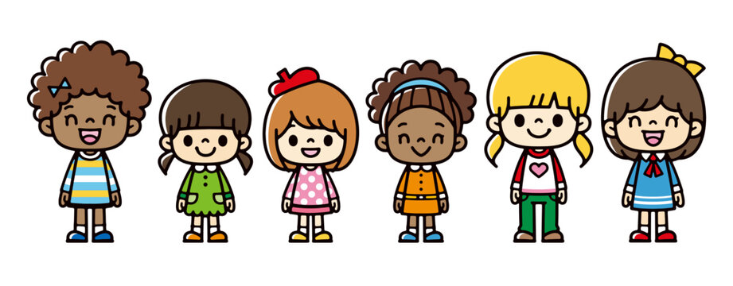

POSITIVE BEHAVIOR MANAGEMENT AND
GUIDANCE PROCEDURE POLICY

Early Learning Connections Positive Behavior Management and Guidance Procedure policy is designed to keep all children and staff safe in the classroom and provide as much support for children as possible. Students, parents, and staff are provided the atmosphere to feel welcome, develop a sense of belonging, and to form respectful friendships and relationships.
Early Learning Connections early learning programs aim to promote children’s social-emotional skills to become competent learners. This includes developing empathy, anger management skills, problem solving, and impulse control skills. A consistent and predictable routine in a safe environment in the classroom helps children to behave in a positive way.
Early Learning Connections staff can help prevent children from behaving in a way that is harmful to themselves, others, or the environment by consistently reviewing behavioral expectations with parents and children daily. Targeted aggression and unsafe behaviors have a negative impact on the learning environment and teachers will intervene so children feel supported and safe.
The policy is designed to support the child, family and staff throughout the multi-tiered process. Prevention, Intervention and Transition procedures are clearly stated for everyone involved. The Positive Behavior Management and Guidance Procedure Policy can be found in your Welcome Packet.


Dual Language Learners

All our programs are equipped to support children and families who are dual language learners. From enrollment to home visits to daily classroom attendance it is our goal to help you and your child feel comfortable using your home language along-side English. Play materials, stories, games, and everyday items can be customized to include your home language along-side those who may speak another language. It is very important to help your child to feel comfortable and to learn both languages while in our classrooms.

Transitions

Transition to Kindergarten
Kindergarten readiness and social competency are the primary goals of the Agency. When a child is of kindergarten age, the Teacher/Family Service Worker will provide parents with registration dates and times from the various school districts, along with other necessary information a parent will need when enrolling their child for school.
Additional information and materials will be sent home to parents regarding the transition to kindergarten experience. Training will also be available for parents of kindergarten bound children to address any questions and discuss ways parents can advocate for their child upon entering the school system.
Lastly, children’s educational records will be forwarded to the school district of residence, with parental consent, in an effort to help schools plan for future programming.
Transition from ITCS to Preschool
Six months before your child turns 3 years old, you and your Enrollment Specialist will begin planning for your child’s transition for preschool.
This includes:
- A review of your family’s income eligibility
- Your interest in where your child attends programming- child care, Head Start, Home Based Head Start, Pre-K Counts
- Coordinating Special Services as needed (IFSP/IEP)
- A visit to the classroom
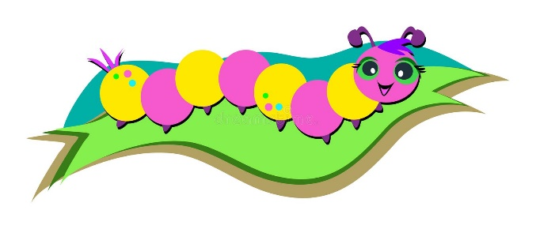



Celebration Policy

The goal is to offer pleasant and meaningful classroom celebrations. The practices we follow are:
- Seasonal Celebrations are part of the programs experience for children.
- Teachers will schedule these events and plan the activities and food for the celebration. Ideas from parents are welcome!
- Due to the potential for allergies that children/staff might have, we are not able to have families and friends bring food from home for the classroom. We require families to bring nutritional store-bought food items in the original packaging for these activities that are low in sugar, salt, and fat. All food served in the classroom must be commercially prepared. It is suggested that teachers develop and offer parents a nutritious snack list.
- We always want children to feel safe. For this reason, we do not allow costumes or masks, as these can be scary to young children. Neither adults nor children are permitted to enter the classrooms in costumes.
- We are fortunate to have families in our program from many different places, cultures, and belief systems. We support the heritage and culture of each child and family as well as responding to the majority culture of the classroom. We invite parents and grandparents to tell stories, show off clothes and artifacts, teach simple crafts, show children how to prepare some of their foods, and tell how they celebrate their heritage at home.

Health Requirements

Parents are required to provide documentation of current age-appropriate Well Child Visit / Immunizations and dental examination.
Parents are required to provide any Special Care Plan for the following needs:
- Medication Policy
- Authorization for Medication Form
- Asthma Care Plan
- Allergy Care Plan (Non-Food)
- Care Plan for Children with Special Needs Form
- Seizure Action Care Plan
- Food Allergies and or Intolerance: Medical Plan of Care for Child Nutrition Programs (CACFP and SFSP) – require Health Care Provider Signature

If a child is unable to eat any of the food that is provided for religious reasons, parents should notify the staff. Parents must present a written statement from their family doctor or clergyman for a child to be given a meal different than the planned menu.

Emergency Medical Treatment

Injuries or Illness Requiring Medical or Dental Care
- The caregiver who is with the child and who has had pediatric first aid training will provide first aid.
- When immediate medical help is required, staff will call 9-1-1. Staff will contact a parent or legal guardian or, if the parent or legal guardian cannot be reached, the alternate emergency contact person. The emergency facility used by the program is the closest medical facility.
- A staff member will accompany the child and remain with the child until the parent or legal guardian assumes responsibility for the child.
- Staff will complete a Child Injury Report as soon after the incident as possible. The form will be signed by the parent or legal guardian.
- Dental emergencies: Dental injuries will be given first aid as in #1 above. If emergency dental care is required, a staff member will accompany the child and remain with the child until the parent or legal guardian assumes responsibility for the child.

Reporting Child Injury

A Child Injury Report Form will be completed for:
- An incident that results in an injury or a visible mark on a child (bites, cuts, bruises, swollen body parts, etc.).
- A medical emergency due to a child’s ongoing health condition (asthma attack, convulsions, seizure, etc.).
- Any incident that involves the child’s head, even if there are no visible marks or signs of a concussion. The parent will be contacted as soon as possible after the incident.

Guidelines for Ill Children

Children will be excluded from Center Based Early Learning programs if:
- The child exhibits signs of an illness listed below. (According to the Academy of Pediatrics)
- FEVER: 100.4 degrees F. for all children
- UNUSUAL LETHARGY, irritability, persistent crying, and difficult breathing.
- UNCONTROLLED DIARRHEA: Three episodes with increased stool water that is not contained by the diaper or toilet use.
- VOMITING: two or more times
- MOUTH SORES: with drooling
- UNIDENTIFIABLE RASH accompanied with a fever or change in behavior.

Parents/Guardians will be given a courtesy call or message if their child exhibits signs of illness that could lead up to the child being sent home. This form of communication will serve as a way to communicate our concerns for the child and prepare the adults for a possible pick up.
In Child Care the Program Manager must be notified before a child is sent home. In other Early Learning Programs, the Head Teacher has the authority to send a child home if the child meets the signs of illness criteria.

If a child is sent home with a fever, excessive vomiting or uncontrollable diarrhea he/she must be symptom free without the use of medication a full 24 hours (equals one full day) in order to return. If the child returns and symptoms re-occur the child will be excluded. Staff must contact the parent or emergency contact to pick up the child.
- The child displays signs of a communicable disease.
When a child is diagnosed with a communicable disease a notice will be sent to all parents of children that would/could be exposed IN THAT CLASSROOM. These notices will be on GREEN paper informing the parents/guardians that their child has been exposed to a specific disease and a listing of the symptoms that they should look for. Each site will have a plan to distribute the notices in a way that ALL parents receive the notice upon picking up their child. No exposure notice will be sent home without Medial documentation that a child was diagnosed with Communicable Disease. No children's names will be disclosed or discussed with any other parents. If more than one child in a classroom contracts the same disease, notices will only be sent out when the first child is diagnosed and again in two weeks if cases are still appearing. Notices will be effective for two weeks and parents, staff, and children should take all precautions related to the specific communicable disease.
Please refer to the following list of communicable diseases as to when the child may return:
Communicable Disease List
Communicable Disease  “CD” code is used only if the child has been diagnosed with one of the following: | When The Child Can Return
Chicken Pox** | When all blisters have scabbed (usually 6 – 10 days)
COVID-19 | For Children who test Positive:  Children returning to School (or socialization):  - Children are required to stay out 3 Full Days if they test positive. They can return if on Day 4 if they are:  - 24 hours fever-free without the use of fever reducing medication  - 24 hours free of diarrhea, nausea, and vomiting  - Other symptoms have improved [productive cough and green/yellow nasal discharge]  - Day 0 is the day of your positive test and Day 1 is the first full day after your positive test [start counting from Day 1].  ***Children assigned to Childcare Programs are regulated by OCDEL to return with a written letter from a medical provider stating that they are healthy enough to return.
Diphtheria** | 48 hours from the time the child is taking antibiotics, or until there are two negative culture tests. Child needs to have a medical letter to return [the letter should state they have been on antibiotics 48hrs, and they have had two negative cultures and or the child is healthy enough to return to classroom].
Fifth Disease | Must be fever free for 24 hours without the use of fever reducing medication and having no respiratory systems; child could still have a rash they are not likely to be contagious. Child will need a medical note to return stating they are healthy enough to come into the classroom.
Flu (Influenza) | Must be fever free for 24 hours without the use of fever reducing medications. Child will need a medical note to return to the classroom.
Giardiasis | 24 hours after diarrhea has and vomiting stops. Must be cleared by medical provider for re-admittance. (symptoms can last up to 6 weeks or longer). The letter needs to state they are healthy enough to return to classroom.
Haemophilus Influenza Type B  (HIB)** | 24 hours after the initiation of antibiotic therapy. Child must have written clearance from a health professional or local health department stating that they are healthy enough to return to classroom.
Hand, Foot, and Mouth | When a child is fever free for 24 hours without the use of fever reducing medications, can contain drool, and all draining sores are covered.
Hepatitis A** | Two weeks after the onset of illness and after immune globulin has been given. Child should have no fever; jaundice has resolved, and appetite has returned. Child needs to have a letter stating they are healthy enough to return and documentation of immune globulin should be provided in letter.
Infectious Diarrhea | Child’s diarrhea has stopped for a full 24 hours and has clearance letter from health care professional and/or negative lab test result. Documentation must be given to staff members before child can reenter school.
Impetigo | 24 hours after doctor prescribed treatment has begun and all sores are scabbed over without drainage; Child must have letter stating they are healthy enough to return to school.
Lice | To re-enter into the classroom, the child must be free of live lice- Appendix HS-C and Appendix HS-D are given to parents.
Measles** | 4 days after the rash began. Child must have a letter to return to school; letter must state they are healthy enough to return to school.
Meningitis | Child must have written clearance from a health care professional stating child is healthy enough to return to school. (symptoms normally last 7-10 days)
Mononucleosis | Child will need a doctor’s written permission to be re-admitted. Documentation must be given to staff member; before child can return.
MRSA | Child must have a doctor’s written clearance to return, and sores must not have drainage or have pus. Sores must be covered.
Mumps** | 5 days after the onset of swelling, documentation must be given to a staff member that child is healthy enough to return to classroom; this can be in the form of a letter from health care professional.
Norovirus | 48 hours after resolution of symptoms [diarrhea/vomiting].  stool must be able to be contained in diapers/toilet trained children do not have accidents.
Pertussis (Whooping Cough) ** | 5 days from the time the child begins taking antibiotics; documentation is needed for when antibiotics are started. A note is required for the child to return stating that child is healthy enough to return to classroom.
Pink Eye (acute bacterial contagious conjunctivitis) | Must return with documentation from a health care provider and after taking antibiotics for a full 24 hours.
Pinworms | 24 hours after the doctor prescribed treatment has begun; documentation is needed when medication is started.
Ringworm | 24 hours after beginning medication; documentation is needed when medication is started.
Respiratory Streptococcal Infections | (Scarlet Fever, Bronchitis, Strep Throat, etc.) Child may return after 24 hours of antibiotic treatment; documentation is needed when medication was started and a note stating that child is healthy enough to return to the classroom.
Roseola | Child may return after fever free for 24 hours without the use of fever reducing medication.
Rotavirus** | Child may return after a full 48 hours of ALL symptoms free without the use of fever reducing medication.
Rubella** | 7 days after rash onset. With outbreaks, exclude unimmunized individuals until they are immunized.
Salmonella | Must be a full 24 hour clear of diarrhea and must have written clearance from a health care professional stating child is healthy enough to return to the classroom.
Scabies | 24 hours after treatment, must have written clearance from health care professional. Documentation must be given to staff members before child can start.
Shigella | After treatment is complete and two stool cultures taken 24 hours apart are negative. Child need a letter stating they are healthy enough to come to school and documentation of stool cultures; must be given to staff member.
Tonsillitis | 24 hours from the time the child begins taking antibiotics and is fever free without the use of fever reducing medication.
Trachoma | 24 hours after the start of antibiotic treatment. Child needs a letter stating they are healthy enough to come to school.
Tuberculosis (TB) | As soon as effective therapy has been started and adherence to medication is documented – will require updates or changes to treatment plan via documentation from health professional. Documentation of treatment plan must be given to staff member.
**Child should have vaccination against – if parent determines they do not want their child to be vaccinated than they must complete Appendix HS-02-L2**
Notice letters for Communicable Diseases can be found at Appendix HS-C2
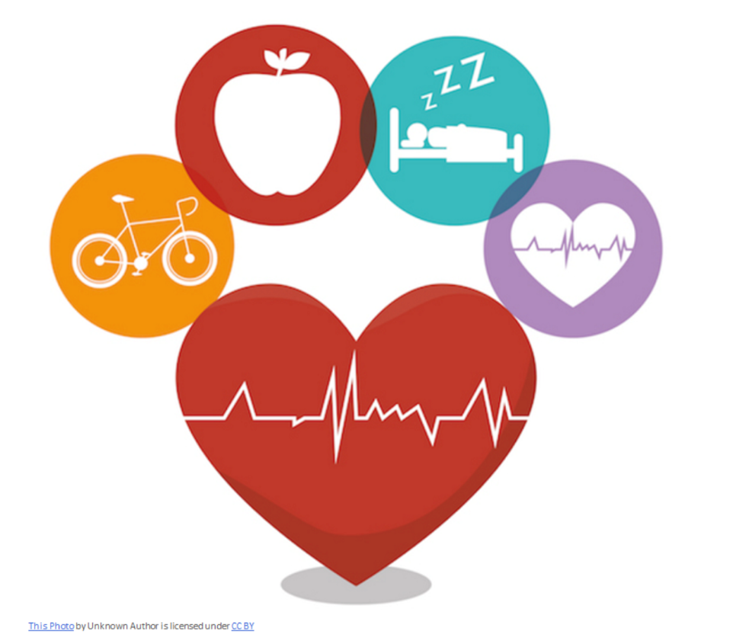
*Additional Notice Letters: Bed Bugs, Molluscum Contagiosum

Re-Admission After Medical Treatment
If any child has been to a hospital, urgent care, emergency room, or has had any surgeries/treatments, the parent must provide written documentation allowing the child to attend the program, with or without restrictions. Documentation must be provided by a health professional and presented to Child Care staff before a child can return.

Administering Medication Policy
Medication administration is limited to prescription, or non-prescription (over the counter) medications ordered by a health care professional for a specific child and accompanied by written consent of the parent/legal guardian.
The Children’s Center will provide parents with an Authorization for Medication Form. The parent must take this form to the child’s physician who completes the top section of the form. (If the parent does not have this form when they go to the physician, a written order from the physician that contains the information listed below will be accepted and stapled to the form.) The written order of the health professional must specify:
- The medical reason for the medication
- Name of the medication
- Dose
- Route
- When (time of the day)
- For how long (number of days)
- Any reactions or side effects that may occur
The documentation is brought to the facility with the required medication. The parent completes the middle section, and the staff person completes the bottom section of the form.
All medication Prescription and non- prescription must be in the original container (pharmacy or manufacturer supplied) with a label that includes the child’s name, date the prescription was issued, and when it expires.
The label must also include the prescriber’s name, dose instructions, pharmacy name and phone number, and relevant warnings.
Preventive and over-the-counter medications (OTC) may be used when parents or legal guardians provide a written note, giving Child Care staff permission to use on their child.
Examples would be diapering rash cream, sunscreen, ChapStick, and body lotion. This would not include items like Tums, Tylenol or Allergy medications. Child Care staff will follow manufacturer instructions for the use of Medication or application unless a medical note provided from a licensed provider dictates differently.
Once a medication is discontinued, if there is any remaining it will be given to the parent or legal guardian when they come to pick up their child. They will be required to sign the bottom of Medication Log (Appendix HS-E2). Three attempts will be made to return unused medication before medication will be disposed of appropriately. The bottom part of Medication Log (Appendix HS-E2) will be completed at this time, the location and date of where unused medication was dropped off will be recorded along with staff members’ name / signature.
Nutrition Program

Early Learning Connections provides nutritional meals which follow the USDA Guidelines for the Child and Adult Food Care Program.
In accordance with the federal civil rights law and U.S. Department of Agriculture (USDA) civil rights regulations and policies, this institution is prohibited from discriminating based on race, color, national origin, sex (including gender identity and sexual orientation), disability, age, or reprisal or retaliation for prior civil rights activity.
Program information may be made available in languages other than English. Persons with disabilities who require alternative means of communication to obtain program information (e.g., Braille, large print, audiotape, American Sign Language), should contact the responsible state or local agency that administers the program or USDA’s TARGET Center at (202) 720-2600 (voice and TTY) or contact USDA through the Federal Relay Service at (800) 877-8339.
To file a program discrimination complaint, a Complainant should complete a Form AD-3027, USDA Program Discrimination Complaint Form which can be obtained online at: https://www.usda.gov/sites/default/files/documents/USDA-OASCR%20P-Complaint-Form0508-0002-508-11-28-17Fax2Mail.pdf, from any USDA office, by calling (866) 632-9992, or by writing a letter addressed to USDA. The letter must contain the complainant’s name, address, telephone number, and a written description of the alleged discriminatory action in sufficient detail to inform the Assistant Secretary for Civil Rights (ASCR) about the nature and date of an alleged civil rights violation. The completed AD-3027 form or letter must be submitted to USDA by:
1. mail: U.S. Department of Agriculture Office of the Assistant Secretary for Civil Rights

1400 Independence Avenue, SW
Washington, D.C. 20250-9410; or
2. fax: (833) 256-1665 or (202) 690-7442; or
3. email: program.intake@usda.gov
This institution is an equal opportunity provider.
05/05/2022



Children and Adults with Disabilities and Special Dietary Needs
Operators of the Child and Adult Care Food Program (CACFP) and Summer Food Service Program (SFSP) are required to make reasonable modifications to Program meals or the meal service to accommodate children or adults (Program participants) with disabilities that restrict the diet.

1. Licensed Medical Authority’s Statement for Participants with Disabilities
U.S. Department of Agriculture (USDA) regulations at 7 CFR Part 15b require substitutions or modifications in Program meals for participants whose disabilities restrict their diets. Sponsors, centers, and day care homes must provide modifications for participants on a case-by-case basis when requests are supported by a written statement from a state licensed medical authority.
The third page of this document (“Medical Plan of Care for Child Nutrition Programs”) may be used to obtain the required information from the licensed medical authority. For this purpose, a state licensed medical authority in Pennsylvania includes a:
- Physician,
- Physician assistant,
- Certified registered nurse practitioner, or
- Dentist.
The written medical statement must include:
- An explanation of how the participant’s physical or mental impairment restricts the diet;
- An explanation of what must be done to accommodate the participant; and
- The food or foods to be omitted and recommended alternatives, if appropriate.

2. Other Special Dietary Needs
Program operators may make food substitutions for individual participants who do not have a medical statement on file. Such determinations are made on a case-by-case basis and all accommodations must be made according to USDA’s meal pattern requirements. Program operators are encouraged, but not required, to have documentation on file when making menu modifications within the meal pattern.
Special dietary needs and requests such as those related to general health concerns and personal preferences are not disabilities and are optional for Program operators to accommodate. Meal modifications for non-disability reasons are reimbursable provided that these meals adhere to Program regulations.

3. Rehabilitation Act of 1973 and the Americans with Disabilities Act
Under Section 504 of the Rehabilitation Act of 1973, the Americans with Disabilities Act (ADA) of 1990 and the ADA Amendments Act of 2008, a person with a disability means any person who has a physical or mental impairment that substantially limits one or more major life activities or major bodily functions, has a record of such an impairment, or is regarded as having such an impairment. A physical or mental impairment does not need to be life threatening to constitute a disability. If it limits a major life activity, it is considered a disability.
Major life activities include, but are not limited to: caring for oneself, performing manual tasks, seeing, hearing, eating, sleeping, walking, standing, lifting, bending, speaking, breathing, learning, reading, concentrating, thinking, communicating, and working. A major life activity also includes the operation of a major bodily function, including but not limited to: functions of the immune system; normal cell growth; and digestive, bowel, bladder, neurological, brain, respiratory, circulatory, endocrine, and reproductive functions.

Children and Adults with Disabilities and Special Dietary Needs

4. Individuals with Disabilities Education Act
Preschool children, infants, and toddlers with disabilities have additional rights under the Individuals with Disabilities Education Act (IDEA). Questions regarding the IDEA’s requirements should be directed to the U.S. Department of Education, which is the federal agency responsible for the administration and enforcement of the IDEA.

Child Nutrition Program (CACFP/SFSP) Contact
For more information about requesting accommodations to Program meals and the meal service for participants with disabilities, contact:
Click here to enter local contact name and information.

USDA Nondiscrimination Statement
In accordance with federal civil rights law and U.S. Department of Agriculture (USDA) civil rights regulations and policies, this institution is prohibited from discriminating based on race, color, national origin, sex (including gender identity and sexual orientation), disability, age, or reprisal or retaliation for prior civil rights activity.

Program information may be made available in languages other than English. Persons with disabilities who require alternative means of communication to obtain program information (e.g., Braille, large print, audiotape, American Sign Language), should contact the responsible state or local agency that administers the program or USDA’s TARGET Center at (202) 720-2600 (voice and TTY) or contact USDA through the Federal Relay Service at (800) 877-8339.

To file a program discrimination complaint, a Complainant should complete a Form AD-3027, USDA Program Discrimination Complaint Form which can be obtained online at: https://www.usda.gov/sites/default/files/documents/USDA-OASCR%20P-Complaint-Form-05080002-508-11-28-17Fax2Mail.pdf, from any USDA office, by calling (866) 632-9992, or by writing a letter addressed to USDA. The letter must contain the complainant’s name, address, telephone number, and a written description of the alleged discriminatory action in sufficient detail to inform the Assistant Secretary for Civil Rights (ASCR) about the nature and date of an alleged civil rights violation. The completed AD-3027 form or letter must be submitted to USDA by:
- mail:
U.S. Department of Agriculture
Office of the Assistant Secretary for Civil Rights
1400 Independence Avenue, SW Washington, D.C. 20250-9410; or
- fax:
(833) 256-1665 or (202) 690-7442; or
- email:
program.intake@usda.gov.
This institution is an equal opportunity provider.

Medical Plan of Care for Child Nutrition Programs (CACFP and SFSP)
Please read pages 1 and 2 before completing this form.

Participant’s Name | Date of Birth |  |  |  | Age/Classroom
Name of Center/Program/Site

Name of Parent/Guardian or Participant’s Representative |  | Phone Number of Parent/Guardian/Representative
Signature of Parent/Guardian or Participant’s Representative |  | Date
1. Provide an explanation below of how the participant’s physical or mental impairment restricts the participant’s diet:
2. Describe the specific diet or necessary modifications prescribed by the state licensed medical authority to accommodate the participant’s needs:
3. List the food or foods to be omitted (please be specific) and recommend alternatives, if appropriate. Foods to be omitted:
Suggested substitutions:
4. Indicate texture modifications, if applicable:

 Chopped/Cut into bite-sized pieces  Diced/Finely Ground  Pureed  Other:

5. List any required special adaptive equipment:

Name of Physician/Medical Authority & Title (Please Print) |  |  | Provider Phone Number
Signature of Physician/Medical Authority |  |  |  | Date
Signing the following section is optional but may prevent delays by allowing the Program to speak with the physician/medical authority.

Health Insurance Portability and Accountability Act Waiver
In accordance with the provisions of the Health Insurance Portability and Accountability Act of 1996 and the Family Educational Rights and Privacy Act, I hereby authorize ______________________________________ (medical authority) to release such protected health information of the participant as is necessary for the specific purpose of Special Diet information to
_________________________________________ (center/program/site) and I consent to allow the physician/medical authority to freely exchange the information listed on this form and in their records concerning the participant with the childcare/adult care/ summer food program as necessary. I understand that I may refuse to sign this authorization without impact on the eligibility of my request for a special diet for the participant. I understand that permission to release this information may be rescinded at any time except when the information has already been released. My permission to release this information will expire on __________________ (date). This information is to be released for the specific purpose of Special Diet information.

The undersigned certifies that he/she is (circle one): Parent Guardian Adult participant or Representative of participant listed on this document and has the legal authority to sign on behalf of that person.

Signature: __________________________________________________________ Date: ______________________________

Butler Community Resources
Child Abuse: | State Childline |  | 800.932.0313
 | Children & Youth Agency |  | 724.284.5156
 | (weekends and after 4:30 pm call 911)
Domestic Violence: | VOICe |  | 724.283.8700
 | VOICe 24 hour Hotline |  | 800.841.8551
Housing or Food: | Salvation Army |  | 724.287.5532
 | Catholic Charities |  | 724.287.4011
Medical: | Butler Memorial Hospital |  | 724.283.6666
 | Ambulance |  | 9-1-1
 | Poison Control Center (Pgh) |  | 800.222.1222
211 | Human Service |  | 211
Need Help? Call 211 for food, housing, mental health, utilities, etc.
American Red Cross | Disaster Assistance |  | 724.283.2810
Butler County Assistance Office | TANF, SNAP, medical assistance, job training, & emergency shelter assistance |  | 724.284.8844
Butler Transit Authority | Bus Schedule Available |  | 724.283.0445
Career Track, Inc | Job training, youth programs, summer jobs for youth and older workers (54+) |  | 724.431.4046
Center for Community Resources | Crisis intervention, service & supports coordination, community education and supports |  | 724.431.0095
Community Cares Connections | Infant stimulation program (0-3years) recreation programs for disabled children (6-8), adult day care and recreation programs for adults |  | 724.283.5945
Early Learning Resource Center – Region 3 |  |  | 724.285.9431
Family First Resource Center | Parent education & family support services for pre and post-natal parents |  | 724.284.4894
Family Service of BMH | Outpatient mental health service, grief & loss support groups for children & families, family literacy programs, teen parenting program, parents anonymous and ADHA programs |  | 724.284.4891
Housing Authority | Affordable housing for disabled individuals & elderly families, owner-occupied housing rehabilitation & first time home buyers service. Public housing &rental assistance for low-income families. |  | 724.287.6767
Lighthouse | Food bank, furniture & appliances, warehouse, wheels to work program & emergency assistance
Mental Health Crisis |  |  | 800.292.3866
Neighborhood Legan Assistance | Legal services to low-income residents |  | 724.282.3888
Resource & Referrals for Child Care |  |  | 724.287.1044
WIC | Supplemental food program for women, infants, & children |  | 866.942.2778
Language Line |  | https://www.languageline.com
Dept of Human Services Child Regulations (view childcare centers) |  | https://www.dhs.pa.gov/providers/Child-Care/Pages/Child-Care-Regulations.aspx

The Department of Human Services (DHS) Licensing
The Department of Human Services (DHS), Office of Child Development and Early Learning regulates programs in Pennsylvania to ensure they meet minimum health and safety standards. DHS conducts annual licensing inspections of providers to determine their continuous compliance with Pennsylvania regulation requirements. The Regional DHS office can be contacted at 1-800-222-2149 or 412-565-2138. Butler County Children’s Center, Inc. dba Early Learning Connections certificate of compliance and inspection details can be found on the PA COMPASS website at www.compass.pa.us.childcare and the Provider Search.

Parent Training
Parents whose children are enrolled in all programs are invited to participate in Early Learning Connections Parent Trainings. The training courses will be offered throughout the year, that will address a wide variety of topics that are of interest to parents of preschool age children. Your child’s teacher will send informational flyers home to you in your child’s backpack. The flyers will include dates, times, locations, and registration information.
Dual Language Families: We will support and provide you with materials and/or interpreters in your home language for the parent training as well as any other family events, meetings and home visits as requested.

Parent Participation in Programs
1. Health Advisory Committee
Parents, staff, and community professionals provide guidance and oversight to the medical, dental, nutritional, and mental health components of our program.
This group formulates health policies, develops, and approves program work plans, participates in program evaluations, and occasionally sponsors health-related events.
2. Positive Behavior Support Core Leadership Team

The PBIS Core Leadership Team leads the program through planning and implantation of the pyramid model practices promoting positive behavior in our program and prevent challenging behaviors. Committees’ members will review policies, procedures, and data to set goals and develop action plans to create safe and productive learning environments for all children.

Home & School Connections
- Parent/Teacher Conferences are held 2 times a program year. These two meetings are a time to talk about your child’s growth and development, and it is your time to talk about what you would like your child to be learning.
- Classroom Times for Preschool is written by your child’s teacher and sent home weekly. Look over it to find out what books will be read and what special events and study units will be occurring (Pets, Buildings, Trees, Recycling, etc.).
- ITCS invites families to use the “Tadpoles App” to send and receive daily communication. The app will send you a daily report at the end of the day that includes your child’s feeding, diapering/toileting, and sleeping information.
