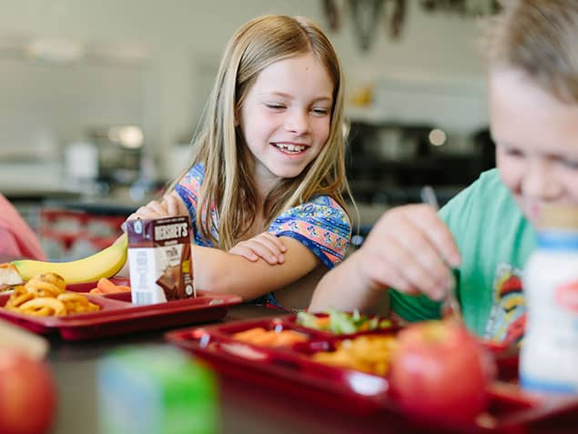
Mealtime
Rules



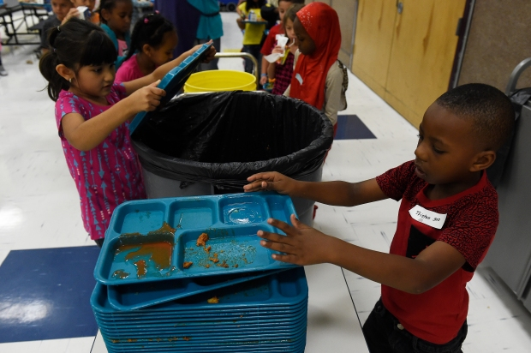
Be Kind and Respectful by raising your hand if you need something
Be Safe and Respectful by sitting in your chair to eat
Be Safe, Kind, and Respectful by cleaning up
Be Kind and Respectful by talking to your friends with an inside voice

