
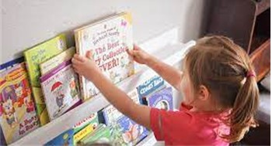
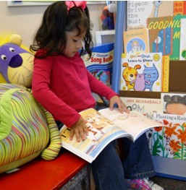
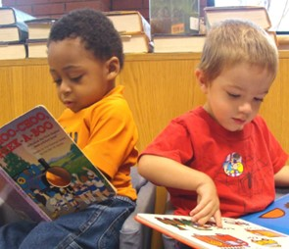
Be Safe and Respectful by putting the books away
Be Safe, Kind and Respectful by keeping your hands to yourself

Library
Rules
Be Kind and Respectful by sitting quietly
Be Kind and Respectful by reading with a friend

