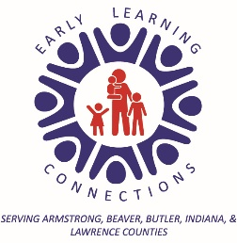

CENTER BASED HEAD START
Family Service Worker and Parent Agreement

We understand that we are in partnership in all areas of ____________________’s developmental growth, including education, nutrition, social, emotional, health and safety.
Our goal for __________________________ is to be ready for school!

As your Family Service worker, I will:
- Be available for at least 2 home visits with you, scheduled at convenient times.
- Support the goals you have made for your family.
- Plan, with ideas from you and the teaching staff, Family Events and Parent Meetings.

- Keep information confidential regarding your child and family.
- Remind you of the monthly learning activities (In-Kind Activities Calendar) for you to do at home with your child.
- Support your efforts in getting your child health exams and dental exams.
- Support you and your child regarding the importance of regular, steady attendance at Head Start for your child’s success in school.

As the parent I will:
- Be available for at least 2 home visits with my Family Service Worker, where we will develop family goals.
- Provide clearances from a health professional if my child has been at the hospital, or ER or has had any surgeries.
- Inform you of any changes in address or phone numbers.
- Provide all the necessary well child exams and dental checkups.
- Develop excellent attendance habits by sending my child to school unless my child is ill.
- Enjoy the monthly learning activities with my child, and return the In-Kind Activities Calendar to the classroom.
- Attend Family Events and Parent Meetings as I am able.
- Call the classroom before the start of the Head Start day to inform you my child will be absent that day.

__________________________________ ________________________________
Parent Family Social Worker

__________________________________ ________________________________
Date Date

