Discovery Rules


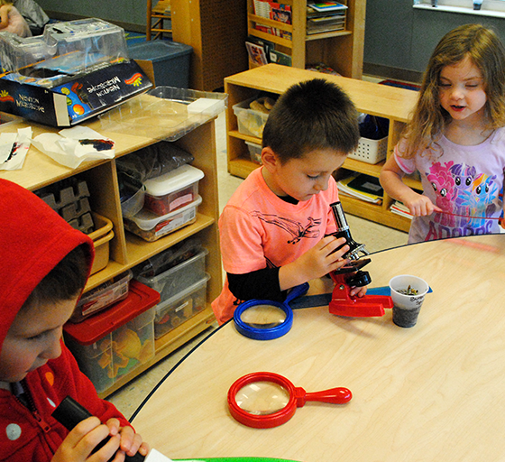

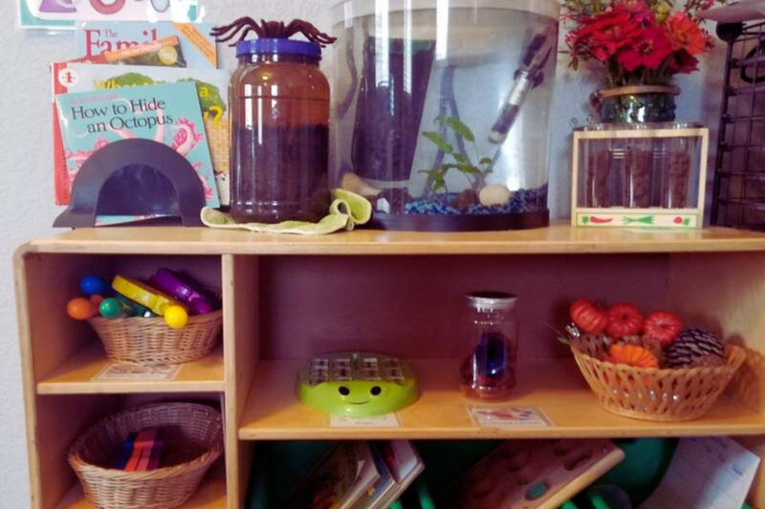
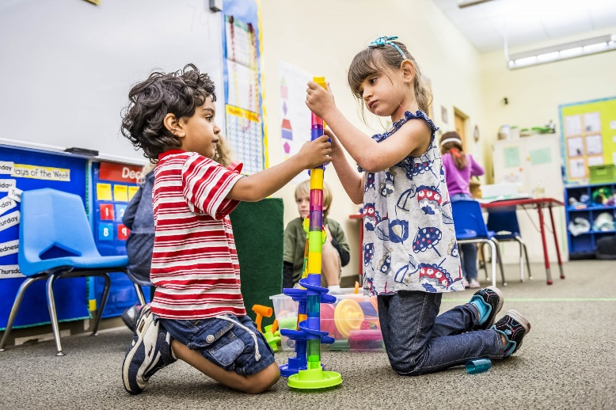
Be Kind and Respectful by raising your hand if you need something
Be Kind and Respectful by taking care of the items in the center

Be Safe, Kind, and Respectful by cleaning up when you are done
Be Safe, Kind and Respectful by taking turns and helping one another

