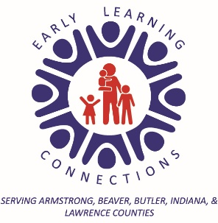

Health Parental Consent

Health Plan Policy

Pennsylvania School Health Law requires physical examinations of kindergarten, new students to the district, all 6th graders, all 11th graders and any students who have no record of a physician's exam on file.

The Pennsylvania School of Health Law requires dental examinations of new students, Kindergarten, all 3rd graders, all 7th graders and any students who have no record of a dental exam on file.

***60 Day Notice: Letter will be given to parents Appendix H-C11
***30 Day Notice: Letter will be given to parents Appendix H-C12

ELC requires parents/guardians to sign the Health Plan Policy H-02-103 as an affirmation that they understand the programs Health Requirements.

- I acknowledge that the ELC Health Plan Policy (H-02-103) has been reviewed and a copy given to me today. After reviewing it, I understand the program’s health requirements, and I am responsible for providing the required documents.

Child’s Name: ________________________________________________________

Parent/Guardian Printed Name: __________________________________________

Parent/Guardian Signature: _______________________________ Date: _________

Staff Signature: _________________________________ Date: ________________

