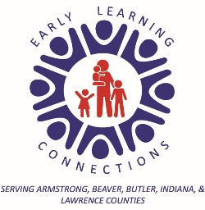

PRE-K COUNTS PROGRAM
TEACHER AND PARENT AGREEMENT
We understand that we are in partnership in all areas of __________________________’s developmental growth, including education, nutrition, social, emotional, health and safety.
Our goal for ______________________________________ is to be ready for school!

As your child's teacher I will:
- Inform you about screening and assessment results and provide information and support when further evaluations might be needed.
- Have learning activities planned that meet the developmental level of your child.
- Provide information about Pre-K Counts through the weekly “Classroom Times”, monthly Newsletter, classroom bulletin board and website: www.earlylearningconnections.org
- Keep information regarding your child and family private.
- Schedule four (4) parent/teacher conferences at convenient times for you to attend. The first will be a home visit but the other three could be held at school or even done on Zoom or over the phone.

As the parent I will:
- Provide information and ideas about my child’s learning and development.
- Provide all the necessary wellness child exams and dental checkups.
- Provide an extra set of clothing for accidental spills.
- Develop excellent attendance habits by sending my child to school unless my child is ill.
- Work on educational and behavioral expectations at home to support my child to further their success in school and at home.
- Attend parent meetings for educational and behavioral success of my child, _________________________, in our Pre-K Counts program either in person, using Zoom, or on the phone.
- Call the classroom before the start of the Pre-K Counts day to inform the teacher my child will be absent that day.

_________________________________________________________________ _________________________
Teacher Signature Date

_______________________________________________________________________ ____________________________
Parent/Guardian Signature Date

