Art Rules

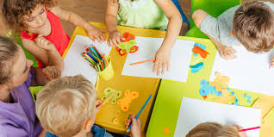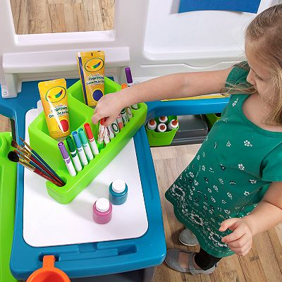
Be Kind and Respectful by Be Kind and Respectful by
taking turns and sharing cleaning up when you are done

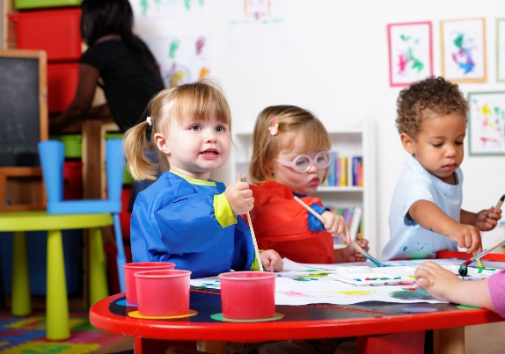
Be Kind, Safe and Respectful Be Kind and Respectful by
by keeping your hands and art drawing or painting on paper
supplies to yourself

