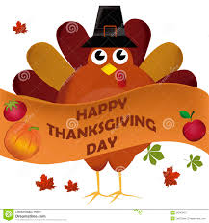  

90 Main Street

Hackettstown NJ 07840

Phone 888-577-8425

Fax 908-852-1078

Email Tickner4758@gmail.com

October 30th, 2024

To: Our Valued Customers,

Re: Thanksgiving Day Schedule  
  
We will be closed Thursday November 28th, 2024. Our schedule for the week of November 25th, 2024, is as follows: If your delivery Day is

**Monday** Delivery Day **– No Change**

**Tuesday** Delivery Day **– No Change**

**Wednesday**-Delivery Day - **No Change**

Thursday- Please, see individual route schedules – If you are not sure what your route is please ask:

Scott’s Shore Route (Cape May, and Ocean) - Orders need to be placed no later than 12pm on Tuesday November 26th for Wednesday November 27th delivery.

Driver 1’s delivery Route (Millburn area) – Orders must be placed no later than 12pm on Wednesday November 27th for Friday November 29th delivery.

Glen’s City Route (Hoboken/Jersey City area) – Orders must be placed no later than 12pm on Wednesday November 27th for Friday November 29th delivery.

Marc’s Sussex County Delivery Route (Sparta, Newton Area) – Orders must be placed no later than 12pm on Tuesday November 26th for Wednesday November 27th Delivery.

Friday-Orders will need to be placed Wednesday November 27th by 12pm for Friday November 29th delivery.  
  
  
 Have a safe and happy holiday!!