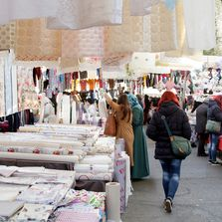
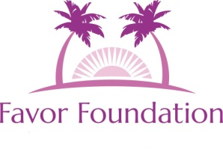

Vendor Fair for Change

To Benefit

Charleston Area Homeless
We are currently accepting vendors for our October 6th Vendor Fair
to be held at

Cathedral (formerly Cathedral of Praise) located at
3790 Ashley Phosphate Road in North Charleston

Vendors have until September 20th to register - Registration $50
300 plus attendees expected, high visibility, you keep your sales

Proceeds benefit to Charleston area homeless will be distributed at our Christmas Outreach in North Charleston on December 22nd.

DONATIONS of non perishable food, coats and new (or gently used) clothes now being accepted

For further information or donation pickup please contact:
Shontia Gilliard at 843-779-7719 or Glenda Backman at 843-514-1257

Favor Foundation is a public charity/non-profit agency (501c3 pending) that assists Charleston, SC and surrounding area homeless, impoverished and in crisis with food, clothes and viable resources.
For further information visit our website at https://favor.foundation/

