**Coronavirus, Self-Isolation & Staying Healthy**

**There are different ways people can get ill**



**Recently, a new virus has spread around the world**

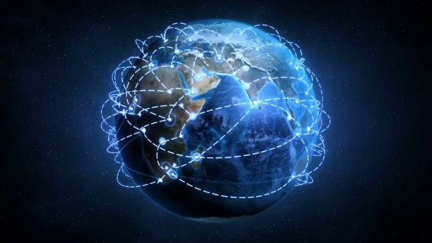

**One of the ways is by catching a virus**

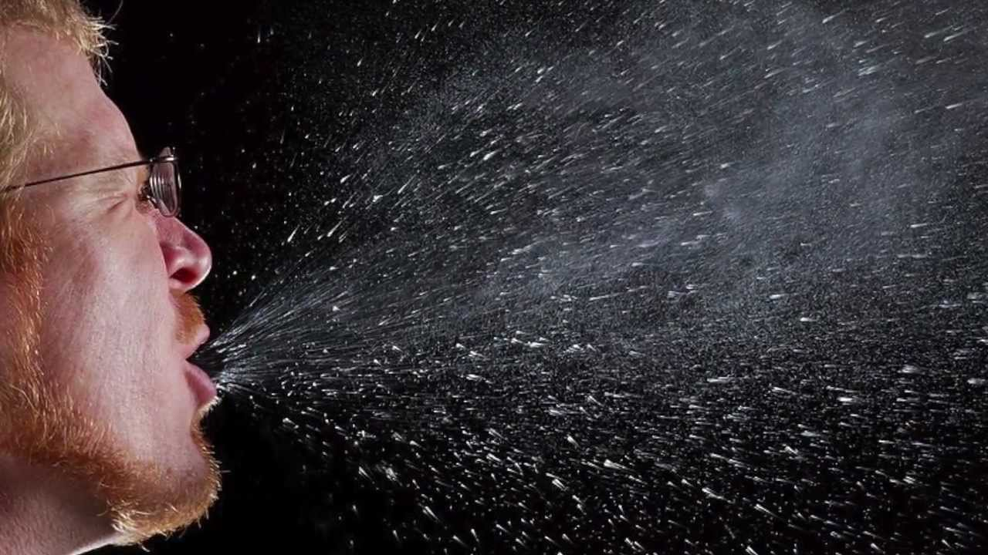

**It is called Covid-19, a type of Coronavirus**

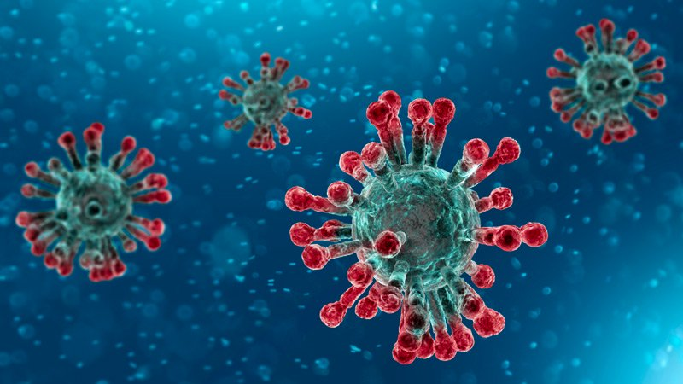

**Scientists and Doctors are working hard to learn about this virus**

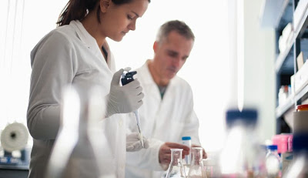

**So that they can protect us and keep us safe and healthy**

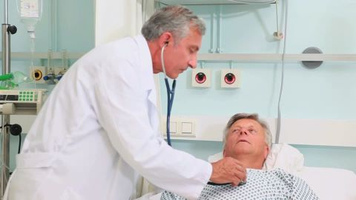

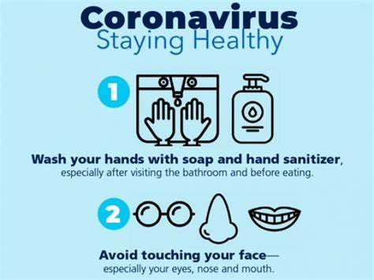**While they are at hard at work, they need us to help by doing simple things:**

1. **Washing our hands regularly and thoroughly**
2. **Try not to touch our eyes, nose and mouth**
3. **Eat well, exercise, take any regular prescribed medicines**

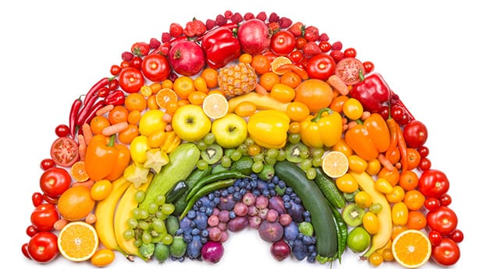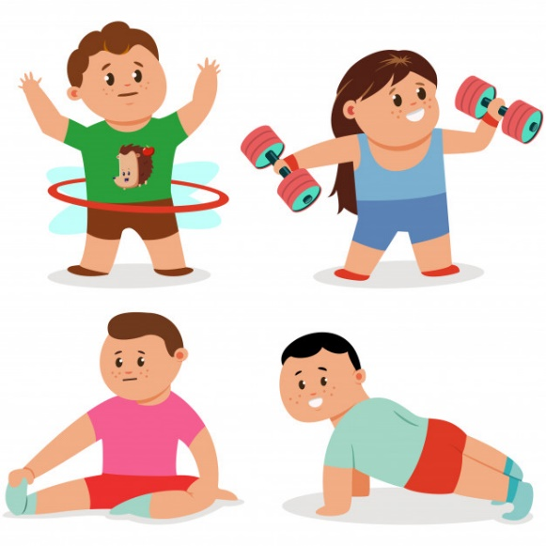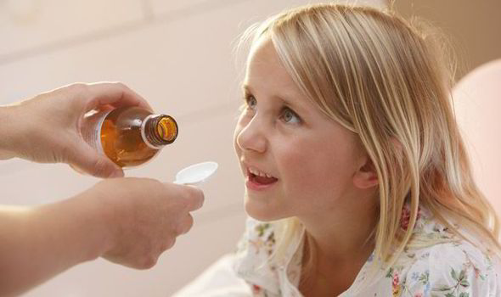

1. **Self-Isolation and/or Social Distancing:**

**The last step is super important**

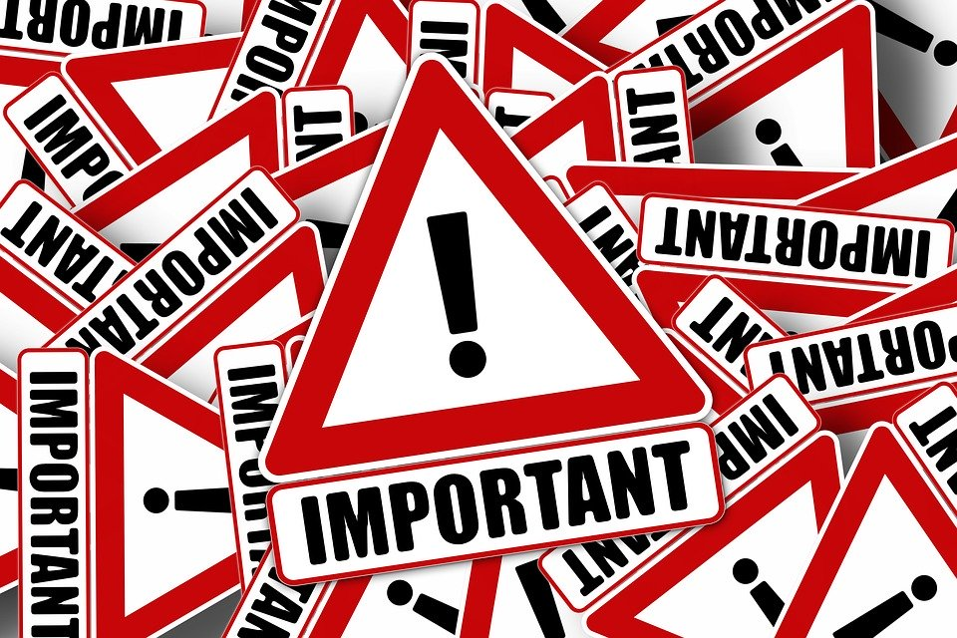

**Self-isolation means staying at home**

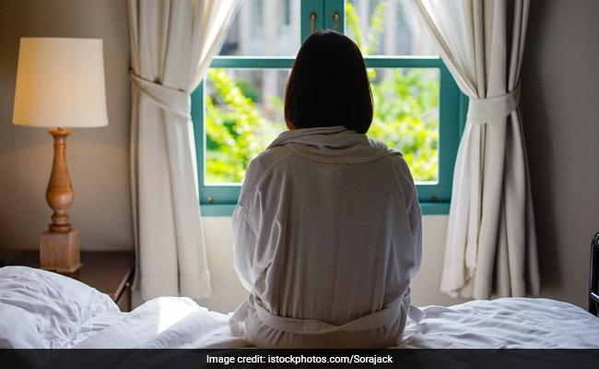

**Social distancing means staying at least 2metres apart from people you do not live with**

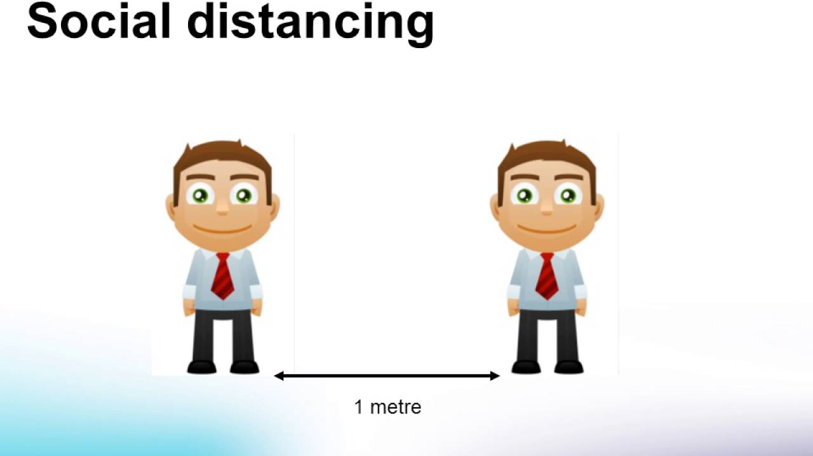

**The reason this is important is because the virus cannot live outside of a person for very long (we think 72 hours – or three days – maximum)**

[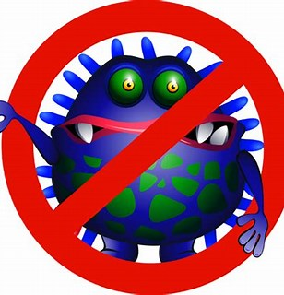](https://www.bing.com/images/search?q=virus+cartoon&id=F8E9FBB45ECDDD3479516ED9A1EA8B2D7F232F59&FORM=IQFRBA)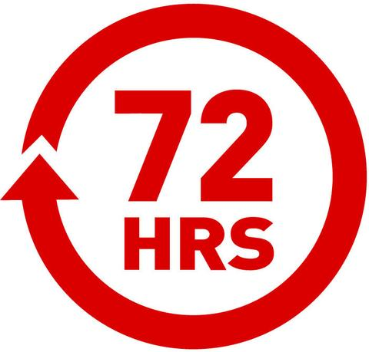

**So, if we stop going out and being with other people**

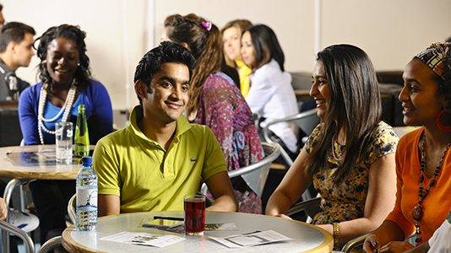

**Which means less people get ill**

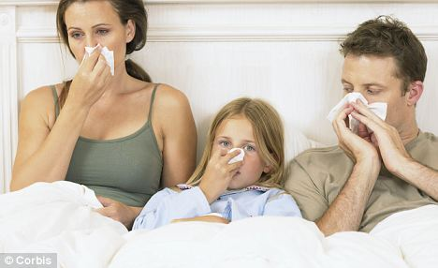

**The virus stops moving around and spreading**

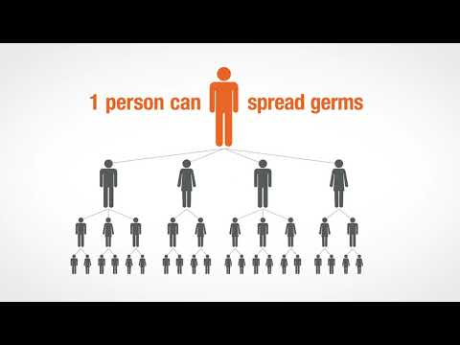

**We will have enough doctors and nurses to take good care of anyone that does get sick**



**And gives the scientists and doctors time to find**

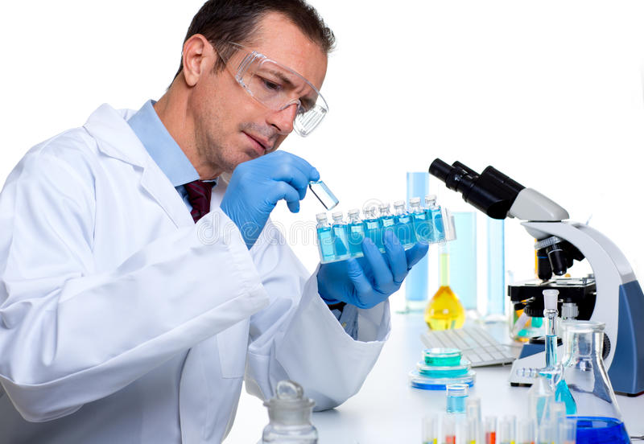

**Vaccines**

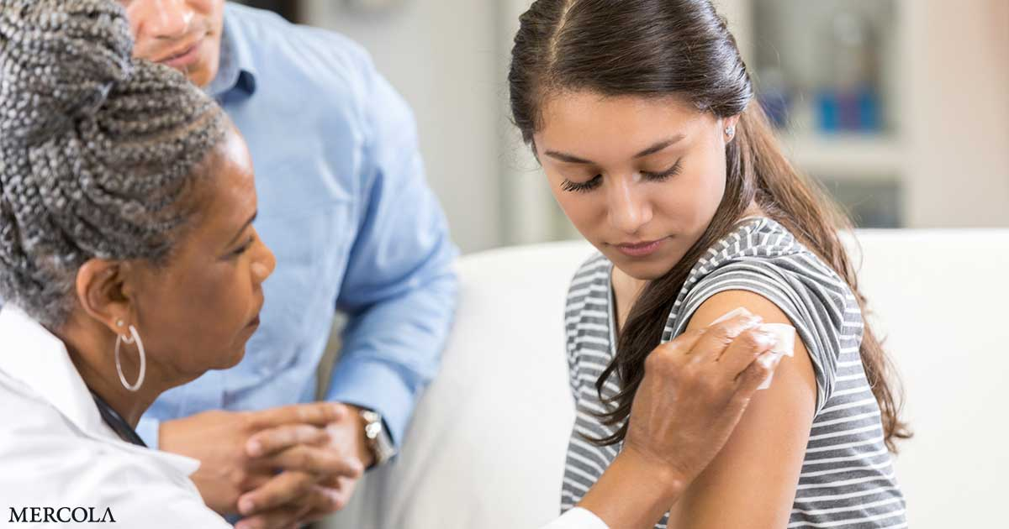

**Treatments**

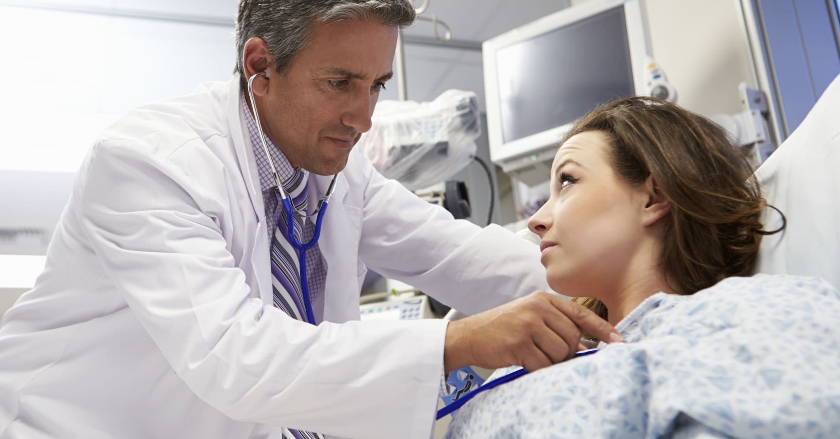

**or cures**

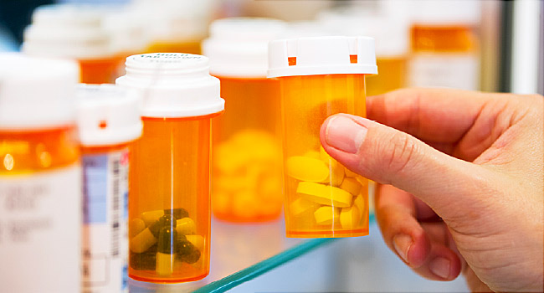

**This means lots of time at home for a while**

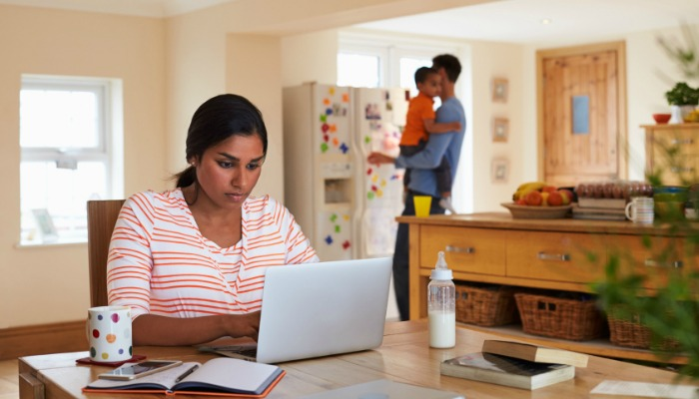

**It means we might not be with some family & friends for a while**

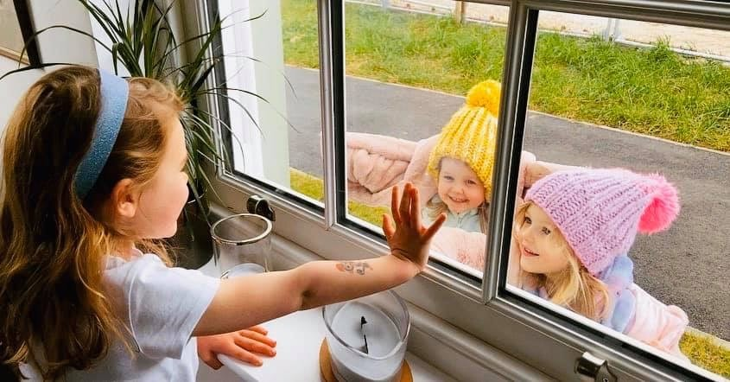

**It means no school**

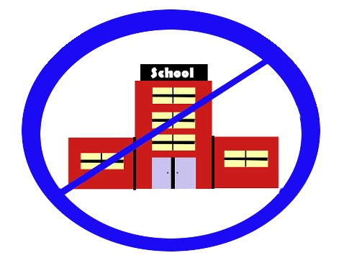

**It means we won’t be able to go to any sports, clubs or activities we usually do**

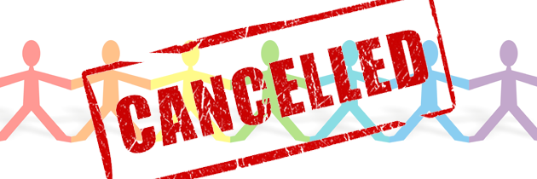

**It means only people who are really important to keeping us safe, healthy and fed should go to work**

 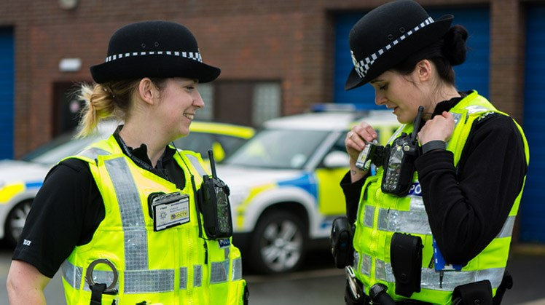 

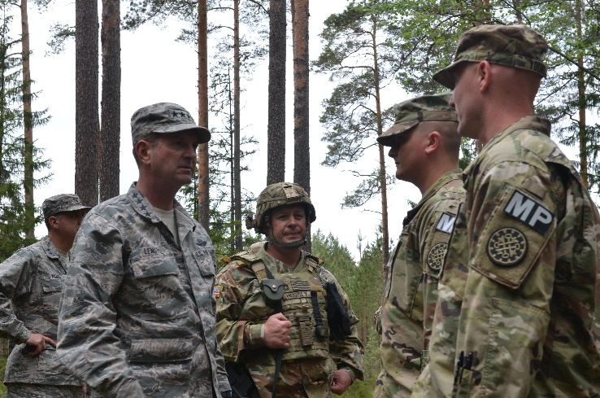 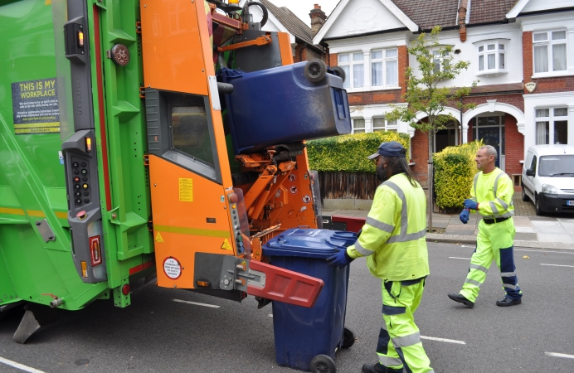

**This change can be hard, for us and those around us**

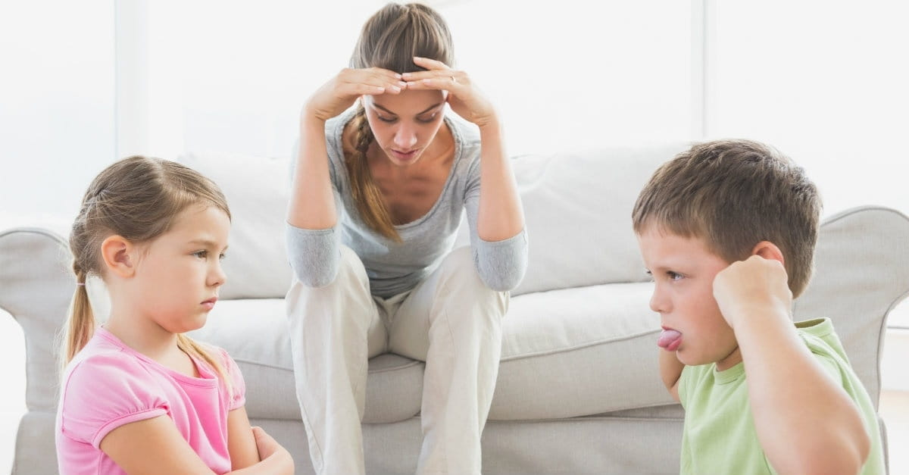

**Some people get bored**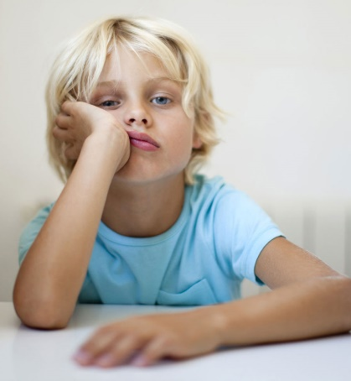

**Some people like being at home**

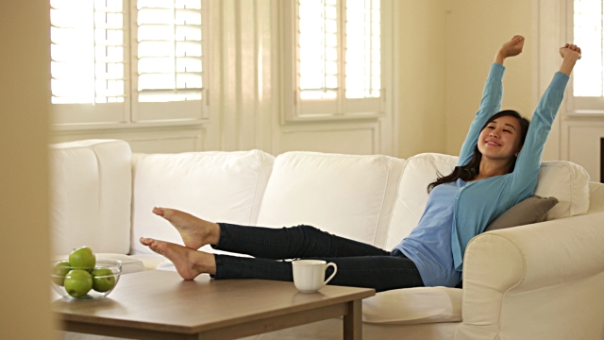

**Both of these things are natural**

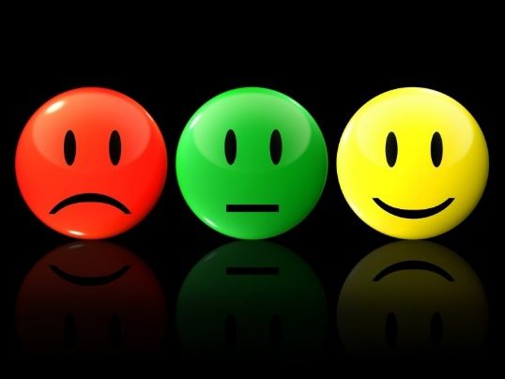

**In the meantime you should keep yourself occupied**

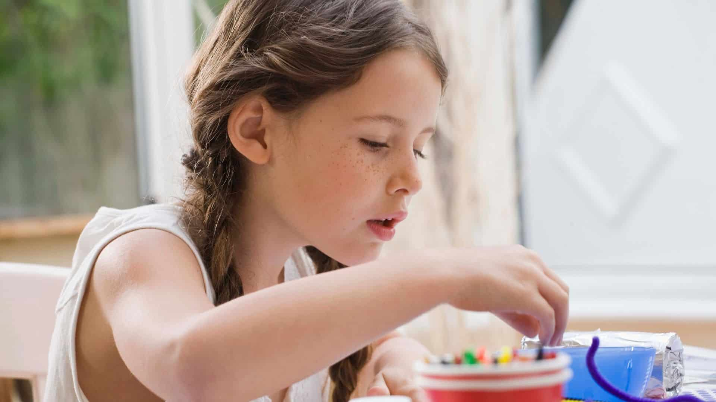

**With reading**



**With work or learning**



**With drawing**

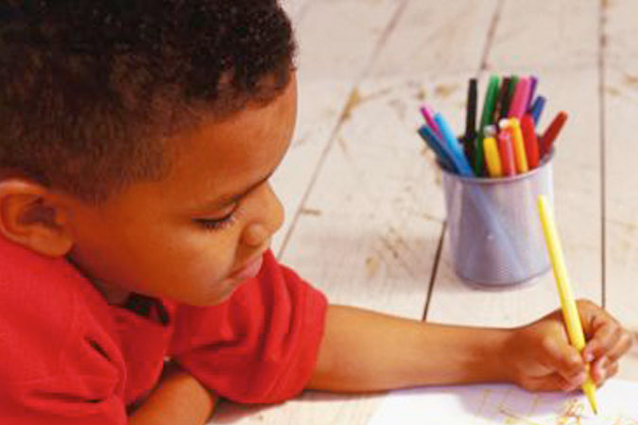

**With watching tv**

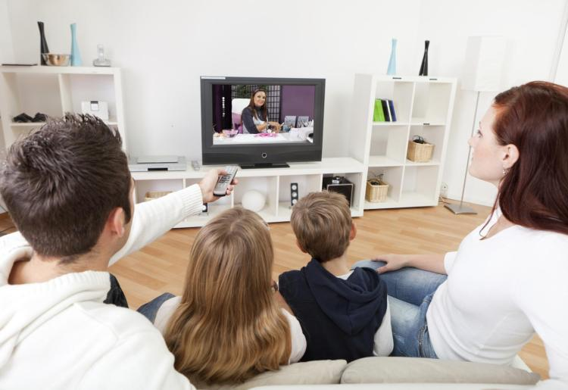

**With exercising**

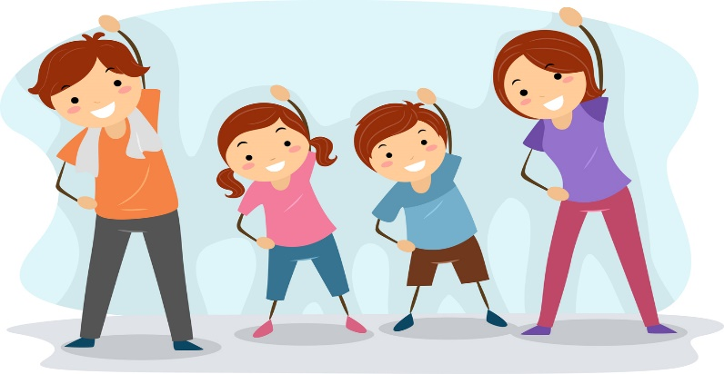

**With spending time with pets**

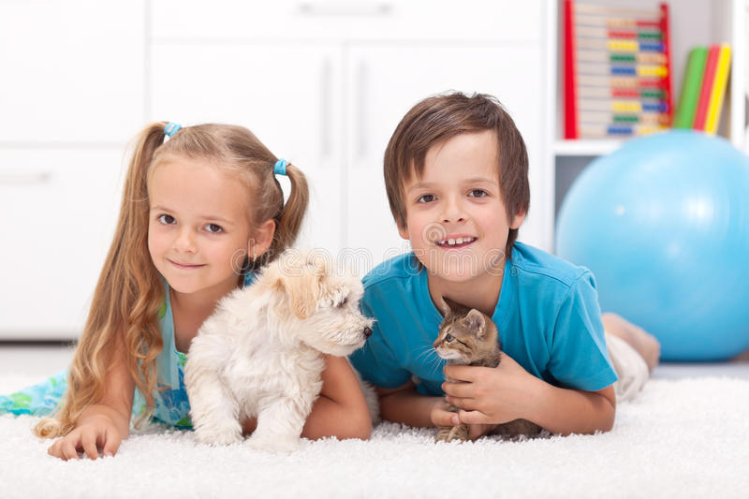

**With gaming**

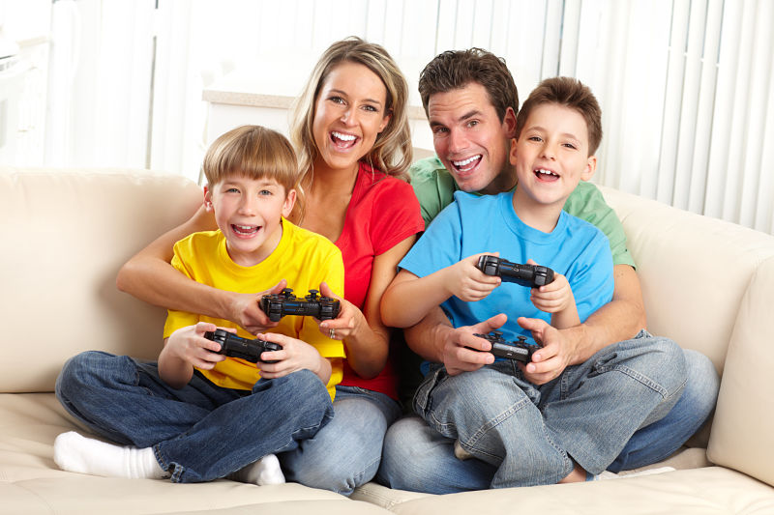

**With spending time with those we live with**

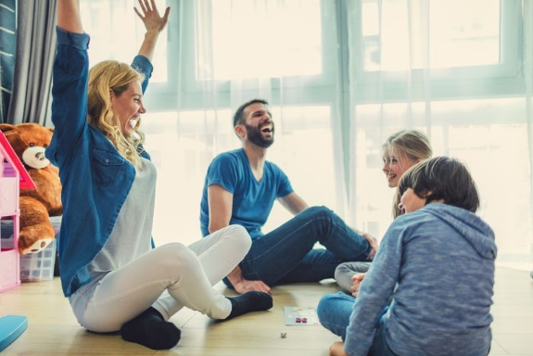



**With using technology to spend time with family and friends**

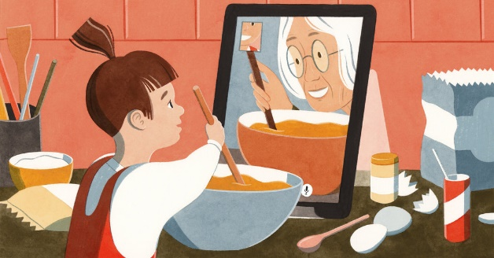



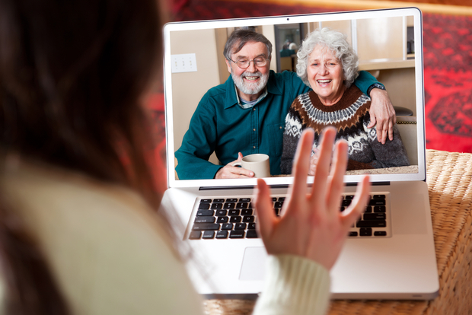

**Once we have learnt what we need to beat the virus & keep us safe**

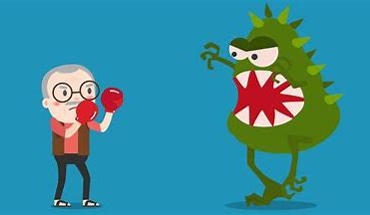

**Back to school, or work**

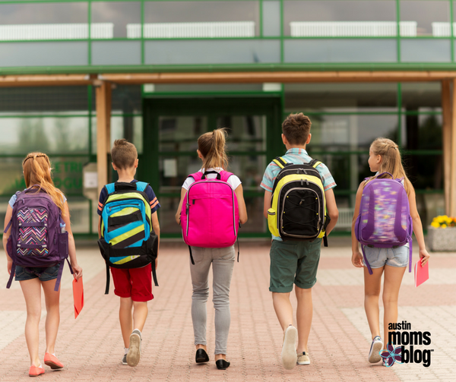

**We will go back to our normal routines**

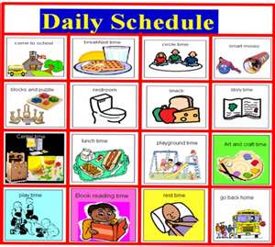

**Back to seeing family or friends**

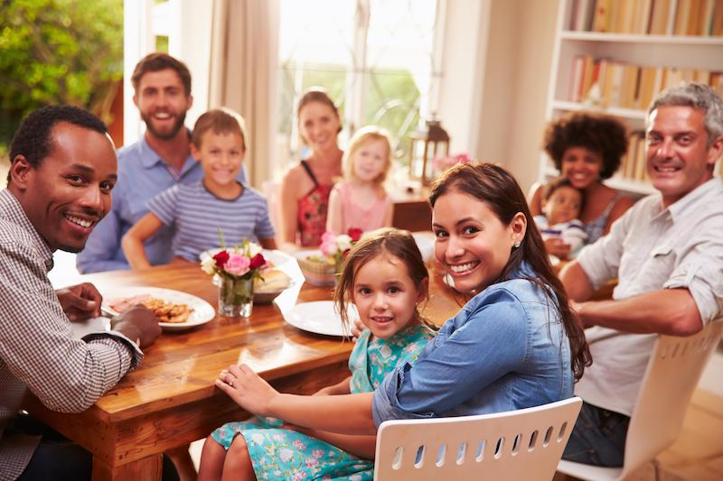

**Back to activities or clubs, like sports**

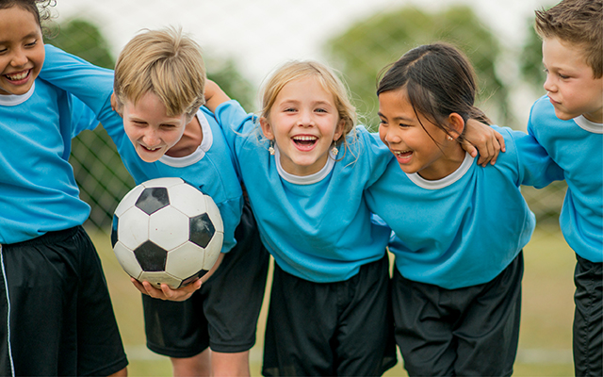

**And everyone might sometimes feel a bit anxious or worried**

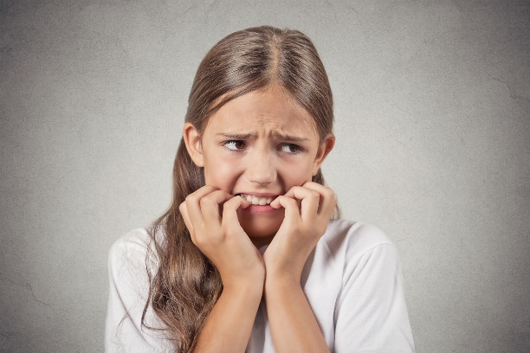

**It can be hard not knowing when this will be**

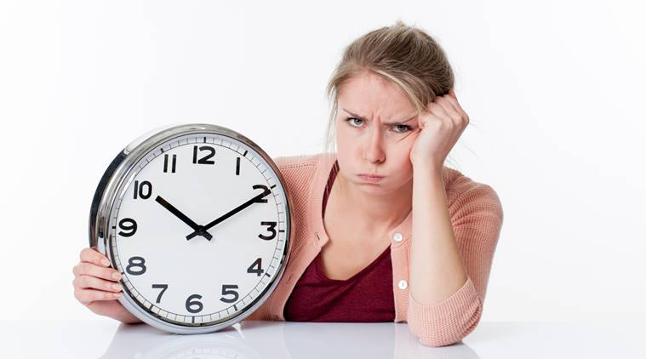

**We might even feel angry**

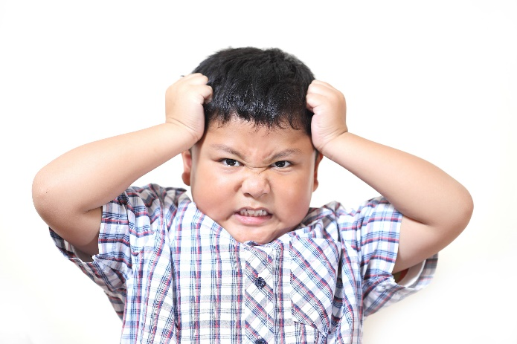

**This is ok, it is good to talk about it**

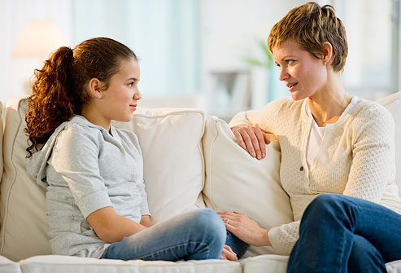

**We are all in this together**

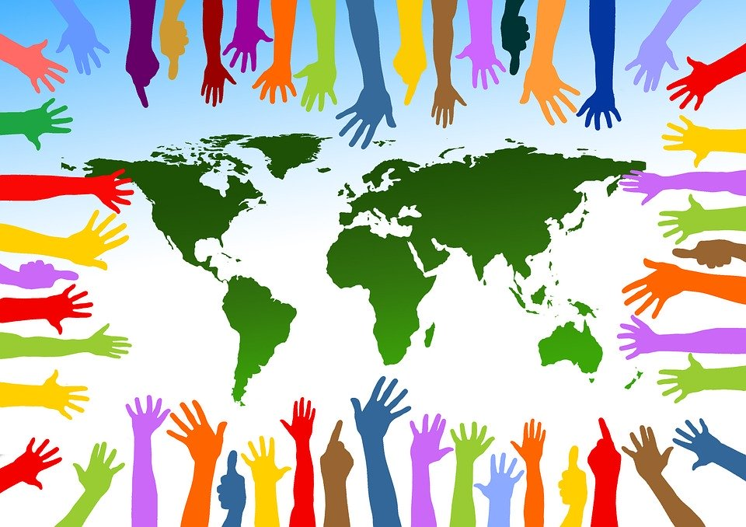

**and together we can stay safe and healthy! 😊**

