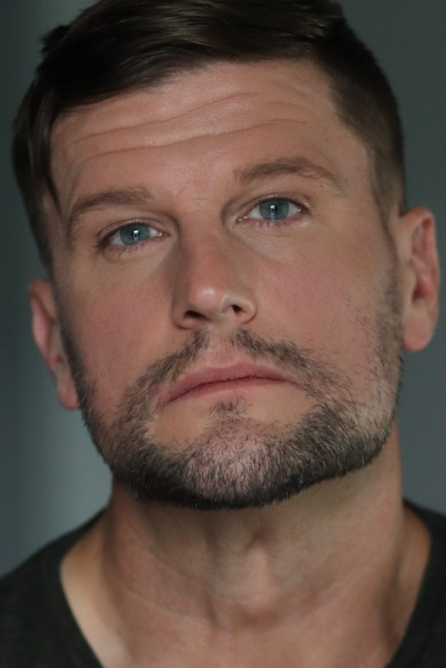Sage M. Lawrence

(Russell J. Terry)

C/O 109 Hobbs Drive, Columbia, TN 38401, USA

**SAG-AFTRA 11486280 Nashville Local**

+1-719-229-6393 (Mobile)

[Sage.Lawrence81@gmail.com](mailto:Sage.Lawrence81@gmail.com)

**Height:** 5’11’’ (180cm) **Skin Color:** White

**Weight:** 195 lbs (88 kg)  **Eye Color:** Blue

**Chest:** 42 in (106 cm) **Hair Color:** Brown

**Waist:** 32 in (81 cm) **Hair Length:** Short

**Ethnicity:** White/Caucasian **Hair Type:** Straight

**Performance and Training Experience**

**Year Role Production Director Company**

2016 Student Stunt Training for Film Lv1-4 Fred Bauer USA SSC Inst. LLC

2017 Student Acting For Film Alan Dysert The Actor’s School

2018 Jaye Alone Ernest B. Indep.

2018 Truck Driver Tommy Callahan H. Kellerman

2018 Edgar The Upper Hand D. Simpson

2019 Multiple In My Shoes A. McCall

2020 Mr. Green Fisher C. Bryson Cassie B. Prod.

2021 Russian Guard Red Notice R.M. Thurber 7Bucks Prod.

2021 Stunt Driver CMA Awards Ford Motor Company

2022 Student Acting for Film K & W Arnold 4th Wall

2023 Student Scene Study L. Holloway Studio for Acting

**Skills**

**Singing** Tenor, Baritone, Bass (Theatric, Jazz, Clean, Rock, Metal)

**Accents** Am. English (Native, Southern, Jersey, Boston), British (Cockney), Scottish

**Character Voices** Various Cartoon Characters.

**Other** Dancer (Foxtrot, Tango, Push-Pull Swing, Waltz, Rumba) Horseback Riding, Fencing (Kendo), Massage Therapy (550 Hrs Trained), Stage Fighting, Tae Kwon Do, Shorei, Ji Do Kwan, Aikido, Kickboxing, Knifefighting, Mace and Taser Training, Advanced Firearms Training (M4, M9, 240B, M16, and others), Non-Verbal Communication, and Computer Design and Programming. Have been on the production side as a director, PA and lighting tech (Grip).