Dog Behavior and Training Handbook

Table of Contents

Understanding Dog Behavior 4

**What is a Behavior?** 4

**Dog Body Language** 4

**Dog Body Language Visual** 5

**Signs of Fear** 6

**Signs of Aggression** 7

**Signs of Stress and Anxiety** 7

**Signs of Confidence and Sociability** 7

Teaching Your Dog to Recall 8

**It’s Disneyland out there!** 8

**Make it worthwhile!** 8

**Come means only good things happen** 8

**Fun ways to achieve a reliable recall!** 9

Exercise and Enrichment 10

**Physical Exercise** 10

**Mental Enrichment** 10

Teaching Your Dog to Stay on its Mat 11

**Getting started** 11

**Settling down** 11

**Staying on the mat** 12

**Adding a cue** 12

**Getting off the mat** 12

Specific Behavioral Issues 12

**Boisterousness** 12

**Play Biting & Mouthing in Puppies** 13

**Signs of Fear** 15

Appendix A: Body Language of Fear in Dogs 16

Appendix B: The Engage – Disengage Game 18

Appendix C: Do’s and Don’t’s of Dog Training 20

Appendix D: Dog Reactivity Chart 22

Appendix E: Dog Calming Signals 23

Appendix F: How Kids Should Interact with Dogs 24

Appendix G: Facial Expressions of Stress in Dogs 25

Appendix H: Physiological Signs of Stress in Dogs 26

Appendix I: Severe Signs of Stress in Dogs 27

# Understanding Dog Behavior

## **What is a Behavior?**

Behavior is a way in which an animal acts. Behavior can be influenced by:

* Genetics
* Early learning experiences
* Environment

Behavior is also based on consequence. A Behavior that has a positive response will result in the animal being **more likely** to repeat the Behavior. 'Positive response' can be a reward in the form of food or praise, but it may also be something you don't expect, like any kind of attention from you, including eye contact or verbal reprimand.

## **Dog Body Language**

All animals demonstrate body language. It is important that volunteers and fosters interpret an animal’s body language and adjust the way they approach an animal to accommodate its emotional state. It is important to understand dog body language and what they are trying to tell you. Everyone should consider the following dog body language:

* Posture
* Ears
* Eyes
* Hackles
* Lips/mouth
* Vocalizing
* Tail

## **Dog Body Language Visual**

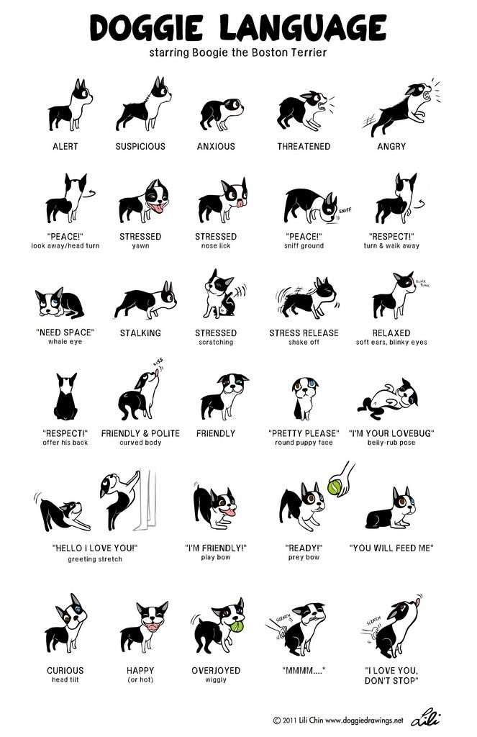

## **Signs of Fear**

* Distance seeking Behavior (requesting more space)
* Tongue flicking/licking
* Lip lift
* Turning away/avoiding eye contact
* Rolling on back (appeasement)
* Urinating
* Crouching down
* Tail tucked under
* Paw lifted
* “Whale eye” (whites of eyes exposed)
* Hiding
* Ears down
* Trembling

*Note: fear can also lead to aggression in a dog if pushed beyond its comfort levels.*

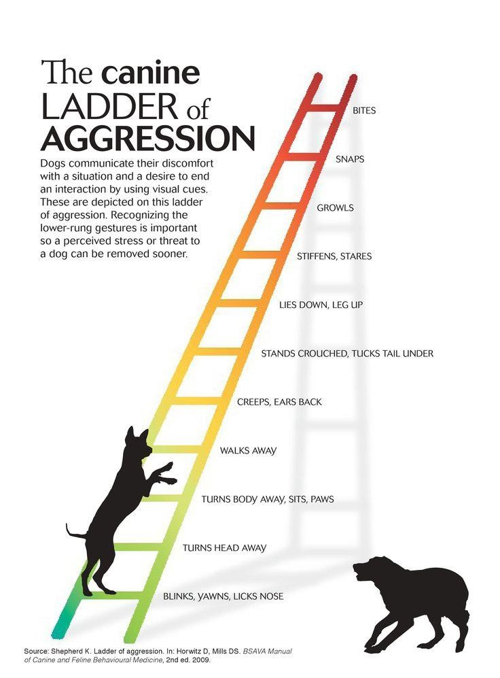

## **Signs of Aggression**

* Stiff body posture
* Direct visual contact
* Forward or defensive posture
* Erect tail (may wag very slowly)
* Retraction of lips/snarling
* Hair standing up on the back of neck
* Barking or lunging

*Note: aggression can occur if earlier fear signs have not been noticed and acted upon. A dog showing signs of aggression is warning you away from them.*

## **Signs of Stress and Anxiety**

* Excessive salivation
* Excessive shedding
* Trembling
* Quiet growling
* Dilated pupils
* Yawning
* Pacing
* Destructive Behavior
* Hiding
* Lip licking
* Showing whites of the eye (“whale eye”)
* Backing away
* Not eating treats or food when previously would
* Fast, shallow breathing
* Vocalizations (ie. whining)
* Obsessive Behavior (ie. tail spinning, tail biting)

Dogs exhibiting these signs of stress or anxiety will need time and extra work to help them to come out of their shell. Volunteers and fosters should proceed extra slowly when working with dogs showing these signs.

## **Signs of Confidence and Sociability**

* Relaxed body posture
* Soft eyes
* Ears forward and relaxed
* Tail wagging at a medium height
* Raised or erect head
* Approaching for more “information”

# Teaching Your Dog to Recall

As much as we would like to believe it, teaching your dog to come or ‘recall’ is not a pre-programmed response. While it is an instinct for a puppy not to venture too far from the pack, as the puppy gets older and more confident, the previously reliable recall quickly fades too.

Despite all of that, recall is one of the most important commands to teach a dog. It's not all about coming back when the dogs off the lead – it is more about getting your dog to focus on you and respond to you. This also makes for a positive relationship between you and your canine friend!

## **It’s Disneyland out there!**

Getting a dog to focus on you on a walk is a difficult task. Imagine taking a child to Disneyland and then while attracted by all the interesting sights and sounds, you try to teach the child something new. You would be unlikely to be successful because of the many distractions that Disneyland would offer. It is much the same when you take your dog to the park where there are all kinds of interesting smells, sounds and sights that catch the dog’s attention. In such a situation, trying to get him to concentrate on what you are trying to teach him, is often extremely difficult. For this reason, to get the best success with a recall, start in the home or garden, where there are minimal distractions. You want to build up the habit of focusing on you – so it becomes second-nature.

## **Make it worthwhile!**

First, work out your dog's motivations. Some dogs are very food-driven and will work for even dry kibble. Some dogs have a favorite toy. Some dogs may need higher stakes, especially when there are more interesting things around, for example little bits of sausage, chicken, or cheese.

Set your dog (and you!) up for success. There is no point working on focus or recall with treats when your dog has just eaten! If your dog has a favorite toy item, try to make this 'special' for training sessions or walks, so he will be more likely to work for it.

## **Come means only good things happen**

To make a recall fast and reliable, your dog should only associate being called to you with good things. This means that you should **never** punish a dog when it comes back to you. Although it may be frustrating, **a recall should always be a positive** **thing** and your dog should always be rewarded for choosing to come back or focusing on you, even if it does take a while. Try to make coming back to you 'normal' - just call your dog's name (or use a certain word) throughout the day or randomly on walks. This way, the recall is of little consequence – your dog will enjoy the food and then return to whatever he is doing. If you need to get your dog to do something it doesn’t like, for example clipping nails or bath and grooming, then it would be better to simply set everything up and then retrieve the dog, rather than calling them to you.

‘Come’ or the dog's name should also be spoken in a happy and cheerful voice. Using a higher pitched voice is more attractive to dogs and therefore more likely to respond to it.

When establishing a recall on walks, start by using a long-line (a lunge-line or an extra-long lead will do) so that the leash is slack, and the dog is effectively 'off-leash' but you still have control. Practice the recall in various situations and only progress to off-leash once you are 100% confident of your dog's recall ability.

## **Fun ways to achieve a reliable recall!**

While this may seem like a daunting task – teaching your dog to come when he is called can be fun for everyone in the family – most importantly the dog. Below are some suggestions which will help you achieve the best recall results.

###### *The name of the game*

Play a game with your dog so he makes an association with his name and food. Start around the house or in the backyard. As soon as your dog looks at you when he hears his name, reward him with a treat. Very soon you’ll have a dog that when he hears his name his head will whip around to see where that treat is hiding! This can also be played on walks too when your dog is clipped to a leash.

###### *Catch me if you can*

This is a great one-person game to play. Drop a piece of food on the ground, make sure your dog sees it and is eating it, then run as fast as you can in the opposite direction. When your dog catches up to you, drop another treat on the ground and sprint off in the other direction. Soon, your dog won’t want you out of his sight.

###### *Piggy in the middle*

If you have several people in your family, playing this game with your dog can be loads of fun. Have everyone loaded with your dog’s favorite treats and spread out. Then one by one, each person should call the dog and when he reaches a person he is rewarded with a treat. This game is a great way to stimulate your dog and is most effective if the people calling the dog avoid using distractions such as making noises and squeaking toys mentally and physically.

###### *Hide and seek*

If you have two people, have someone hold your dog while you find a place to hide (remember to keep it easy for beginners). When you are ready, call your dog and wait until he finds you. When he does, make sure that you praise him and reward with a favorite treat.

###### *What to do if it isn’t going to plan when off-leash*

Despite all our efforts, your dog isn’t always going to be a perfect angel and sometimes things will go wrong. You may find that your dog has found an irresistible good smell that he just can't leave. Remember, don’t waste your breath calling his name, instead go towards him and clip him on his leash for the rest of the walk - practicing your name game the rest of the way home. Alternatively, run in the opposite direction if it is safe to do so. The dog should always come to you – so moving away will encourage the dog to recall. Remember, even if it takes time, always reward your dog for coming back. There is also little point to calling a dog that is fully engrossed in something else.

It is important to remember that it is a privilege to have our dogs off leash. For this reason, and out of courtesy to others, **please only let your dog off leash if you have complete control, even he is friendly with all dogs and people.** Never assume other people or their dogs will be happy with your dog coming up to them. **Only let your dog off-leash in an approved area where it is safe to do so.**

# Exercise and Enrichment

Some dogs, especially working breeds, have a lot of energy and drive, but all dogs can become bored. Every dog needs some level of exercise, but dogs are intelligent creatures who like to problem-solve. At its worst, boredom can lead to many behavioral problems such as excessive barking, digging and destructive behavior. Boredom can also contribute to more serious problems, such as separation anxiety and obsessive, compulsive behaviors.

It is important to provide BOTH physical and mental stimulation, especially for breeds which were bred to have a

'job'.

## **Physical Exercise**

Exercise should be at an appropriate level for the dog. Some dogs may be content with one daily walk, whereas others need multiple walks – especially breeds like Huskies and Collies.

Walks are important, but it is important that they are 'constructive' too. Being dragged around on a short leash for 40 minutes will likely just be frustrating and not as fulfilling as a 20 minute 'sniffer' on a loose leash. Walks should be an opportunity for your dog to explore the world and build a good relationship.

Try to keep walks to quieter areas, especially in the early days. Try to keep the leash loose and stay as relaxed as possible – don't rush the dog around and allow him to sniff at his pace as much as possible. This keeps walks relaxed and positive.

Take food on walks, and try to walk the dog when he is hungry (i.e. not straight after a meal). As you walk along, periodically call his/her name and reward him/her with a treat. This encourages your dog to focus on you. Some dogs are very food-motivated and will work for their normal kibble, whereas for some dogs you will need to 'up the ante' and use higher value food, like sausage, chicken, cheese, or ham.

Playing games in the garden is a good way for your dog to exercise, and again builds your bond. Constructive toy play like fetch and 'find it' are great. Always swap one toy for another and encourage your dog to drop a toy before throwing another; avoid taking anything out of your dog's mouth, as this is confrontational and may encourage your dog to guard what is his.

## **Mental Enrichment**

Enrichment can really mean anything – it's whatever is stimulating for your dog and gets his brain working!

*Sniffing*

* Go for a long, meandering walk dictated by your dog's nose. The time is his – don't rush him. Sniffing really calms dogs down and releases happy hormones.
* Try different scents using essential oils or even natural scents, like herbs.

*Training sessions*

* Keep sessions short but positive – use whatever most motivates your dog (food, a favorite toy, praise). If your dog loses interest, then the session is too long or difficult.
* Teach him something new! The obvious tricks are 'sit', 'drop', 'shake', 'high five', 'stay', but there are lots of others! You can teach a dog to touch your hand or an object (targeting), paw at an object or stand on a mark (free shaping), speak, learn the names of objects, crawl on his belly or bow...the possibilities are endless!

*Food enrichment*

* Using food is a great tool for dogs who like their food. You can make enrichment items a 'treat' or, for high-drive dogs, use ALL their daily food in the form of enrichment items.
* This is also great for dogs who like to inhale their food.

Remember to start easy and increase the difficulty. Dogs may need help working out how items work and may get frustrated if they don't understand – this will make them less likely to engage in the future.

*Make Things Interesting*

* Scatter food on the floor (or in the garden) so the dog must snuffle around.
* Hide food:
  + under blankets, around the garden, etc.
  + Put food in boxes or scrunch it into newspaper.
* Puzzle toys: there are loads on the market, or you can make your own using boxes or plastic bottles.
* Stuff food into a Kong, or smear a Kong with peanut butter, canned cheese, bologna or chopped meats (for the pros you can even freeze it).
* Long lasting chews like rawhides and antlers.
* Fill a kiddie pool with water (for dogs who like to swim) or sand (for dogs that like to dig). You can bury items in the sand – like food or favorite toys.
* Rotate toys and items so that the dog doesn't get bored.

People are always coming up with new and interesting enrichment ideas. Search online for inspiration or get creative!

# Teaching Your Dog to Stay on its Mat

By providing a mat for your dog, you give it an easily recognizable area where it can go if it is feeling

uncomfortable or wants a rest. It also gives you a place to send the dog if you want it out from under your feet or away while you enjoy a meal. You can take the mat wherever you go, which makes it easier for the dog to behave appropriately outside the home.

## **Getting started**

* Start in an environment where the dog is calm and there are minimal distractions.
* Put the mat on the ground and place your dog’s favorite treat or toy on top.
* If your dog puts at least one paw on the mat, mark the behavior with a “yes”, and give a treat.
* If the dog keeps its feet on the mat, mark the behavior again and give the dog another treat.
* Repeat this step until your dog is quite comfortable with its feet on the mat.

## **Settling down**

* You want to get the dog to settle in a comfortable position that it will be able to maintain for extended periods - usually a ‘drop’ position.
* Lure the dog into a down position and mark the behavior with “yes”, followed with a treat.
* Continue to give the dog treats for maintaining the drop position.
* If it gets up, lure it back to the drop position and give the dog treats for staying on the mat.
* You are trying to teach the dog that good things will happen if it stays on the mat.
* It is best to repeat these steps in several short sessions.

## **Staying on the mat**

* When the dog is in a comfortable position, offer it a treat as you move around the mat.
* Move away and then come back and reward the dog.
* Gradually increase the distance each time you move away.
* You will need to make sure your dog is quite comfortable on the mat before you leave the room.
* Using enrichment items, such as Kong’s, pig’s ears, or bones, will also encourage your dog to stay on its mat.
* Each time the dog receives a treat inside, it must first settle on its mat.
* If the dog moves off the mat, calmly ask it to get back on and reward it for doing so.
* You will be able to go about your daily business while your dog is busy enjoying its treat but remember to verbally praise your dog and try to return before it finishes the treat.

## **Adding a cue**

When you are confident that your dog understands how to use the mat, it is time to add a cue to the Behavior.

* Have some treats ready and cue the behavior of getting on the mat with a word such as “mat”.
* If the dog gets on the mat, mark the behavior (“yes”) and immediately reward it.
* Let the dog off the mat and try again.
* Initially, you should do this close to the mat, so the dog understands what you are asking for.

## **Getting off the mat**

It is important that you let the dog know when it can move off the mat, otherwise it will become confused. Saying words such as “OK” or “off” will let the dog know when it can move off the mat.

# Specific Behavioral Issues

## **Boisterousness**

A boisterous dog has not yet learned how to interact in a ‘polite’ way with people and can show over the top attention-seeking Behaviors such as jumping up and mouthing. This is in part because he loves attention and is very excited about getting it, so he finds it difficult to act calmly, and in part due to some anxiety about interacting with people – which can drive more ‘over the top’ Behaviors.

Teach the dog that these inappropriate Behaviors get no reward and are therefore pointless. At the same time, reward the dog for showing desirable Behaviors. It’s essential that everybody interacting with the dog follows the same rules so it can learn and ensure that everyone is ALWAYS aware of the following rules.

To teach this dog how to interact appropriately you will need to be positive, patient, and consistent with him. Every time you interact with him you are essentially rewarding the Behavior he is showing at the time, and you can use this to teach him about how to interact. He should learn this very quickly (within 2 weeks).

* Boisterous dogs tend to be excitable dogs. Try to interact with your dog calmly, using calm movements and tones. You don’t want to 'hype him up' by being boisterous or excitable yourself.
* You will need to completely ignore any unwanted or inappropriate attention seeking Behaviors (no touch, talk or eye contact). This will remove the reward for the attention seeking Behavior. Expect the dog to try harder for a little while and then give up. You need to be very consistent – if you give up after a while or when the try especially hard you will simply teach them to persist. If you can’t ignore the behavior, make a distraction that does not involve direct attention (i.e. a noise in another room).
* Give the dog lots of positive attention whenever they show good/calm Behaviors. This will teach them what they should be doing more of – and they will repeat these Behaviors more and more to please you. You can also use treats to begin with to speed up this process.
* Give the dog lots of appropriate outlets for their energy – walks, enrichment feeding, and training are all great ideas. Games such as tug, playing with toys or hide and seek with treats are also really good ways of using up some of this energy.
* Avoid any form of punishment or reprimand. This will only make the dog more anxious and therefore is likely to lead to a deterioration of their Behavior in the long term and may result in the development of other fear related Behaviors such as aggression. In addition, for a dog like this, negative attention is still attention, so is still likely to reinforce his ‘naughty’ Behaviors.

**GOLDEN RULE:** Totally ignore (NO TOUCH, TALK OR EYE CONACT) inappropriate behaviors and instead reward the dog for showing appropriate Behaviors. Expect the dog to try harder before giving up – don’t give in as you will only teach them to try persisting. Never tell the dog off – this will reinforce its fear and is likely to make the Behavior more intense and may result in fear related Behavioral issues.

## **Play Biting & Mouthing in Puppies**

Just as children like to explore the world with their hands, puppies like to explore the world with their mouths. Mouthing is a common and normal Behavior in most young puppies. Mouthing Behavior is rarely aggressive and not intended to cause harm. As puppies are usually highly motivated to exhibit this type of Behavior, attempts to suppress or stop it are unlikely to be successful unless you give your puppy an alternative Behavior.

Although often thought to be a teething Behavior; nipping, mouthing, and biting in puppies is generally a form of social play and exploration. Teething is more likely to involve gnawing or chewing on household objects. If you are experiencing problems with teething, make sure your puppy has ample opportunity for play. Social play with people could involve chase and retrieve games, as well as walks and exercise relevant to your puppy’s health requirements.

Although wrestling and tug-of-war games can be fun, they may lead to play that is too rough or unruly - and dogs don't know the difference between rope toys and your sleeve! Constructive games that encourage dogs to use their brain, like fetch and 'find-it' are more beneficial than games that rely on brute strength. Having said that, puppies do need an outlet for chewing and some dogs, especially certain breeds, do have a need to tug and shake. It is important that they have a safe, appropriate outlet for these behaviors.

Puppies need to learn bite inhibition. This is something they start to learn with their littermates and one reason why puppies stay with their parents until they’re 7 - 8 weeks old. During this time, the puppies have had time to practice social skills with other dogs. Regular interactive social play periods with other dogs or puppies in the home or in the neighborhood can therefore be beneficial to the development of your puppy.

*Give them appropriate chew toys*

All puppies require toys and things to chew as they are exploring the world. Make sure that they have plenty of things to chew rather than chewing on inappropriate items. Items such as rawhides and Kongs are ideal. For teething puppies, rubber items that have been put in the freezer for a short time can give some relief to their gums. To get more wear out of the toys, use them on a rotational basis so the puppy has something new to chew. At the end of the day, this item is replaced with a new or different toy. This way, your puppy is only getting the same toy once every few days, rather than having the same ones all the time.

*Re-direct the Behavior*

If your puppy likes to chew on your hands while you are playing, the first thing to do is to try and re-direct it onto something more appropriate to chew. If your puppy is chewing on your hand, have a toy or dog chew nearby; distract the dog with the toy and let it play with this toy instead. Remember to praise the puppy for doing so. Keep the petting sessions short, as the longer your puppy is petted, the more excited it is going to get and more likely it is to nip. To make this even more successful, remember to quietly praise your puppy every time you see the puppy chewing something appropriate. This will reinforce that chewing toys makes ‘good’ things happen and is something to be repeated. Providing your dog with plenty of acceptable chew toys will enable the puppy to appropriately exhibit this Behavior.

##### *Bite inhibition*

Usually mouthing becomes a problem if the puppy hasn’t learnt that humans have very soft, sensitive skin and don’t appreciate being chewed. All dogs and puppies need to learn that human skin is very sensitive and the slightest pressure from their jaws causes pain. This is called bite inhibition. All dogs can bite, especially if provoked, so it is important that we teach the dogs to be gentle with their mouths. To have the best success it is also important that we teach our puppy this from an early age.

When puppies play with each other, if puppy (A) bites on puppy (B) too hard, puppy (B) will yelp. If that does not work, puppy (B) will get up and walk away. This tells puppy (A) that if it bites too hard the game will stop. Therefore, puppy (A) will learn that for the game to continue, it needs to be gentle.

We can do a similar version of this by teaching our puppy that nipping ‘turns off’ all attention and social interaction with you. As soon as you feel his teeth on your skin, yelp in a high-pitched voice and if necessary, stand up and walk away. This sends the message to the puppy that the bites are painful, and that biting will cause play to be terminated. Here we are acting like puppy (B) and ending the fun if your puppy gets too rough. When consistently administered this will often stop playful biting. For this to be completely effective, we need to be consistent and do this every time the puppy bites on our hands. Using this, in conjunction with re-directing the puppy onto something nicer will reduce the frequency of the puppy biting your hands.

*What if yelling does not help?*

Remember that play biting is a component of play Behavior in puppies. Play is a form of social interaction. Realize that your puppy is trying to play with you even though the Behavior is rough. Remember that when the play gets too rough, immediately end the play session, and leave. Social withdrawal can be a very powerful tool. Leave the puppy alone for around a minute before returning. If upon your return the wild playing begins, leave again. Although it is tempting to pick the puppy up and take it out of the room, this interaction may be interpreted by your puppy as additional play and the biting may continue as you carry the puppy to a confinement location.

Some puppies' arousal levels spike quicker than others, and some may be prone to being too rough. For those dogs that become mouthy on a regular basis, and that are more challenging, catching them before that Behavior develops is key. For example, identifying triggers, ensuring the dog is well exercised and has plenty of outlets for play, and establishing a routine. The Behavior team can assist in giving you more individual advice.

## **Signs of Fear**

* Running away and hiding
* Aggression when cornered and unable to escape
* Becoming stiff and immoveable
* Clingy to people
* Tail tucked and ears held back

# Appendix A: Body Language of Fear in Dogs

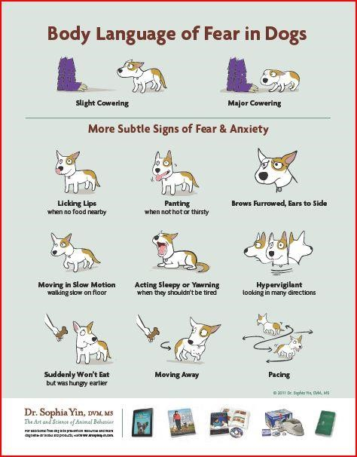

# Appendix B: The Engage – Disengage Game

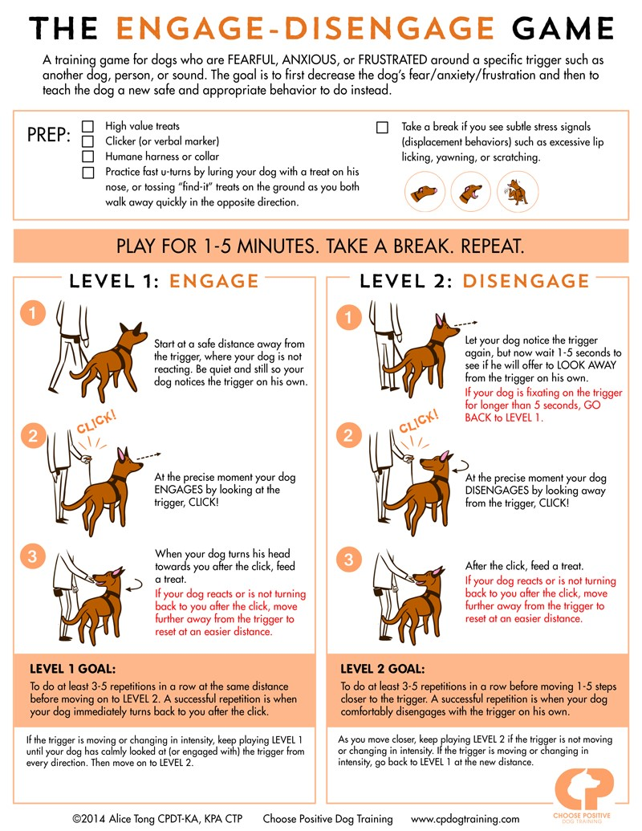

# Appendix C: Do’s and Don’t’s of Dog Training

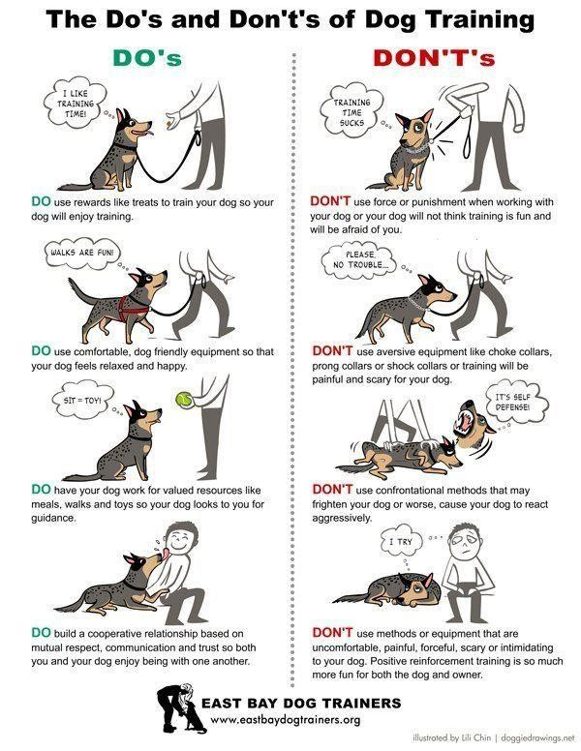

# Appendix D: Dog Reactivity Chart

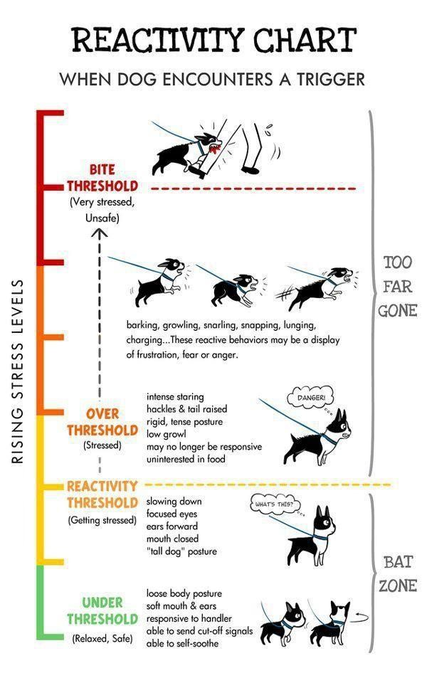

# Appendix E: Dog Calming Signals

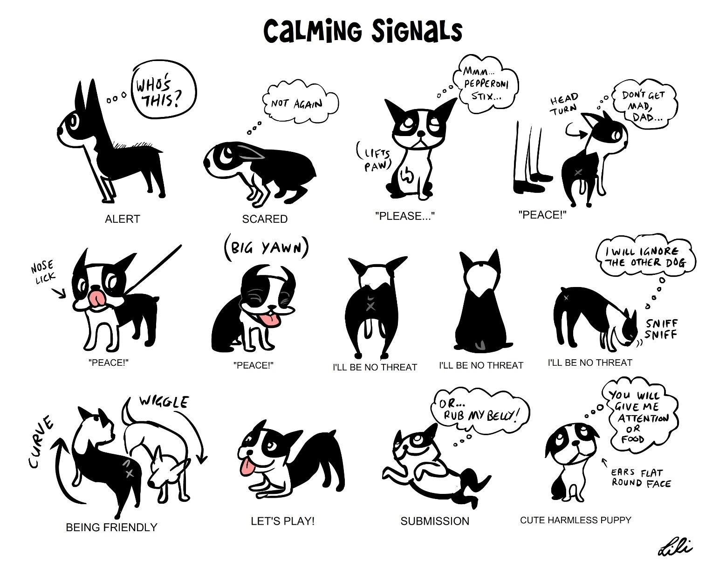

# Appendix F: How Kids Should Interact with Dogs

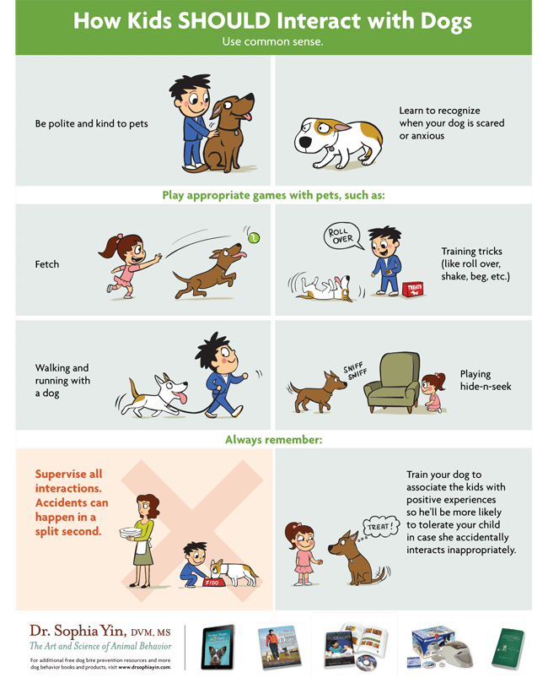

# Appendix G: Facial Expressions of Stress in Dogs

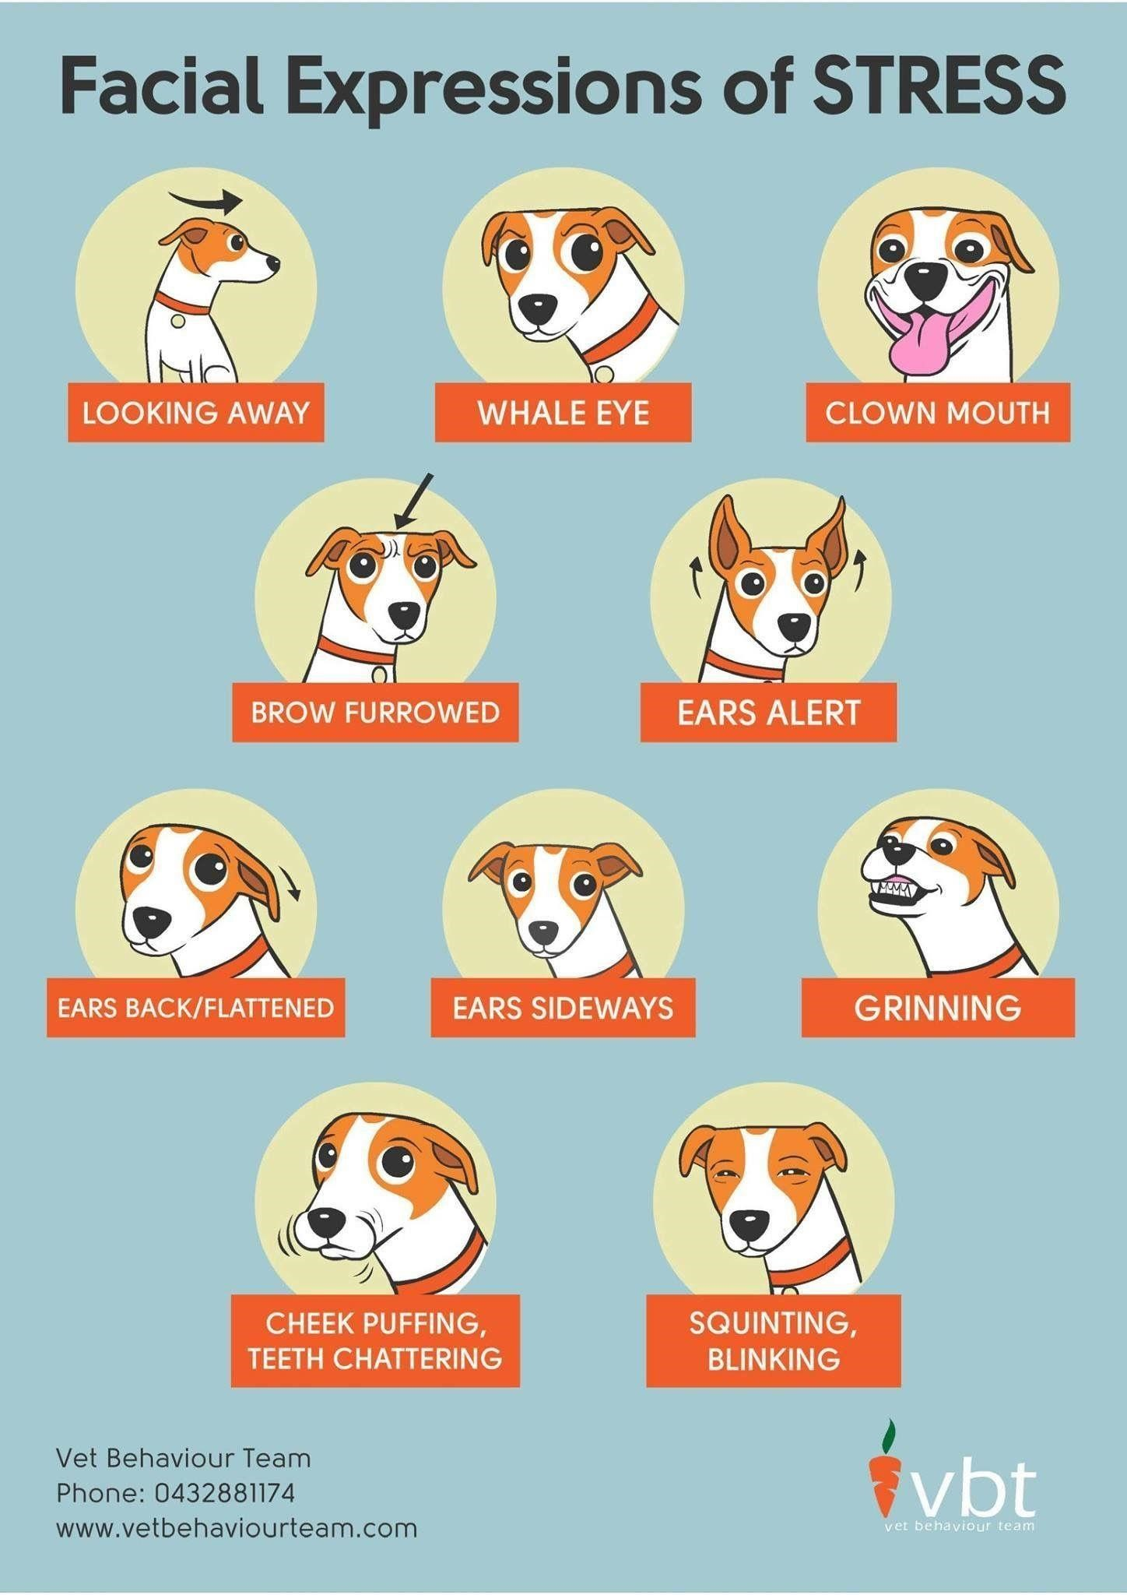

# Appendix H: Physiological Signs of Stress in Dogs

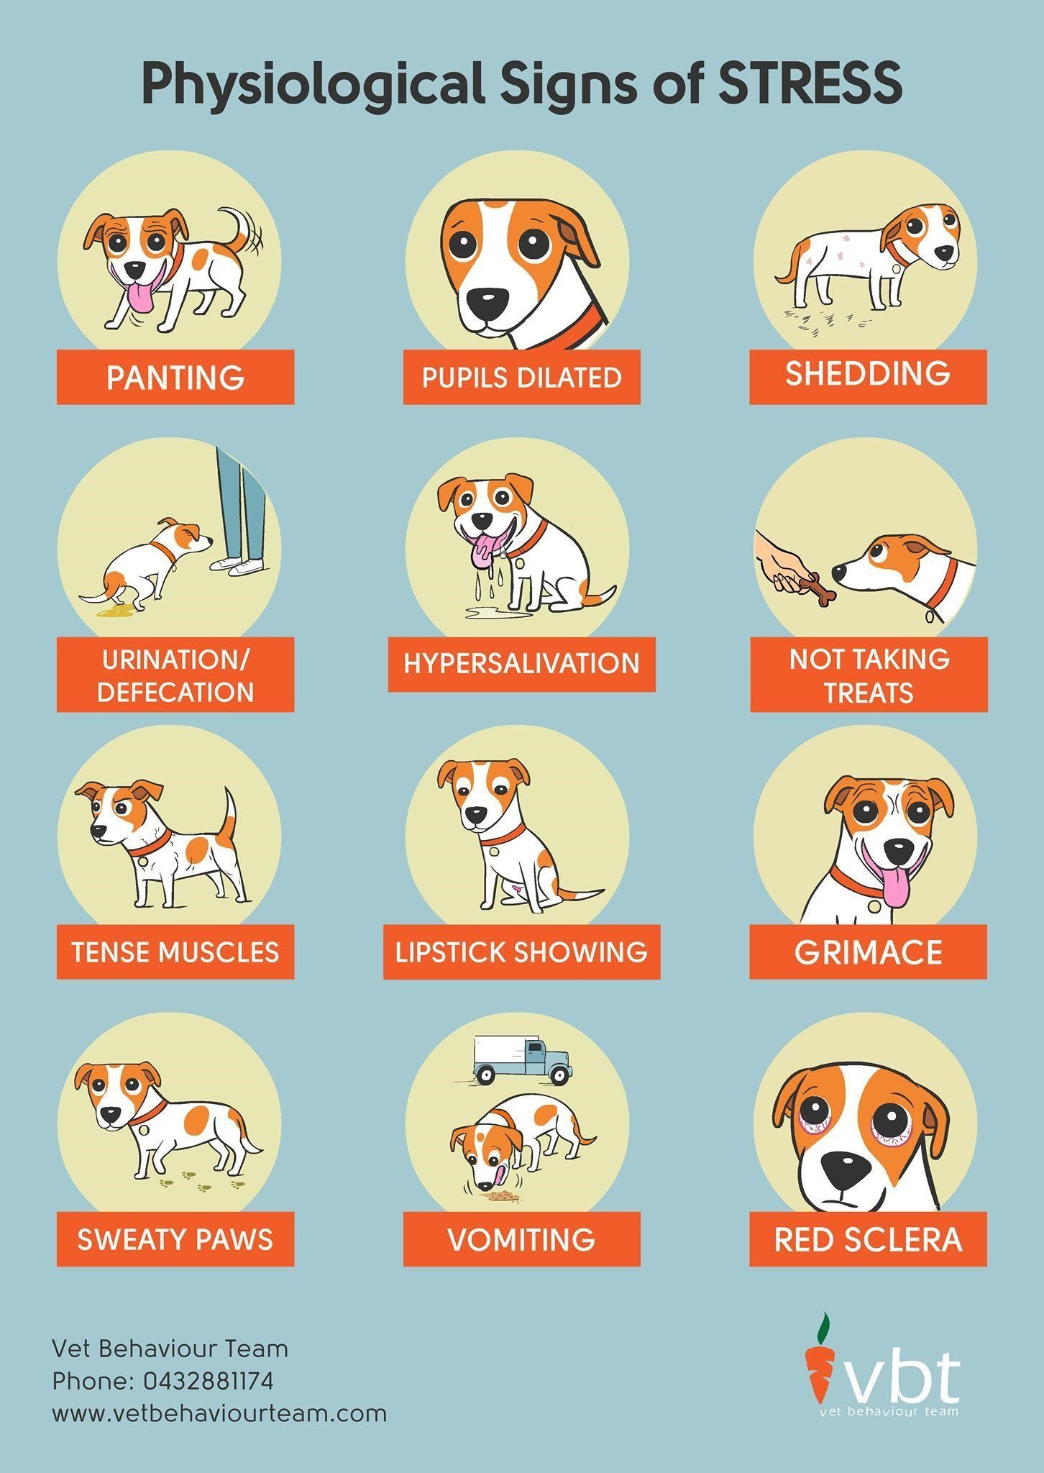

# Appendix I: Severe Signs of Stress in Dogs

