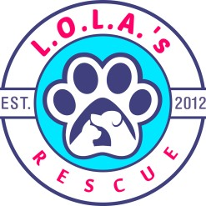

Canine Volunteer Handbook

Our Vision and Mission

L.O.L.A.’S Rescue is a non-profit animal rescue organization. We are based in Colorado, providing services for Colorado and surrounding states. Our rescue was founded on the idea of being able to save as many at-risk animals as possible from uncertain futures, while upholding the highest regard and values for animals in our care. Our concentration is on animals from high-kill shelters and at-risk animals in abuse, neglect, and abandonment situations, reducing the number of lives needlessly lost to euthanasia (due to overcrowding) in shelters and surrounding areas. We rehabilitate these animals so they can be placed in amazing, loving homes without the threat of an uncertain future.

L.O.L.A.’S Rescue has a higher need for volunteers and support because our animals are fully vetted. Instead of having an illness clause in the adoption contract, we keep the animals in our rescue for at least 10 days, which is the standard incubation period of most illnesses seen in animals. Our animals are fully vaccinated and spayed/neutered, all while in the care of the rescue. The rescue also has three trainers that can help with behavioral issues that may be seen while the animals are in our care. That means that the overhead is higher, but the adopter is getting a healthy, fully vetted animal and we can make a much better match with adopter and animal.

Our founder, Roni Taylor, has been saving animals since she was a teenager. She formed the rescue in 2011, after her Weimaraner, Lola, passed away. Since then, we have:

- Successfully placed approximately 600 dogs a year in forever homes.
- Drastically reduced the number of unwanted litters and homeless animals who were being euthanized
- Provide education on the importance of spaying/neutering and info on local low-cost or free resources
- Expanded from saving large & giant breeds to taking in all cases who need our help and care

We want all of our animals are in foster homes, thus, we want to consistently increase our number of fosters and volunteers to save more lives. We are always open to support from local businesses & individuals -- financial donation, dog/cat food, animal supplies (crates, leashes, collars, etc.) or even sharing us on social media. We operate solely on the donations and support from our community. We are immensely proud of this relationship and hope to increase it as we continue growing as a rescue.

Thank you for volunteering with Lola’s Rescue. Volunteers are the most important part of our team and help us in so many ways. We hope you agree that the work at an animal rescue can be extremely difficult, and also extremely rewarding.

You make a big difference! We're excited to have you!

Key Information and Contacts

L.O.L.A.s Rescue Center
22351 E Bayaud Pl
Aurora, CO 80018
303-343-1031

Points of Contact
Role | Name | Email | Cell Phone #
Volunteer Coordinator | Christy Hess | volunteers@lolasrescue.com | 303-887-8592 (text)
Foster Coordinator
 | Roni
 | Jamie

Participating in Opportunities
Generally, volunteer opportunities are found through the Volgistics platform (https://www.volgistics.com/). You can log in anytime to see current needs, sign up for open shifts, and view your schedule.
Life in animal rescue is always throwing curveballs, so will occasionally reach out to our volunteers via email with any immediate needs.

Volgistics portal
The volunteer portal can be accessed at: https://www.volgistics.com/vicnet/554595/login
You can also access it from the LOLAs.com volunteer page -> Current Volunteer
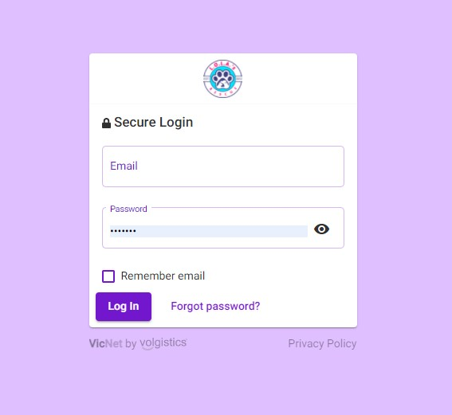

Once logged in – you will be brought to the Home tab:
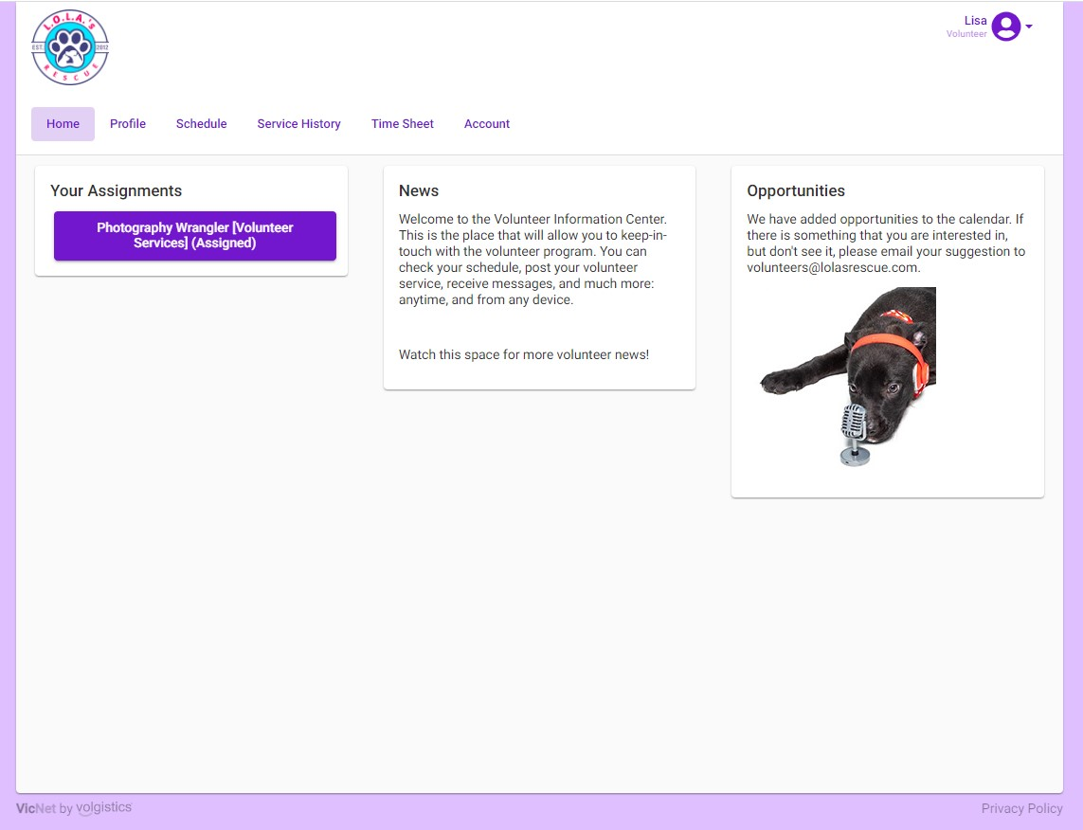
Update the Profile tab to make sure that your information is current. Please also upload a photo if you can:
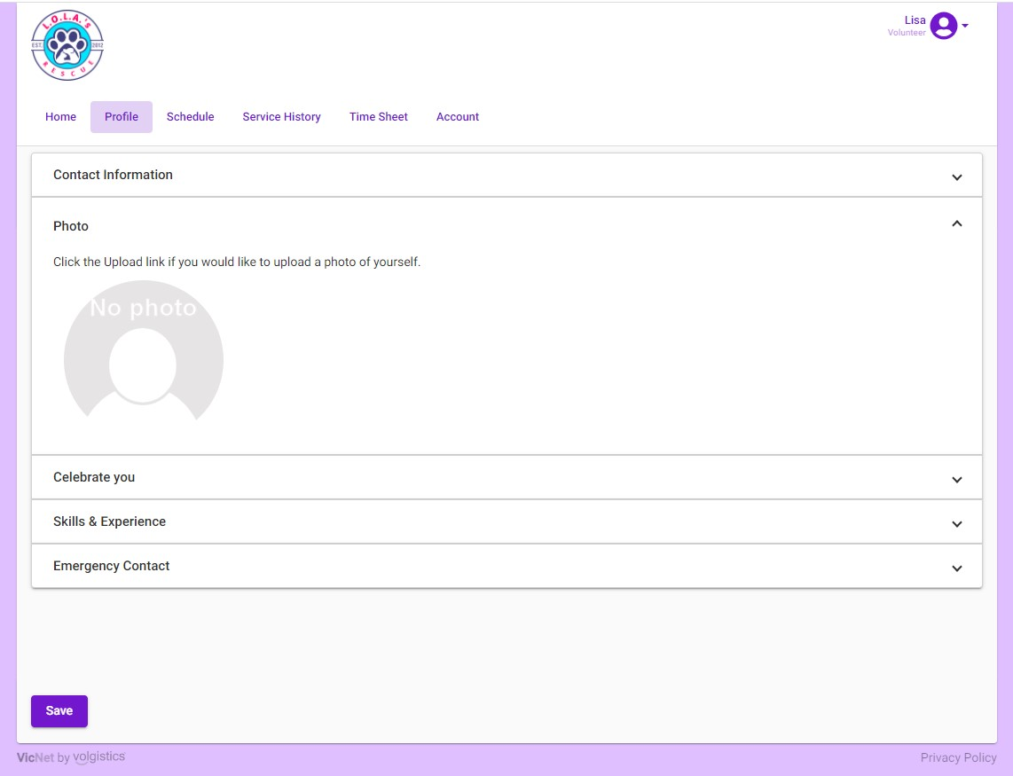

To view or schedule volunteer opportunities, go to the Schedule tab:

Click on the day to see the Openings:
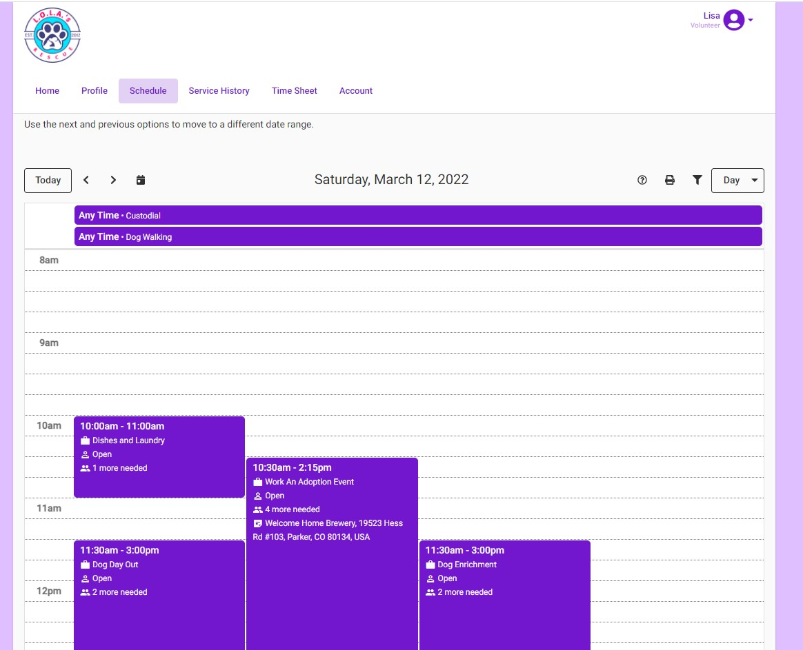
Click on any “Open” position to sign up.
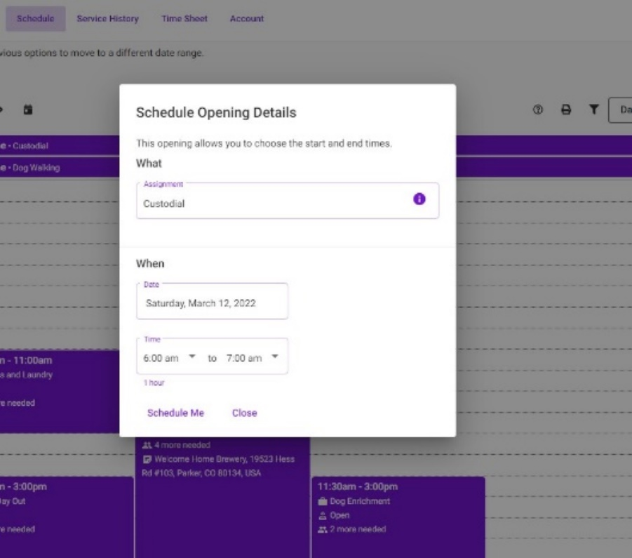
To volunteer for opportunities that are available at “Any Time”, enter the time that you are planning to help. For roles where there are times already entered, just click on Schedule Me, then click YES for validation.
Not sure what a role entails?
Click on the “i” icon in the assignment box for more information. Click to expand Duties and Qualifications to see the information.
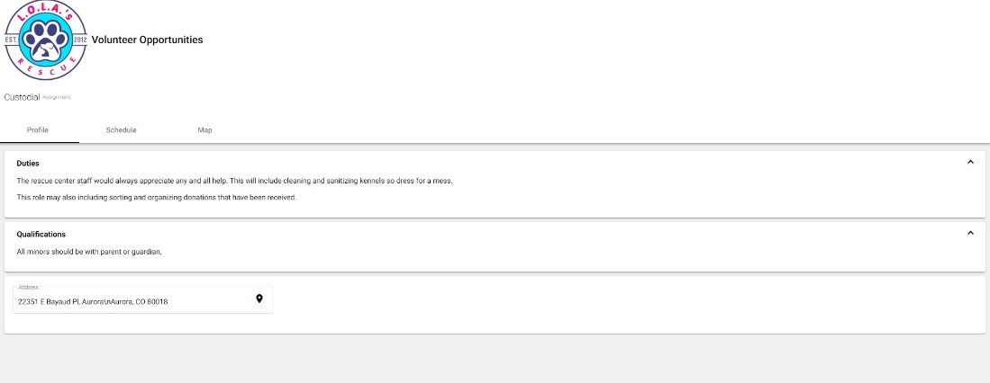

What each volunteer opportunity/role means

Work an Adoption Event
May include setup and clean-up, walking dogs, meeting with potential adopters, processing adoption applications (such as calling references), caring for cleaning up after dogs, chatting with potential adopters about what type of pup they are looking for, etc. We will be working on defining each of these roles, but for now check in with the person leading the event to find out how you can help.

Dog Shuttle
Pick up dogs at the rescue center and transport them to or from events or vet appointments. We have a special spot every Tuesday to shuttle dogs to and from the vet appointments.

Process Adoption Applications
Review applications for completeness and verify information provided, including calling landlords, veterinarians, and references.

Fundraiser
Community outreach to raise funds to support LOLAs’ mission. May occasionally involve staffing information tables at events.

Rescue Center

Custodial (note: With this option you can enter your times in manually)
The rescue center staff always appreciate all help. Especially with cleaning and sanitizing kennels, so dress for a mess. This role may also include sorting and organizing donations that have been received.

Front Office
We are seeing more and more traffic to the rescue center. Take time to hang out in the front office, answer the door, answer phones and free up staff to really work with dogs.

Dishes and Laundry
DISHES: After every meal the rescue center staff collects all the bowls from the kennels. All bowls must be washed and dried before they can be used for the next meal.
LAUNDRY: Laundry is a never-ending task at the rescue center! The rescue center staff appreciates help in making sure the laundry is washed, dried, folded, and put away.

Dog Day Out
Join us for our Dog Day Out program. Take a shelter dog out for an adventure and experience some new things together! Whether you want to go on a slow walk, an energetic hike, or you want a date to one of our local dog-friendly breweries, we have a dog who would love to be your newest adventure buddy! At this time, we are requiring that new volunteers help out in other areas 5 times before a dog day out adventure.

Dog Enrichment
Help the rescue center staff run dogs. If they make a mess, please clean it up. You can bring special treats for the pups and work on some basic commands or throw a ball for a while in the rescue runs.

Dog Walking
Take a dog for a walk outside around the rescue center property. Work with the staff to make sure that you are able to handle the dog for a walk. Dress for the weather. The rescue center will make sure there is a good fitting harness on the dog,

Rescue Center Care Day
Do tasks around the rescue center like pulling weeds, deep cleaning spaces, organizing leashes and collars.

Special Event
This might be working a table at an event giving information at a fundraiser or other event.

Volunteer Meet-Up
These will be sporadically scheduled in different parts of town to get to know each other better. I would prefer in person but might be zoom as well.

FAQ

QUESTION | ANSWER
What time should I be there for my scheduled shift? | If you are early we will not complain. At adoption events it would be nice to have people there 30-60 minutes early to help setup.
What if I’m late or can’t make it to a planned shift? | If you know within 24 hours you can unassign yourself. If it is less than 24 hours please email or text the Volunteer Coordinator.
What supplies do I need? | Dress for mess. Everything else will be supplied.
Can I bring someone with me? | Everyone participating will need to sign a Volunteer Agreement and Release. If the additional person is under age 18, a Release and Waiver of Liability for Minors is also required.
Can I bring my dog? | No. It is not appropriate to bring your dog when our focus is on the dogs in our care.
How long does Lola’s have the dogs in the rescue before they can be adopted? | Lola’s keeps all dogs in the rescue (either in the rescue center or in foster) for a minimum of 10 days. All dogs must be fully vaccinated, spayed/neutered and fully vetted as healthy before they are adopted.

Shelter Schedule


5p-7p
Potty Breaks
Wash dishes
Laundry
7a –9a
Wake up
Breakfast
Potty breaks
10a –11a
Wash dishes
4p-5p
Dinner
11a-3p
Enrichment & Exercise
Adoption meet & greets
Wash Dishes
Laundry
Clean kennels

Rescue Center Code of Conduct

Dress Code
- Closed toed flat shoes/slip resistant (athletic shoos are good). No sandals
- No short skirts. You are safer with all body parts covered so you are not easily scratched. Must be family appropriate attire.
- Avoid jewelry in which animals could get caught or it could break.

General Items
- Always wash/sanitize your hands before touching each animal and before leaving the rescue center.
- Do not bring personal food into areas with animals.
- Do not bring guests of visitors. Everyone must sign up to be a volunteer and sign waivers.
- Smoking is restricted to designated outside area and NEVER around animals,
- A calm quiet demeanor around animals helps them feel relaxed and less anxious.
- If you witness or receive an injury report it immediately to rescue center staff.
- Volunteers are required to follow the same adoption and foster policies as the public.
- No drugs or alcohol will be tolerated at the rescue center. Use of these substances jeopardizes animal welfare and will not be tolerated.

Dog Day Out Release Form (below) should be filled out before you take your dog. Report card will need to be filled out after the day out. https://forms.gle/7Hba2AcyGp9fCSxh6
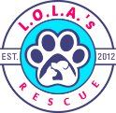 ‘DOG DAY OUT’ - AGREEMENT AND RELEASE

Volunteer Name: Name of Dog: Date:

L.O.L.A.’S RESCUE (LR) AGREES TO DO THE FOLLOWING:
1. Give the VOLUNTEER possession and control of the Dog on the above written date from ____________ until ______________, so long as the VOLUNTEER complies with the terms of this Agreement.
2. Provide VOLUNTEER with necessary records and/or supplies. LR is providing VOLUNTEER: ____________________________
______________________________________________________________________________________________________________
______________________________________________________________________________________________________________

IN RETURN, VOLUNTEER AGREES TO THE FOLLOWING: (Initial/Check each Section verifying you have read & understand each section)
____☐1. VOLUNTEER agrees to abide by the Volunteer Agreement and Release, as well as all LR policies, procedures, and protocols in effect.
____☐2. VOLUNTEER agrees to keep the Dog safe and under the VOLUNTEER’S direct care and control at all times, and to not let the Dog roam freely outside of the home or fenced yard.
____☐3. VOLUNTEER agrees to provide adequate food, water, shelter, exercise, grooming, positive training, and medical care for the Dog in a devoted and humane manner at all times while in VOLUNTEER’s care.
____☐4. VOLUNTEER agrees the Dog is NOT to be left unattended with small children at any time.
____☐5. VOLUNTEER agrees to notify LR immediately if the Dog becomes lost or exhibits signs of illness or injury.
____☐6. VOLUNTEER acknowledges and understands that even with LR’s efforts, behavioral issues, communicable illnesses, and unforeseen ailments may be present without LR’s knowledge. LR will not be held liable for any illness or ailment attributable to exposure or potential exposure of any individual, including VOLUNTEER’s or any third party’s pet(s), to the Dog.
____☐7. VOLUNTEER understands that should the Dog cause personal injury or property damage while in VOLUNTEER’s care, LR shall in no way be liable in whole or part for that damage. VOLUNTEER hereby assumes and agrees to hold LR harmless from any and all liability for any injury or damage that may be caused by the Dog. TO THE FULLEST EXTENT OF THE LAW, VOLUNTEER, ON BEHALF OF HIS/HERSELF, SPOUSE, NEXT OF KIN, HEIR(S), ADMINISTRATOR(S), REPRESENTATIVE(S), AND EXECUTOR(S) HEREBY ASSUMES AND AGREES TO RELEASE AND FOREVER DISCHARGE AND HOLD HARMLESS LR AND ITS DIRECTORS, OFFICERS, EMPLOYEES, VOLUNTEERS, AGENTS, SPONSORS, INSURERS, ATTORNEYS, SUCCESSORS, AND ASSIGNS FROM ANY AND ALL LIABILITY, INJURIES, ILLNESS, CLAIMS, AND DEMANDS OF WHATEVER KIND OR NATURE, EITHER IN LAW OR IN EQUITY, WHICH ARISE OR MAY BE ATTRIBUTED TO VOLUNTEER’S PARTICIPATION IN ‘DOG DAY OUT’ ACTIVITIES. VOLUNTEER UNDERSTANDS THIS RELEASE DISCHARGES LR FROM ANY AND ALL LIABILITY OR CLAIM THAT VOLUNTEER MAY HAVE AGAINST LR WITH RESPECT TO ANY INJURY, ILLNESS, DEATH, PROPERTY DAMAGE, OR ANY OTHER CAUSE OF ACTION THAT MAY RESULT FROM VOLUNTEER’S ELECTIVE PARTICIPATION.

I have been given adequate time to review this Agreement and I have fully read the terms of this Agreement and the Volunteer Agreement and Release. I understand and acknowledge that by signing this Agreement I am agreeing to certain legal obligations and waiving certain legal rights. I hereby accept and agree to the terms written above.

Volunteer’s Signature: ☐ I AGREE Date ________________________
By typing in your legal name, you are signing this Agreement electronically and agree your electronic signature is the legal equivalent of your acceptance and agreement as if actually signed by you in writing. You also agree that no certification authority or other third party verification is necessary to validate your e-signature and that the lack of such certification or third party verification will not in any way affect the enforceability of your e-signature or any resulting Agreement between you and LR.

Agent of L.O.L.A.’S RESCUE: Date ___________________

Questions to verify adopter application. You might be asked to call references, landlord or vets if you are at an adoption event.

general questions for the landlord
- confirm the applicant is a tenant
- how long has the applicant rented
- does applicant have a good rent payment history
- does the lease have a clause allowing pets
- has the applicant had pets in the past
- are there any restrictions on the type of pet allowed, ie height, weight, breed type
- if a fence is indicated in the application, confirm the fence, the height, construction and security (is the fence in good repair)
- without being intrusive engage in conversation to find out the life style, community and personality of the applicant

general questions for the vet
**NOTE: some vets will not release even the simplest piece of information without permission from the client. if that is the case, contact the applicant directly to ask that they instruct their vet to release information to you.

- confirm the applicant is/has been a client (if previous pet has passed)
- confirm all applicant pets are/were up to date on shots, vaccines & preventatives
- confirm what shots & preventatives have been given, especially rabies & parvo
- confirm the family pet has/was seen on a regular basis

general questions for the references
- how long have they known the applicant?
- how did the relationship originate?
- does the reference know or visited with the applicant’s pets?
- is the applicant capable of handling behavioral & medical issues?
- would the reference trust their own family pet to the care of the applicant (if the reference has pets)
- would the applicant make a good home for our rescued foster; is the applicant ready to adopt (or again if the applicant pet has passed)
- if possible open the conversation to find out a little more about the applicant, family history with animals, how active the applicant is

L.O.L.A.’S RESCUE ADOPTION CONTRACT Date:

Intake # Adopter Name: Name of Pet:

L.O.L.A.’S RESCUE AGREES TO DO THE FOLLOWING:
1. Give the ADOPTER title to, possession, and control of the Pet as described, for so long as the ADOPTER complies with the terms of this contract. This contract is considered automatically in breach and void if full compliance by ADOPTER is not executed, and ownership of the animal will be returned to RESCUER without warning.
*All liability due to property damage or personal injury, accident, or illness will be transferred to the new owner upon adoption.
2. Provide ADOPTER with any and all veterinary records available for Pet along with current medications as soon as they are obtained by RESCUER. (A current rabies vaccine for Pets over 16 weeks, alteration, and treatment of "known" illness are the only services we are required to provide for licensing. We fully practice exceptional treatment of all animals in our program and gift you, the ADOPTER, with all the additional services and "perks" provided. RESCUER acknowledges receipt from ADOPTER of a donation as noted below to aid with reimbursement of expenses incurred to consider Pet for adoption.)

IN RETURN, THE ADOPTER AGREES TO THE FOLLOWING:
3. ADOPTER agrees to pay a nonrefundable adoption fee. If within the first 30 days it is determined by a licensed Veterinarian that a life-threatening aliment is present, not suspected to be caused by actions or neglect of ADOPTER, medical documentation must be provided and released to RESCUER for review by a rescue-appointed Veterinarian. If the rescue Veterinarian agrees with the diagnosis and severity to qualify as life threatening, a full refund of your adoption fee will be given to assist with medical care. The ADOPTER is responsible for all medical care and veterinary expenses as of the contract date of adoption and thereafter. We cannot, and will not, assume financial responsibility for your medical decisions.
4. ADOPTER agrees to keep the Pet as a pet and companion and not to abandon, trade, give away, or sell it, nor is the Pet to be used or sold for commercial use or research purposes. If the ADOPTER is unable to keep the Pet within the terms of this contract, the RESCUER must be contacted immediately by written request via email at info@lolasrescue.com and given the first right of refusal or the opportunity to help you place your Pet in an appropriate situation. *Please understand as a foster based organization we do not readily have open spots for return animals, it can take time, days or even weeks to find an open foster home to house your Pet temporarily. Please do not expect our or any other rescue to be able to take your animal immediately. We will also recommend a training program at your expense, fitting to your animal before the consideration of accepting them back into rescue if behavioral issues are noted. You are held liable for all expenses incurred for RESCUER to take back ownership should you abandon/drop off your animal with a shelter. A minimum of a $100 owner surrender fee will be assessed should you need to return your animal back to our care, pursuant to Section 23 below.
5. ADOPTER has done adequate research regarding training, breed-specific behavior and characteristics, medical issues, and planning for the absolute best care outcome for the estimated breed and age of this Pet.
6. ADOPTER acknowledges and understands that even with the RESCUER’S best efforts for treatment and prevention, communicable illnesses such as but not limited to kennel cough; giardia; and coccidia , parasites internal and external, and unforeseen ailments may be present without RESCUER’S knowledge. Your veterinarian should always be consulted on testing and prevention after adoption. RESCUER will not be held liable for these expenses.
7. ADOPTER agrees to provide an adequate, high-quality premium diet, water, shelter, exercise, grooming, positive training, and medical care at all times and care for the Pet in a devoted and humane manner for the remainder of its natural life.
8. ADOPTER agrees to have the Pet examined by a licensed veterinarian at least once a year, maintain appropriate vaccinations and other preventive health and dental care, and provide copies of the Pet’s care records to RESCUER upon request.
9. The Pet shall reside within the ADOPTER’S home, not be crated for more than 8 hours, and not be left in a fenced yard unattended, while ADOPTER is not home. The Pet shall NOT ride in the back of a truck or be left in a car unattended.
10. ADOPTER agrees to keep the Pet under the ADOPTER’S control and not let the Pet roam freely outside of the home or fenced yard. Keeping the Pet on a chain, rope, in a Pet-run or similar containment method is not permitted.
11. ADOPTER agrees to provide a humane collar (no electric collars ever permitted) or harness for the Pet to wear at all times and to keep on this collar, at minimum, contact information and the rabies tag if provided.
12. ADOPTER must notify RESCUER immediately if Pet becomes lost or passes away, as well as any change in address, phone number, or email. Failure to respond back in adequate time, determined by the urgency of the occurence, to RESCUER’S attempt to contact ADOPTER by the means ADOPTER has listed will void this contract. If your Pet ends up in the possession of an animal control agency, that animal control agency will relinquish said Pet to RESCUER, and ADOPTER will be held responsible for any fees and or costs incurred due to this event.
13. ADOPTER agrees the Pet is NOT to be left unattended with small children at any time.
14. ADOPTER agrees during the Pet’s lifetime, RESCUER or assigned volunteer may visit the premises where the Pet is kept and reclaim the Pet if, in the judgment of the RESCUER, the Pet is not being adequately cared for or ADOPTER has not complied with any provision of this contract.
15. ADOPTER agrees to pay all costs necessary to enforce this agreement including reasonable attorneys’ fees, costs of litigation, Pet recovery fees, and all medical bills to restore the Pet’s health back to adoptable status.
16. ADOPTER authorizes any animal care or control agency to release the Pet to a L.O.L.A.’S RESCUE representative, hereby designated as Agent for the ADOPTER, if the Pet is found running at large or is brought into a shelter facility for any reason.
17. ADOPTER acknowledges that the Pet is adopted “as is” and that no implied or expressed warranties have been made by RESCUER in reference to the breed, health, training, and/or temperament of the Pet. RESCUER shall not be held responsible for any veterinary expenses after adoption of the Pet or held liable for any misrepresentations unknown to this RESCUER.
18. ADOPTER understands that should the Pet cause personal injury or property damage after adoption, the RESCUER shall in no way be liable in whole or part for that damage and hereby assumes and agrees to hold RESCUER harmless from any and all liability for the Pet, or any injury or damage that may be caused by it. ADOPTER hereby waives all claims, losses, or damages which may arise after the adoption of this Pet, caused by any act or omission by RESCUER, which results in personal injury or property damage to any person by this Pet, and the ADOPTER agrees not to bring any legal action seeking any remedy against RESCUER in connection with this agreement or in connection with personal injuries or property damage claimed to result from any act or omission by RESCUER whether by ADOPTER or any third party.
19. ADOPTER certifies that neither ADOPTER nor anyone residing in ADOPTER’S household has ever been charged with or convicted of crimes against animals or humans, including but not limited to neglect, abuse, or housing animals in unsanitary living conditions.
20. ADOPTER agrees to allow a home visit, as deemed necessary, before adoption completion will be considered!
21. ADOPTER agrees that if the RESCUER deems or finds at any time the ADOPTER’S application has incorrect or falsified information, this will be considered a dangerous situation and immediate possession/ownership will be returned to RESCUER.
22. If for any reason payment of adoption fee does not go through or is not provided to the RESCUE immediately after notification, this will be considered theft; if the animal is not returned immediately, authorities will be notified, and ADOPTER will be charged.
23. Should ADOPTER find that they can no longer keep this Pet, for ANY reason, where the Pet must be returned to RESCUER, and the RESCUER has available space to accept the Pet, ADOPTER agrees at their expense to pay at minimum: A $100 return fee and a professional behavioral assessment fee (by one of our chosen trainers) unless a behavioral assessment can be provided by ADOPTER from a licensed behaviorist within the past 90 days. ADOPTER also agrees to donate to the RESCUER in order to place the Pet in an appropriate board and train program chosen by the RESCUER (Avg. Cost is $1,300 to $1,800 per month). Should the RESCUER have to retrieve this Pet from a local shelter or organization, a minimum $1,200 retrieve and reentry fee will be charged.
24. ADOPTER agrees to leave RESCUER as the secondary contact on this Pet’s microchip account for life.
25. ADOPTER agrees to allow RESCUER to take photos, videos, and/or audio recordings of ADOPTER’s and/or Pet’s likeness (“Images”) in adoption day activities and progress updates as seen fit. These Images will be owned by RESCUER, and RESCUER shall have the right to use, edit, post, copy, and exploit such Images in whole or in part for any lawful purpose whatsoever, in perpetuity, throughout the world, without additional compensation, consideration, notification, or permission.
This section to be completed by L.O.L.A.’S RESCUE REPRESENTIVE
Name of Pet: Sex: ☐Male ☐Female Altered: ☒Yes ☐No Breed Guestimate: Color:
Approximate Age: as of this date: D.O.B. (if known): Month/Year ☒Dog ☐Cat
Vaccinations are up to date as of Contract Date (1st set provided by L.O.L.A.’S). Next Vaccines due:
Notes:
Adoption Disclosure signed and returned? Prepared by:
Adoption Fee Amount: $ | ☐ CASH | ☐ CHECK # | ☐ CREDIT CARD # (LAST 4 )
Adoption fees only support a portion of the cost of saving a life, some animals care can exceed the thousands. Donations allow us to continue to help those with special needs. |  |  | EXP:
 |  |  | CVC#
In Kind donation sponsoring medical fees & program longevity $ |  |  | BILLING ZIP CODE:
Total Amount Due: $ |  |  | NAME ON CARD:
Intake Tracking # : |  |  | Online PayPal verified:
Contract Addendum ☐NO ☐YES DESCRIBE:

Please Print Clearly & Complete.
This contract is made between: (ADOPTER or “you”) and L.O.L.A.’S RESCUE (RESCUER or “we”).
(Adopter’s full name)
Adopter’s Address: | (Street#, Name, & Unit#)  (City) (State) (Zip Code)
Adopter’s Primary Phone |  | Adopter’s Alternate Phone
Adopter’s Email Address
Adopter’s driver’s license #/state | / |  | Adopter Age 18 or older? ☒Yes ☐No
BY SIGNING BELOW, ADOPTER CERTIFIES THAT THEY HAVE DONE ALL POSSIBLE RESEARCH AND PREPARATION, AND UNDERSTANDS THE NEEDS OF CARING FOR AN ANIMAL. ADOPTER UNDERSTANDS THAT EVERY ANIMAL IS AN INDIVIDUAL AND WILL NEED TO BE CARED FOR AND RESPECTED AS THAT INDIVIDUAL. ADOPTERS ARE ALSO SIGNING THAT THEY HAVE OR WILL RECEIVE IN THEIR DIGITAL PET PROFILE, THE RABIES PAMPHLET REQUIRED BY PACFA ADDRESSING THE IMPORTANCE OF THE RABIES VACCINATION.
ALL ANIMALS’ NEEDS AND CHALLENGES ARE DIFFERENT.
PER THE PET ANIMAL CARE FACILITIES ACT, ALL ANIMALS FROM RESCUES MUST BE ALTERED BEFORE CUSTODY IS TRANSFERRED TO AN ADOPTER.
ADOPTER UNDERSTANDS & AGREES TO ALL TERMS OF THIS CONTRACT & HAS READ ACCEPTED EACH NUMBERED SECTION.
By typing in your legal name, you are signing this contract electronically and agree your electronic signature is the legal equivalent of your acceptance and agreement as if actually signed by you in writing. You also agree that no certification authority or other third party verification is necessary to validate your e-signature and that the lack of such certification or third party verification will not in any way affect the enforceability of your e-signature or any resulting contract between you and Rescuer.

Adopter’s Signature: ☐ I AGREE Date

Agent of L.O.L.A.’S RESCUE: Date

20. ADOPTER agrees to allow a home visit, as deemed necessary, before adoption completion will be considered!
21. ADOPTER agrees that if the RESCUER deems or finds at any time the ADOPTER’S application has incorrect or falsified information, this will be considered a dangerous situation and immediate possession/ownership will be returned to RESCUER.
22. If for any reason payment of adoption fee does not go through or is not provided to the RESCUE immediately after notification, this will be considered theft; if the animal is not returned immediately, authorities will be notified, and ADOPTER will be charged.
23. Should ADOPTER find that they can no longer keep this Pet, for ANY reason, where the Pet must be returned to RESCUER, and the RESCUER has available space to accept the Pet, ADOPTER agrees at their expense to pay at minimum: A $100 return fee and a professional behavioral assessment fee (by one of our chosen trainers) unless a behavioral assessment can be provided by ADOPTER from a licensed behaviorist within the past 90 days. ADOPTER also agrees to donate to the RESCUER in order to place the Pet in an appropriate board and train program chosen by the RESCUER (Avg. Cost is $1,300 to $1,800 per month). Should the RESCUER have to retrieve this Pet from a local shelter or organization, a minimum $1,200 retrieve and reentry fee will be charged.
24. ADOPTER agrees to leave RESCUER as the secondary contact on this Pet’s microchip account for life.
25. ADOPTER agrees to allow RESCUER to take photos, videos, and/or audio recordings of ADOPTER’s and/or Pet’s likeness (“Images”) in adoption day activities and progress updates as seen fit. These Images will be owned by RESCUER, and RESCUER shall have the right to use, edit, post, copy, and exploit such Images in whole or in part for any lawful purpose whatsoever, in perpetuity, throughout the world, without additional compensation, consideration, notification, or permission.
This section to be completed by L.O.L.A.’S RESCUE REPRESENTIVE
Name of Pet: Sex: ☐Male ☐Female Altered: ☒Yes ☐No Breed Guestimate: Color:
Approximate Age: as of this date: D.O.B. (if known): Month/Year ☒Dog ☐Cat
Vaccinations are up to date as of Contract Date (1st set provided by L.O.L.A.’S). Next Vaccines due:
Notes:
Adoption Disclosure signed and returned? Prepared by:
Adoption Fee Amount: $ | ☐ CASH | ☐ CHECK # | ☐ CREDIT CARD # (LAST 4 )
Adoption fees only support a portion of the cost of saving a life, some animals care can exceed the thousands. Donations allow us to continue to help those with special needs. |  |  | EXP:
 |  |  | CVC#
In Kind donation sponsoring medical fees & program longevity $ |  |  | BILLING ZIP CODE:
Total Amount Due: $ |  |  | NAME ON CARD:
Intake Tracking # : |  |  | Online PayPal verified:
Contract Addendum ☐NO ☐YES DESCRIBE:

Please Print Clearly & Complete.
This contract is made between: (ADOPTER or “you”) and L.O.L.A.’S RESCUE (RESCUER or “we”).
(Adopter’s full name)
Adopter’s Address: | (Street#, Name, & Unit#)  (City) (State) (Zip Code)
Adopter’s Primary Phone |  | Adopter’s Alternate Phone
Adopter’s Email Address
Adopter’s driver’s license #/state | / |  | Adopter Age 18 or older? ☒Yes ☐No
BY SIGNING BELOW, ADOPTER CERTIFIES THAT THEY HAVE DONE ALL POSSIBLE RESEARCH AND PREPARATION, AND UNDERSTANDS THE NEEDS OF CARING FOR AN ANIMAL. ADOPTER UNDERSTANDS THAT EVERY ANIMAL IS AN INDIVIDUAL AND WILL NEED TO BE CARED FOR AND RESPECTED AS THAT INDIVIDUAL. ADOPTERS ARE ALSO SIGNING THAT THEY HAVE OR WILL RECEIVE IN THEIR DIGITAL PET PROFILE, THE RABIES PAMPHLET REQUIRED BY PACFA ADDRESSING THE IMPORTANCE OF THE RABIES VACCINATION.
ALL ANIMALS’ NEEDS AND CHALLENGES ARE DIFFERENT.
PER THE PET ANIMAL CARE FACILITIES ACT, ALL ANIMALS FROM RESCUES MUST BE ALTERED BEFORE CUSTODY IS TRANSFERRED TO AN ADOPTER.
ADOPTER UNDERSTANDS & AGREES TO ALL TERMS OF THIS CONTRACT & HAS READ ACCEPTED EACH NUMBERED SECTION.
By typing in your legal name, you are signing this contract electronically and agree your electronic signature is the legal equivalent of your acceptance and agreement as if actually signed by you in writing. You also agree that no certification authority or other third party verification is necessary to validate your e-signature and that the lack of such certification or third party verification will not in any way affect the enforceability of your e-signature or any resulting contract between you and Rescuer.

Adopter’s Signature: ☐ I AGREE Date

Agent of L.O.L.A.’S RESCUE: Date

