Welcome! Thank you so much for your raising your hand and wanting to volunteer with Lola’s Rescue.
Your information has been added to new volunteer management system.
To give a little background on why this system is so important. This system will allow us to communicate with volunteers on what opportunities are available, alert rescue center staff or event coordinators when you sign up for an opening, so they know who to expect and when and be able to track volunteer hours. The last point is very important when we are applying for grants.
I will be working on opening the communication channels by sending update emails weekly starting out. If you ever need to contact the volunteer coordinator (Christy Hess) directly please email volunteers@lolasrescue.com or contact cell number is: 303-887-8592 (prefer text if possible).
Note – this system is new – so if there is an opportunity that you are interested in but do not see listed on the portal, please let me know.
I also can’t say thank you enough – you are a key part of making Lola’s Rescue successful. Can’t wait to meet you and get to know you.
Sincerely,
Christy Hess

To get started:
The portal can be accessed using this link: https://www.volgistics.com/vicnet/554595/login
You can also access it from the volunteer page -> Current Volunteer
Enter your email and the temporary password will be:
lolas
You will be taken to a page to reset your password.
Once logged in – you will be brought to the Home tab.
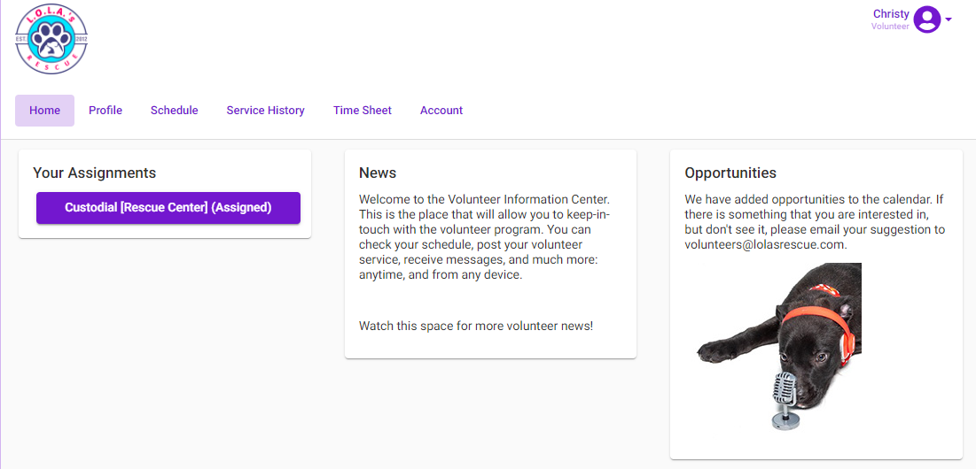
Profile tab:
Update the profile page to make sure that it is current and upload a photo if you can:
Schedule tab:
Go to the Schedule tab:
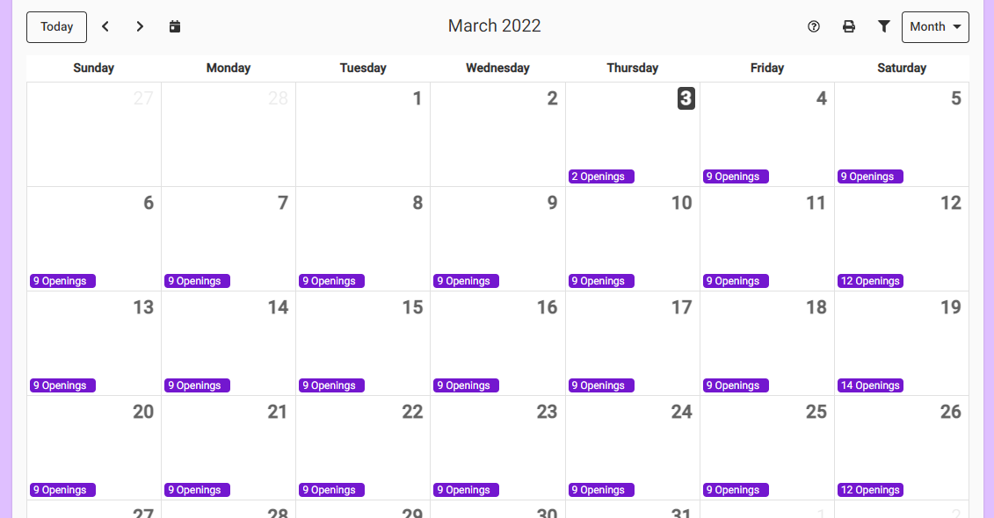
Click on the day to see the Openings:
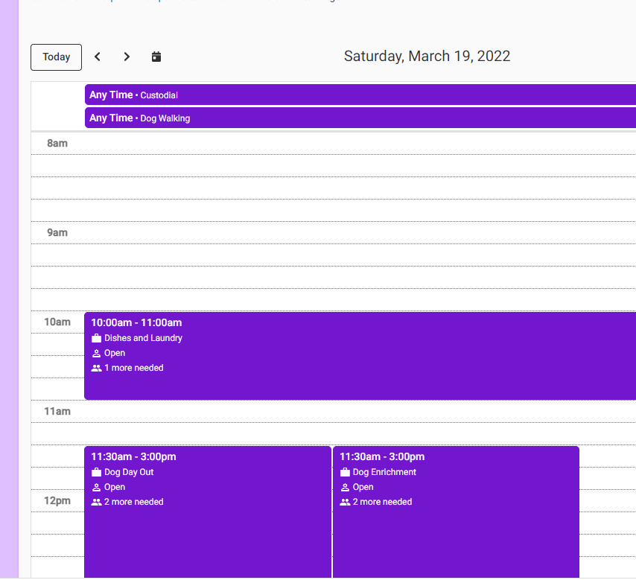

To volunteer for opportunities that are available at Any Time – you will have to enter the time that you will be able to help:
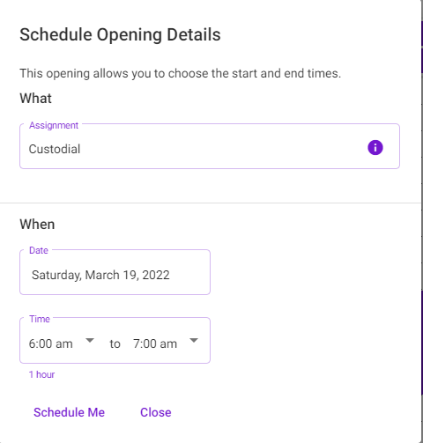
For the items where there are times already entered, just click on Schedule Me, then click YES for validation.
Not sure what a role is?
All opportunities have additional information. Click on the icon in the assignment box. Click on the word of Duties and Qualifications to see the details.
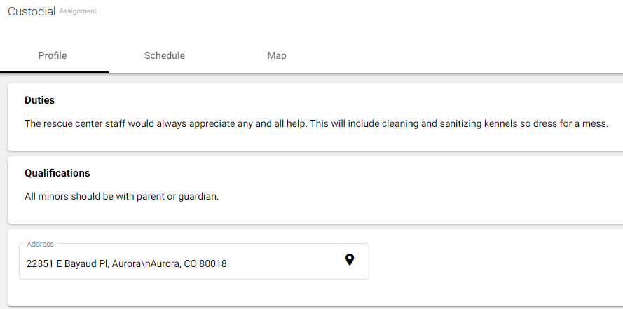
Note: We will have a handbook soon, to detail all volunteer opportunities.

